**121M1INISTRY OF EDUCATION AND TRAINING VIET NAM**

**FPT UNIVERSITY**

Capstone Project Document

[Low or High Price]

|  |  |  |
| --- | --- | --- |
| Low or High Price **Group** | | |
| **Group Members** | Lê Duy Công | SE03929 |
| Nguyễn Thanh Tùng | SE03924 |
| Trần Hồng Quân | SE03733 |
| Nguyễn Văn Vinh | SE03927 |
| Nguyễn Huy Phong | SE03697 |
| **Supervisor** | **Mr. Trần Bình Dương** | |
| **Capstone Project code** | LowHoPe | |

Ha Noi 5th Oct, 2017

**Acknowledge**

We specially thank to Mr. Tran Binh Duong, our supervisor, for  
his support throughout this project. His instruction and  
motivation has been lessons for us not only about technique,   
but also about how to work as a team in a real project.  
We also thank to our families and friends. Their encouragement  
has helped us to overcome many pressure to complete our  
product

**Record of change**

*A - Added M - Modified D - Deleted

|  |  |  |  |  |
| --- | --- | --- | --- | --- |
| Effective Date | Changed Items | A* M, D | Change Description | New Version |
| 12/09/2017 | Project document | A | Initiate version | 1.0 |
| 12/09/2017 | Introduction | A | Initiate version | 1.0 |
|  |  |  |  |  |
|  |  |  |  |  |
|  |  |  |  |  |
|  |  |  |  |  |
|  |  |  |  |  |
|  |  |  |  |  |
|  |  |  |  |  |
|  |  |  |  |  |
|  |  |  |  |  |
|  |  |  |  |  |
|  |  |  |  |  |
|  |  |  |  |  |
|  |  |  |  |  |
|  |  |  |  |  |
|  |  |  |  |  |
|  |  |  |  |  |
|  |  |  |  |  |

Table of Contents

CHAPTER 1: INTRODUCTION 8

**1.1** **Purpose** 8

**1.2** **Project Information** 8

**1.2.1** **Project members** 9

**1.2.2** **Problems** 9

**1.2.3** **Solution** 10

**1.2.4** **Existed system** 10

**1.2.5** **Our Proposal** 12

CHAPTER 2: SOFTWARE PROJECT MANAGEMENT PLAN 14

**2.1. Purpose** 14

**2.2. Problem Definition** 14

**2.2.1. Name of this Capstone Project** 14

**2.2.2. Problem Abstraction** 14

**2.2.3. Project Overview.** 15

**2.3. Project organization** 17

**2.3.1 Software Process Model** 17

**2.3.2 Software Process Model** 18

**2.3.3 Tool and Techniques.** 21

**2.4. Schedules** 22

**2.5. Communication Management** 22

**2.5.1 Stakeholders and Contacts** 22

**2.5.2 Communication Management Approach.** 23

**2.5.3 Communication Requirements** 23

**2.5.4 Communication Method and Technologies** 23

**2.5.5 Communication Matrix** 24

**2.6. Risk Management** 25

**2.6.1 Risk Management Approach** 25

**2.6.2 Risk Identification** 26

**2.6.3 Risk Qualification and Prioritization** 26

**2.6.4 Risk Monitoring** 26

**2.6.4 Risk Register** 27

**2.7. Quality Management** 30

**2.7.1 Quality Management Overview** 30

Definitions and Acronyms

| Acronym | Definition | Note |
| --- | --- | --- |
| BA | Business Analyst |  |
| Analysis and Design | A&D |  |
| Front-end Design | FD |  |
| LowHoPe | Low or High Price |  |
| BU | Business Unit |  |
| CI | Configuration Item |  |
| CM | Configuration Management |  |
| CSCI | Computer Software Configuration Items |  |
| DEV | Developer |  |
| DB | Database |  |
| MM | Meeting Minute |  |
| PC | Person in charge |  |
| PM | Project Manager |  |
| PMP | Project Management Plan |  |
| PTL | Project Technical Leader |  |
| QA | Quality Assurance Officer |  |
| SDD | Software Detail Design |  |
| SUM | Software User Manual |  |
| SRS | Software Requirement Specification |  |
| W# | Week# |  |
| WR | Weekly Report |  |
| TP | Test Plan |  |
| TC | Test Case |  |
|  |  |  |

# CHAPTER 1: INTRODUCTION

## **Purpose**

The purpose of this chapter is to provide an overview of Low or High Price web service and why we chose it. And we also show Idea, solution, some basic functions in this project. Besides, we have some benefit and limitation in the project. Thereby, we will research orientation of future.

## **What is Bitcoin.**

### **Summary Short**

* Bitcoin is a electronic cash, also known as Cryptocurrency, that can traded online and converted into currencies type.

### **Blockchain.**

* **Definition**
* A blockchain is a continuously growing list of records, called blocks, which are linked and secured using cryptography. Each block typically contains a hash pointer as a link to a previous block, a timestamp and transaction data. By design, blockchains are inherently resistant to modification of the data. Harvard Business Review defines it as "an open, distributed ledger that can record transactions between two parties efficiently and in a verifiable and permanent way." For use as a distributed ledger, a blockchain is typically managed by a peer-to-peer network collectively adhering to a protocol for validating new blocks. Once recorded, the data in any given block cannot be altered retroactively without the alteration of all subsequent blocks, which requires collusion of the network majority.
* Blockchains are secure by design and are an example of a distributed computing system with high Byzantine fault tolerance. Decentralized consensus has therefore been achieved with a blockchain. This makes blockchains potentially suitable for the recording of events, medical records, and other records management activities, such as identity management, transaction processing, documenting provenance, or food traceability.
* **Where It All Started**

Blockchain technology was first introduced in a whitepaper entitled: “Bitcoin: A Peer-to-Peer Electronic Cash System,” by Satoshi Nakamoto in 2008.

* No reliance on trust
* Digital signatures
* Peer-to-peer network
* Proof-of-work
* Public history of transactions
* Honest, independent nodes control majority of CPU computing power
* Nodes vote with CPU computing power
* Rules and incentives enforced through consensus mechanism
* **Cryptocurrency Summarized**
  + Bitcoin was the first digital, i.e., cryptocurrency
  + A maximum of 21 million Bitcoins can be generated
  + Just as with real world mining, energy must be invested to solve complex mathematical problems by which systems earn Bitcoins
  + <https://www.cryptocoincharts.info/coins/info> claims to be indexing 4,220 cryptocurrencies
  + Most circulated: Bitcoin, Ethereum, Litecoin
* **The Technology Behind Bitcoin**
  + Think of Bitcoin as an electronic asset (as well as a digital currency)
  + A network of computers keeps track of Bitcoin payments, and adds them to an ever-growing list of all the Bitcoin payments that have been made, called “The Bitcoin Blockchain”
  + The file that contains data about all the Bitcoin transactions is often called a “ledger”
  + Bitcoin value is created through transaction processing, referred to as “mining,” which is performed by distributed processors called “nodes” of the peer-to-peer network
* **Mining Evolution**
  + Think of Bitcoin as an electronic asset (as well as a digital currency)
  + A network of computers keeps track of Bitcoin payments, and adds them to an ever-growing list of all the Bitcoin payments that have been made, called “The Bitcoin Blockchain”
  + The file that contains data about all the Bitcoin transactions is often called a “ledger”
  + Bitcoin value is created through transaction processing, referred to as “mining,” which is performed by distributed processors called “nodes” of the peer-to-peer network
* **Three “Levels” of Blockchain**

1. Storage for digital records
2. Exchanging digital assets (called tokens)
3. Executing smart contracts
   * Ground rules – Terms & conditions recorded in code
   * Distributed network executes contract & monitors compliance
   * Outcomes are automatically validated without third-party

* **A general Discussion about tokens**
* A broader use is supported by the digital infrastructure introduced through Bitcoin, as represented by “tokens”.
* A “token” can be defined as a “scarce digital asset based on underlying technology inspired by Bitcoin.”
* Tokens may use similar codebases but different blockchain databases.
* Ethereum was Bitcoin-inspired but has its own blockchain and is engineered to be more programmable. Tokens can be issued on top of the Ethereum blockchain.
* Token buyers are buying private keys, which are similar to API keys, but can be transferred to other parties without consent.
* Tokens have a value and therefore a price.
* Tokens are a new model for technology and can be an alternative to equity-based financing.
* Tokens do not dilute capital. They introduce a huge increase to buyer base and time-to-liquidity.
* Token launches differ from equity sales; however, they can be issued as a way to share profits.
* Tokens can be sold internationally over the internet and are always open for business.
* Tokens decentralize the process of funding technology.
* Tokens enable a better-than-free new business model.
* Tokens will introduce the rise of the “tech savvy senior executive.”
* Tokens accommodate immediate custody without an intermediary.
* Tokens can be extended to hardware, as part of the internet of things.
* **Smart Contract**
* Current paper-based systems drive $18 trillion in transactions per year. Consensus protocols are key to determining the sequence of actions resulting from the contract’s code. This enables peer-to-peer trading of everything from renewable energy to automated hotel room bookings.

## **Project Information**

|  |  |
| --- | --- |
| **Project name** | Low or High Price |
| **Project code** | LowHoPe |
| **Project type** | Website |
| **Project manager** | Trần Hồng Quân |
| **Start** | Sep 6ᵗʰ 2017 to Dec 14ᵗʰ 2017 |

## **1.4 Project members**

* **Supervisor:**

|  |  |  |
| --- | --- | --- |
| Full name | E-mail | Title |
| Trần Bình Dương | **duongtb@fpt.edu.vn** | **Lecturer** |

* **Team Members:**

|  |  |  |  |
| --- | --- | --- | --- |
| Full name | Roll Number | E-mail | Phone |
| **Tran Hong Quan** | SE03733 | Quanthse03733@fpt.edu.vn | 0962575594 |
| **Le Duy Cong** | SE03929 | Congldse03929@fpt.edu.vn |  |
| **Nguyen Thanh Tung** | SE03924 | Dungltse02166@fpt.edu.vn | 0974803191 |
| **Nguyen Van Vinh** | SE03927 | Vinhnvse03427@fpt.edu.vn |  |
| **Nguyen Huy Phong** |  |  |  |

## **1.5 Initial ideal**

### **1.5.1 Problem**

In the world today, the electronic cash market is growing. There are many types of electronic cash but the most popular nowadays is bitcoin. Therefore, more and more people are interested in bitcoin. One way to evaluate object interested in bitcoin is observing major growth of the number of wallet used by investors to store their bitcoin. Accordingly, research shows that number of wallets are registered on blockchain.info. In 2016 there are 10,980,042 people have registered wallet on blockchain.info. Until 2017, there are 17,515,831 people have registered wallet. It has nearly doubled. Those numbers are still constantly growing bigger and bigger.



According to another in September 15, 2017, market value and popularity of electronic cash. Shows that, bitcoin occupies 48.61%.



However, there are few websites can provide exact information about bitcoin prices; bitcoin prediction market or bitcoin game. So if there is a secure website can provide bitcoin prediction market or bitcoin game, it is really convenient for people who are interested in electronic cash.

### **Solution**

Create a website provides exact information about market fluctuates bitcoin prices every day. Creating bitcoin prediction game and exchange market bitcoin. So the website will help people who are interested in bitcoin.

## **1.6 Existed system**

**BITKONG**



Bitkong is a game website. It is related to bitcoin. Bitkong allow user to send a small amount of bitcoin, and user have to play game to increase bitcoin number. And this game is controlled by a monkey.

* Advantages:
* Game is interesting.
* Easy game.
* User can earn bitcoin fast and don’t spend much time.
* Disadvantages:
* The website has only one game to play.

**SIMPLEFX**



*Figure 1:simplefx*

This website introduces advanced trading methods with the Electronic cash especially bitcoin. The website allow users to exchange (buy or sell) electronic cash, update bitcoin prices fluctuate all of time.

* Advantages:
* Power supply electronic cash prices superfast.
* Support almost needed features about exchange electronic cash.
* Update exact electronic cash prices all of time.
* Disadvantages:
* Complicate.

**IQOPTION**



*Figure 2: IQoption*

This website introduces advanced trading methods with the Electronic cash especially bitcoin. The website allow users to exchange (buy or sell) electronic cash, update bitcoin prices fluctuate all of time.

* Advantages:
* Power supply electronic cash prices superfast.
* Support almost needed features about exchange electronic cash.
* Update exact electronic cash prices all of time.
* Disadvantages:
* Complicate.

## **1.7 Our Proposal**

We will develop a single website bitcoin prediction market and betting exchange that support people who are interested in bitcoin.



*Figure 3: LowHope*

* We create some bitcoin betting games. The essence of a betting exchange is that you don’t bet against the house, you bet against other users. Winner will receive attractive prizes. The web will have the below main functions:
* Traditional bitcoin betting game.
  + This game is played once a week.
  + Player estimate bitcoin price at specific time.
  + Winner of this game will receive attractive prizes.
* Yes or No betting game.
  + Allows the player to make bitcoin betting game, exchange with answer Yes - No.
  + Winner of this game will receive points to play traditional betting game.
* Multiple choice betting game.
  + Allows players to create multiple choice games about bitcoin prices.
  + Winner of this game will receive points to play traditional betting game.
* Our website sets up the market, matches bettors each other and pays out the winner with the losers’ money.
* We update exact bitcoin prices all of time. It is showed by chart.
* Most of our predictions are on bitcoin prices betting.
* Our combination of a 0% fee policy, automation friendly UI (API) are the foundation of our outstanding odds.
* No account needed.



*Figure 4: chart of Lowhope*

# CHAPTER 2: SOFTWARE PROJECT MANAGEMENT PLAN

## **2.1. Purpose**

In this chapter, we will talk about the specific roles of the project team members. Plan and organize the project, the responsibilities of the members in each task. Project team members use this document to know their responsibilities and actions in the project.

## **2.2. Problem Definition**

### **2.2.1. Name of this Capstone Project**

* **Capstone project name:** Low or High Price**.**
* **Abbreviation:** LowHPe

### **2.2.2. Problem Abstraction**

The electronic cash market is growing and the most popular nowadays is bitcoin. There are a lot of websites where providing bitcoin prediction market and exchange (buy or sell) but there are very few game website about bitcoin for people who want to play some bitcoin betting games.

People feel bored with bitcoin websites that only bitcoin exchange (buy or sell).

Everyone has difficulty finding a bitcoin website that can update exact information about bitcoin prices and be entertained to play bitcoin betting games.

### **2.2.3. Project Overview.**

#### **2.2.3.1. Project description.**

In this project, we will develop a website with PHP to provide bitcoin prediction market and exchange through bitcoin betting game. User login website to play bitcoin betting game and update exact information about bitcoin prices all of times. This website will help user feel interesting. It is not boring as other bitcoin website. The website will be designed to be easy to use.

#### **2.2.3.2 Scope.**

This project covers all processes, from planning, requirement, specification, design, development, to testing. Project team will develop a website with PHP for user to play bitcoin betting game and update exact information about bitcoin prices, and manage data collection from API under JSON format.

* **Functional requirements:**

The website allows user to play bitcoin betting game and update exact information about bitcoin prices and this website developed for Admins and Manager of website. Admins and Manager can login, logout, manage their profile, manage database (upload, edit, delete). Admin can add/edit/delete manager’s account.

* **Non-functional requirements:**

The website must be design for user’s convenience and easy to use. Interface design should be beautiful looking and easy to understand.

#### **2.2.3.3. Standard Objectives.**

* This project must be finished no later than 15/12/2017.
* The final Application covers 100% of requirements.
* The 5 team members give best effort to complete the project.

#### **2.2.3.4. Development Environment.**

|  |  |  |
| --- | --- | --- |
|  | **Minimum Requirements** | **Recommended** |
| Internet Connection | Cable, Wi-Fi (4 Mbps) | Cable, Wi-Fi (8 Mbps) |
| Computer Processor | Intel® Core™ i3 | Intel® Core™ i7 |
| Computer Memory | 4 GB | 8 GB or more |
| Web Browser | Google Chrome 60.0.3112.101 | Google Chrome 60.0.3112.101 or higher |
| Operation System | Window 7 | Window 10 |

#### **2.2.3.5. Milestones and Deliverables.**

##### **2.2.3.5.1 Milestones**

|  |  |  |  |
| --- | --- | --- | --- |
| **No.** | **Task** | **Start date** | **End date** |
|  | Approve Project’s initial idea | 06/09/2017 | 06/09/2017 |
|  | Create and submit report 1: Introduction | 12/09/2017 | 16/09/2017 |
|  | Create and submit report 1: Management Plan ver1.0 | 22/09/2017 | 26/09/2017 |
|  |  |  |  |

##### **2.2.3.5.2 Deliverables**

|  |  |  |  |  |  |
| --- | --- | --- | --- | --- | --- |
| **No** | **Deliverables** | **Format** | **Delivery date** | **Verified by** | **Deliver Medium** |
|  | Approve Project’s initial idea |  |  |  |  |

## **2.3. Project organization**

### **2.3.1 Software Process Model**



Figure 5: Iterative and Incremental process model

The reason why the project team chooses Iterative & Incremental software process model:

* This model is more flexible – less costly to change scope and requirements.
* Reduce the risk of delay due to the important work done first.
* Establish a good relationship between users and developers. Project team will always communicate with users to obtain information to meet the needs of users.
* Repetition of the phases can be built so that the system really met the demand of users
* Through every iterative, we can control scope and requirements, flexibly update or even change things if we think it will help us to have a better product.
* It is easy to manage risk by dividing it into pieces and solve it as quick as possible in each iterative.

### **2.3.2 Software Process Model**

#### **2.3.2.1 Team organization structure**

**Tran Binh Duong**

**Supervisor**

**Tran Hong Quan**

**PM**

**Nguyen Thanh Tung**

**Nguyen Van Vinh**

**Nguyen Thanh Tung**

**Le Duy Cong**

**Tran Hong Quan**

**QA & Project Document Leader**

**Testing Leader**

**FD Leader**

**Backend Leader**

**Analysis&design Leader**

**Le Huy Phong**

**Tester #2**

**DEV #2**

**DEV #1**

**Tester #1**

**Nguyen Van Vinh**

**Tran Hong Quan**

**Member #1**

**Designer #1**

**Nguyen Huy Phong**

**Tran Hong Quan**

**Nguyen Huy Phong**

**Nguyen Van Vinh**

**Nguyen Van Vinh**

**Member #1**

**Le Duy Cong**

**Member #2**

**Nguyen Thanh Tung**

**Le Duy Cong**

**Tester #3**

**Member #3**

**Tester #4**

#### **2.3.2.2. Roles and responsibilities**

|  |  |  |  |
| --- | --- | --- | --- |
| **Role** | **Full Name** | | **Quality Responsibility** |
| **Instructor** | Project Management | | - Give instruction for project team.  - Verify deliverables.  - Supervise project team’s status |
| **PM** | Tran Hong Quan | | Have overall responsibility of the project  - Create project plan  - Assign task to team members  - Tracking team member’s work  - Report work status to the instructor |
| * **Requirement analysis team** | | | |
| **QA & Project Document Leader** | Nguyen Thanh Tung | | - Write document report for project.  - Complete SRS Document and submit to PM.  - Manage the Quality Assurance function  - Audits and approve project deliverables from QA perspective. Review plans and deliverables for compliance with applicable standards. Provides guidance and assistance on process matters |
| * **Analysis and Design Team** | | | |
| **Analysis**  **&design leader** | Tran Hong Quan | - Analysis and design ideas for website and database | |
| **Member #1** | Nguyen Van Vinh | - Support in design for website | |
| **Member #2** | Le Duy Cong | - Support in design for database | |
| **Member #3** | Nguyen Thanh Tung | - Drawing details for entity relationship diagram. | |
| * **Front-end Design Team** | | | |
| **Front-end Design leader** | Nguyen Van Vinh | - Design interface for website screen. | |
| **Designer #2** | Nguyen Huy Phong | - Support in design interface for screen website | |
| * **Backend Team** | | | |
| **Backend leader** | Le Duy Cong | - Train other member of website with PHP development  - Create coding convention  - Decide technique and tools to be used  - Develop Website with PHP  - Create SDD  - Code backend | |
| **DEV #1** | Tran Hong Quan | -Code all function for Manager page and Admin page. | |
| **DEV #2** | Nguyen Huy Phong | - Research on web data collection from API under JSON format.  -Code for automatic processing of game.  - Code for web data collection from API under JSON format.  - Code for database related functions of website with php. | |
| * **Test Team** | | | |
| **Testing Leader** | Nguyen Thanh Tung | - Responsible for test execution, including test set-up and test run, evaluation of test run and error recovery, defect logging and test results recording.  - Create test plan  - Create test cases  - Execute text cases  - Report test result | |
| **Tester #1** | Tran Hong Quan | - Create test cases  - Execute text cases | |
| **Tester #2** | Nguyen Van Vinh | - Create test cases  - Execute text cases | |
| **Tester #3** | Nguyen Huy Phong | - Create test cases  - Execute text cases | |
| **Tester #4** | Le Duy Cong | - Create test cases  - Execute text cases | |

### **2.3.3 Tool and Techniques.**

#### **2.3.3.1. Hardware**

- Personal computer for coding and testing with minimum configuration of 2GB RAM, 80GB of hard disk, Intel core 2 Duo.

- Internet network connection.

#### **2.3.3.2. Software**

|  |  |  |
| --- | --- | --- |
| Category | Software Name | Version |
| Operating system | Microsoft Windows 10 | Professional |
| Office tools | Microsoft word | 2013 |
| Microsoft Excel | 2013 |
| Microsoft Power Point | 2013 |
| Management Tool | Microsoft Project | 2013 |
| Trello |  |
| upm.fpt.edu.vn |  |
| Design Tool | Astah professional | 6.9.0 |
| Adobe ILLustrator | 2017 |
| Mysql Workbench | 6.3.9 |
| Development Tools | Sublime Text 3 |  |
| Visual Studio | 2015 |
| Database Tools | SQLite manager | 0.8.1 |
| MySQL |  |
| Source code management Tool | Github.com |  |
| Programming Language | C#, JavaScript, HTML, CSS, Bootstrap, PHP. |  |

## **2.4. Schedules**

## **2.5. Communication Management**

### **2.5.1 Stakeholders and Contacts**

|  |  |  |  |
| --- | --- | --- | --- |
| **Name** | **Title** | **Role** | **Contacts** |
| Tran Binh Duong | Mr. | Supervisor | [duongtb@fpt.edu.vn](mailto:duongtb@fpt.edu.vn)  (84) 936-168-165 |
| Tran Hong Quan | Mr. | PM | quanthse@fpt.edu.vn |
| Le Duy Cong | Mr. | Developer |  |
| Nguyen Van Vinh | Mr. | Front-end design |  |
| Nguyen Huy Phong | Mr. | Developer |  |
| Nguyen Thanh Tung | Mr. | QA ; SRS Document and Tester |  |

### **2.5.2 Communication Management Approach.**

Project team communicate frequently to ensure the progress of each member’s work. Project manager report to the Supervisor frequently and honestly so that the Supervisor can track the team’s work and give support/advice as need.

All request for change or proposal of new ideal must be discussed in team. If project team agree to change, project team must then discuss with the Supervisor. Once the change is approved, project manager will update the plan and to project team and Supervisor.

The communications requirements are documented in the Communications Matrix of This document. The Communications matrix will be used as guide for what/when/how/who/whom to communicate throughout the project.

### **2.5.3 Communication Requirements**

The project manager will communicate with the Supervisor in order to determine his preferred frequency and time of communication.

As all project team members still take part in classes while doing project, project manager should communicate to understand their schedule, and therefore specify appropriate communication plan for the team.

### **2.5.4 Communication Method and Technologies**

- Create a Facebook private group for team member to discuss and share informal information and activity. This would be a place for member to communicate freely, and therefore would help in strengthen relationship between members.

- Use Google docs to share documents.

- Public weekly reports of team members in Google docs to keep them writing report. This will help project manager in tracking work of team members, and also help team member understand progress of the others.

- Update Work schedule before weekly meeting with Supervisor.

### **2.5.5 Communication Matrix**

|  |  |  |  |  |  |  |  |
| --- | --- | --- | --- | --- | --- | --- | --- |
| **Communication Type** | **Objective** | **Medium** | **Frequency** | **Audience** | **Owner** | **Deliverable** | **Format** |
| Kickoff Meeting | Discuss and agree on project objective, and scope | - Face to face | Once (At the start of the project) | - Instructor - Project Team | Project Manager | Meeting Minutes | - Soft copies on  Microsoft Word |
| Project Team Meeting | Review status of the project. Discuss solutions for any raised issues. Assign tasks for team members | - Face to face - Email - Conversation (Skype) | 3 times per week, base on personal schedule. | - Project Team | Project Manager | - Project schedule - Assigned tasks | - Soft copies on  Microsoft Word - Assigned tasks on  Trello |
| Project Plan Meeting | Discuss and planning project process | - Face to face - Email - Conversation (Skype) | As needed | - Project Team | Project Manager | - Meeting Minutes - Project Management Plan | - Soft copies on  Microsoft Word - WBS on Microsoft Project |
| Architecture Design Meeting | Review prototype Discuss, contribute and review System Architecture Design | - Face to face - Email | As needed | - Project Team | Backend Leader | - Meeting Minutes - System Architecture Design Document | - Soft copies on Microsoft Word - System Architecture Design on Astah |
| GUI Design Meeting | Discuss, contribute and review GUI Design | - Face to face - Email | As needed | - Project Team | Front-end Leader | - Meeting Minutes - GUI Design -Document | - Soft copies on Microsoft Word - GUI Design on Photoshop |
| Database Design Meeting | Discuss, contribute and review Database Design | - Face to face | As needed | - Project Team | Backend Leader | - Meeting Minutes - Database Design | - Soft copies on Microsoft Word |
| Automatic processing Meeting | Discuss solutions for any raised issues, contribute | -Face to face | As needed | Project team  Instructor | Backend Leader | - Meeting Minutes.  -Automatic processing. | - Soft copies on  Microsoft Word |
| Test Plan Meeting | Discuss, and review Test Plan | -Face to face | As needed | Project team | -Front-end leader  -Backend leader | -Meeting Minutes  -Test Plan | -Soft copies on  Microsoft Word |

|  |  |  |  |  |  |  |  |
| --- | --- | --- | --- | --- | --- | --- | --- |
| Bug Report | Report found bugs to team members and assign fix tasks. | - Face to face - Email | As needed | - Project Team | Test Leader | - Bug Report | - Soft copies on Microsoft Excel |
| Personal Weekly Report | Report task status (what is done, what will be done next week, any issue) of personal work. | - Email - Google driver | Every Friday | - Project team | Project Manager | - Personal Weekly Report | - Soft copies on Microsoft Excel |
| Project team weekly report | Report task status (what is done, what will be done next week, any issue) | - Email | Every Saturday | - Instructor | Project manager | - Weekly report | - Soft copies on Microsoft word |
| Meeting with Instructor | Report project status of team’s work to instructor.  Get advices for project from instructor. | - Face to face - Email | Every Monday | - Instructor - Project Team | Project Manager | - Meeting Minutes - Team Weekly Report | - Soft copies on Microsoft Word |
| Unexpected Issue | Find a solution for any unexpected raised issues. | - Face to face - Conversation (Skype) - Facebook private group | As needed | - Instructor - Project Team | Project Manager | - Meeting Minutes | - Soft copies on Microsoft Word |

## **2.6. Risk Management**

### **2.6.1 Risk Management Approach**

The approach to manage risks for this project is the process by which project team identifies and ranks the various risks. The most likely and high impact risks will be added to the risk register and will be delivered to all team members, to ensure that every member perceive of these potential risks. Project manager must pay attention to all items in risk register during project and take appropriate action when a risk triggered. Upon the completion of the project, project manager will analyze each risk as well as the management process. Base on this analysis, project manager will identify any improvements that can be made to risk management process, and capture these improvements as a part of lessons learned.

### **2.6.2 Risk Identification**

Risk identification will be conducted in the first project team meeting. The method used by project team to identify risk will be brainstorming. Every team member raise their idea about any risk that might happen. PM will note down team member’s idea. There must be no judgment or bias during brainstorming. When there is no other idea, project team will review all risks that have been note down. Risks that is almost unlikely to happen will be erased. Risks with high impact or most likely to happen will be kept. There should be no more than 10 risks to be kept. Besides, project team will review other capstone project in order to determine the most common risks and the strategies used to mitigate those risks.

### **2.6.3 Risk Qualification and Prioritization**

In order to determine the severity of the risked identified by the project team, a probability and impact factor will be assigned to each risk. PM then will prioritize risks base on their probability and impact. Finally, PM will create a probability – impact matrix.

### **2.6.4 Risk Monitoring**

Risk monitoring will be a continuous process throughout the project. Avoidance plan should be taken carefully from start of the project. In case a risk is about to happen, PM will apply contingency plan to prevent risk. If risk is already happen, PM apply fall back plan to minimize impact.

### **2.6.4 Risk Register**

#### **2.6.4.1 Risk Description**

|  |  |  |  |  |  |  |  |
| --- | --- | --- | --- | --- | --- | --- | --- |
| **No** | **Risk Name** | **Description** | **Category** | **Probability** | **Avoidance Plan** | **Impact** | **Trigger** |
| **R1** | Team members lack technical skills and knowledge. | Team members are unable to complete work because they do not know how to do. | human | High | Person in charge of Development Team provides workshops and training sessions for developers to acquire needed knowledge and techniques.  Encourage team members to study on themselves for their technical personal needs.  Develop project plan with regards to training and self-study period. | High | Team members take a lot of time to do their task/Team member informed that they cannot do the task. |
| **R2** | Team member conflict. They refuse to cooperate with each other | Team member disagree with each other and refuse to work. | human | High | Hold teambuilding activities to build team’s spirit.  Create a friendly environment. | High | When somebody does not work because of disagreement |
| **R3** | Change of requirement | The scope may change, unplanned requirements may get added | Requirement | Medium | Take time to brainstorm features carefully with all team members.  Meticulously design system, take care of all possible situations to avoid changes. | High | When Supervisor or team member request to change requirement |
| **R4** | User reject the product | Unfriendly GUI Large for downloading Application is not suitable with market trend | Requirement | Medium | Front-end leader must be design GUI for user’s convenience and easy to use.  GUI design should be beautiful looking and easy to understand.  Listen to users' complaint and find solution  Conduct a market survey Follow coding construction | High | User complaint about the application |
| **R5** | Absences of team members | Team member do not pay enough time for the project | Human | Medium | Provide meeting schedules and deadlines in advance so that all team members know the time and place where they will be needed  PM should be warned immediately when team member plan to be absent for a period of time.  Arrange team work frequently. Sketch deadline for the assigned tasks | High | Team members does not spend time for work and tasks are not completed on time |
| **R6** | Lost data | Admin’s Computer is infected with virus resulting in data loss | Human | Low | Backup database automatically daily by using some Version Control Tools or Clouding Service | Medium |  |
| **R7** | Lack of Supervisor support | Supervisor may have not enough time to support project team | Human | Low | You can meet supervisors after slot in class.  Define a meeting schedule with Supervisor.  Use communication medium effectively.  Reference from other source. | Medium | It takes 2 day or more for mail response. Meeting with Supervisor is hard to arranged. |
| **R8** | Schedule flaws | Time for one task may too long or too short Trouble may occurs during process that makes task longer than expected | Estimates | High | You must to set the correct time for each task so as not to delay the progress of project.  Get to known team member skill.  Use Microsoft Project tool.  Add slack time for importance task | Medium | Somebody have much time to free and some did not finish their task on time |

#### **2.6.4.2 Probability – Impact matrix**

|  |  |  |  |
| --- | --- | --- | --- |
| **High** |  | **R8** | **R1, R2** |
| **Medium** |  | **R6, R7** | **R3, R4, R5** |
| **Low** |  |
|  | **Low** | **Medium** | **High** |

**Probability**

**Impact**

## **2.7. Quality Management**

### **2.7.1 Quality Management Overview**

#### **2.7.1.1 Organization, Responsibilities, and Interfaces**

|  |  |  |
| --- | --- | --- |
| **Name** | **Role** | **Responsibilities** |
| Tran Binh Duong | Supervisor | - Helps define product quality expectations. - Determines final acceptance of product’s quality. |
| Tran Hong Quan | PM | - Facilitate resolution of quality issues, escalating as needed |
| Nguyen Thanh Tung | DOC leader | - Create quality plan |
| Nguyen Thanh Tung | Test leader | Provide test and test management |
| Team members: - Le Duy Cong - Nguyen Huy Phong - Nguyen Van Vinh - Tran Hong Quan | Developer | - Provide feedback on quality plan, help determine metrics and criteria for this project  - Be a part of quality reviews and provide feedback on deliverables |

#### **2.7.1.2 Tool, Environment, and Interfaces**

|  |  |
| --- | --- |
| **Tool** | **Description** |
| **Cause-and-effect diagram** | Used to find the root cause problem when there is a complaint about quality problem. |
| **Flowchart** | Used to illustrate a solution model for a problem. |
| **Control chart** | Used to detect logical error of functions. Apply Seven tools Run Rule. |

### **2.7.2 Quality Planning**

#### **2.7.2.1 Define Project Quality**

* **System Output:**
* A website with PHP to provide bitcoin prediction market and exchange through bitcoin betting game and manage web data collection from API under JSON format.
* **Functionality:**
* The website allow admin and manager to login, upload/edit/delete data. It also provide service.
* **Performance:**
* Time delay for image processing is less than10s.
* Other functions of website perform well while player login to website.
* **Reliability:**
* The website is available 24/7.
* The website can handle a least 1000 clients concurrently.
* The accuracy of Bitcoin prices is at least 99%.
* **Maintainability:**
* Website with PHP is easily to be update without any crashes. Source code is readability, complies with coding convention.
* System has to be design to be easy to extend.
* **Security:**
* Information of admin/ manager on sever is secured.

### **2.7.3 Quality Assurance**

#### **2.7.3.1 Analyze Project Quality**

|  |  |  |  |
| --- | --- | --- | --- |
| **Milestone** | **Deliverables** | **Goal** | **Review and Approved** |
| 15/09/2017 | Interface design ver1.0 | - Good looking & easy-to-use - Cover all functions specified in SRS | VinhNV, PhongNH |
| 16/09/2017 | Software architecture design ver1.0 | Design to be easy to extend | TungNT, Supervisor |
| 05/10/2017 | Result of testing web data collection from API under JSON | Tested with web data collection from API under JSON on bitcoin prices. | TungNT,  Supervisor,  PhongNH |
| 20/10/2017 | Admin and manger of website | - Reveal API for use. - Information of admins / manager on website is secured | CongLD, QuanTH |
| 20/10/2017 | Chart screen | Display data on the chart and data need to real-time data. | PhongNH |
| 25/11/2017 | Result of testing Game. | - Tested with all functions of Traditional Game.  - Tested with all functions of Yes-No Game.  - Tested with all functions of Multiple choice Game.  - Tested with all functions of Daily Game | TungNT Supervisor  PhongNH  CongLD |
| 27/11/2017 | Result of testing Automatic processing | - Tested with automatic game creates “Traditional betting bitcoin game”.  -Tested with automatic processing as close game, increase or reduce player’s points based on rules of game.  -Tested with automatic processing send notifications for player. | PhongNH,  CongLD |
| 28/11/2017 | Game screen | Users are initialized game and playing game without error. | VinhNV |
| 29/11/2017 | Result of testing Manager page and admin page | -Tested with all functions of Manager page.  -Tested with all functions of Admin page. | QuanLD,  VinhNV |
| 6/11/2017 | Integration test report | 30– 34 test cases / KLOC 2– 4 bugs / KLOC | Tungnt |
| 6/11/2017 | System test report | 30– 34 test cases / KLOC 2– 4 bugs / KLOC | Tungnt |

#### **2.7.3.2 Improve Project Quality**

|  |  |
| --- | --- |
| **Issue** | **Action** |
| Difficult to track project’s progress | - Weekly report, team work 3 days / week - Using Trello to track team members’ work |
| Maintainability | - Specify coding conventions document - Concentrate on architecture design |
| Low quality code | - Unit Test - Peer review, peer coding among developers - Using Open Source and Framework: OpenCV, Tesseract, Spring framework |
| Automatic processing | -Research about cron-job in nodejs. |
| Reward and discipline | - Teambuilding to increase communication ability between project’s members - Have punishment rules when: + Submit terrible code (which causes to re-coding more than 10%) + Miss deadline |
| Acceptance of users | Do survey to discovery what features user want from this projects. Do it before design progress. |

### **2.7.4 Quality Control**

|  |  |  |  |
| --- | --- | --- | --- |
| **Deliverables** | **Goal** | **Quality control activity** | **Frequency / Interval** |
| Interface design | - Good looking & easy to-use - Cover all functions specified in SRS | Designer has to: - Ask for advice of some other designer - Take comment from friends on completed work - Have approve from SRS leader | Each time design a new screen |
| Software architecture design | Design to be easy to extend | Have review and judgment from Supervisor | On completion |
| Result of testing web data collection from API under JSON | Tested with web data collection from API under JSON on bitcoin prices. | Have approve from Test leader and Technical leader | On completion |
| Result of testing Game. | - Tested with all functions of Traditional Game.  - Tested with all functions of Yes-No Game.  - Tested with all functions of Multiple choice Game.  - Tested with all functions of Daily Game. | Technical leader test leader review and evaluate game processing algorithm. | On completion |
| Result of testing Automatic processing | - Tested with automatic game creates “Traditional betting bitcoin game”.  -Tested with automatic processing as close game, increase or reduce player’s points based on rules of game. | Technical leader test leader review and evaluate automatic processing. | On completion |
| Admin and manger of website. | - Information of admins/manager on Website is secured | Testers execute security test | On completion |
| Chart screen | Display data on the chart and data need to real-time data. | PM requires developer to report to technical leader about method to be used | Report before and after coding |
| Game Screen | Users are initialized game and playing game without error. | Technical leader test leader review and evaluate game processing algorithm. | On completion |
| Result of testing Manager page and admin page | -Tested with all functions of Manager page.  -Tested with all functions of Admin page. | Have approve from Test leader and Technical leader | On completion |
| Integration test report | 30– 34 test cases/KLOC.  2– 4 bugs/KLOC. | PM requires testers to report on work | Weekly |
| System test report | 30– 34 test cases/KLOC.  2– 4 bugs/KLOC. | PM requires testers to report on work | Weekly |

### **2.7.5. Action Plan.**

|  |  |  |  |  |
| --- | --- | --- | --- | --- |
| **What** | **Who** | **When** | **How** | **Output** |
| Define coding convention | QuanTH | 19/09/2017 | Read standard coding convention of PHP PSR-2 modify to reuse it. | Coding Convention. |
| Training GIT and github | All team | 7/9/2017 | QuanTH guides team members how to use GIT and github |  |
| Training upm.fpt.edu.vn | All team | 7/9/2017 | QuanTH guides team members how to use GIT and github |  |
| Market research | Quanth  TungNT | 12/9/2017 to 20/9/2017 | Do survey to find out what functions users need |  |
| Research for automatic processing. | PhongNH | 25/09/2017 | -Research about cron-job in nodejs. | cron-job in nodejs training report. |
| Training web data collection from API under JSON | Quanth  PhongNH | 10/9/2017 to 18/9/2017 | -Read data collection from API under JSON documents.  - Try functions for data collection from API under JSON | -Data collection from API under JSON training report. |
| Training Unit Test | Tungnt  Congld  Quanth  Vinhnv  Phongnh | 12/09/2017 | -Training how to create and perform Unit Test | Training Report |

# CHAPTER 3: SOFTWARE REQUIREMENT SPECIFICATION

## **3.1. Introduction.**

### **3.1.1. Purpose**

The main purpose of this chapter is providing specific information the system. It covers details specification about user requirements, software requirements and entity relationship diagram. This chapter provides the overview description of both the functional requirement and non-functional requirements of LowHope website. Developers base on this document to develop the system, and tester base on this to assure the quality of the output system. Project manager base on this document to create schedule and assign task to team members.

### **3.1.2. Scope**

This document define all functional and nonfunctional requirements for LowHope website.

### **3.1.2. Overview**

Chapter 2 of this document provides overall information of the project, while excluding the specific requirements. Instead, it provides the background for those requirements, which are defined in Chapter 3.

Chapter 3 describes all the requirements in detail, including functional requirements and non-functional requirements. Each function is described based on the following format:

- Use Case: the detailed description of all use cases.

- Screen: The mockup/prototype of the screen which describes the workflow of the Use case.

## **3.2. User Requirement Specification.**

### **3.2.1 User Oriented**

Our target customers are:

- People who are interested in bitcoin.

- Investor or business man want to have an observation of bitcoin's price in the past or a prediction of bitcoin's price in the future.

- Player who want to play games related to bitcoin or prediction or betting.

### **3.2.2. User description.**

Project team will develop a website with PHP to provide Bitcoin prediction market and exchange through three bitcoin betting game and manage web data collection from API under JSON format.

In LowHope Website, there are 4 types of end-user: Guest, Player, Admin, Manager.

1. **Guest** is people who use LowHope website without register. They have to register to become a Player user with full functions of LowHope or they can login with Facebook or Google account.
2. **Player** is people who have registered an account or login with Facebook or Google account. Player is people who are interested in bitcoin. They will use the website LowHoPe to play or create bitcoin betting game and update exact information about bitcoin prices.
3. **Admin** is the administrator. The administrator has the responsibility to manage the system such as user accounts.
4. **Manager** is under control Admin. The manager has the responsibility to manage the system such as user accounts.

In the system there are 4 user groups as shown in the following:



*Figure 6: User case level 0*

### **3.2.3. User Requirement.**

#### **3.2.3.1 Guest**

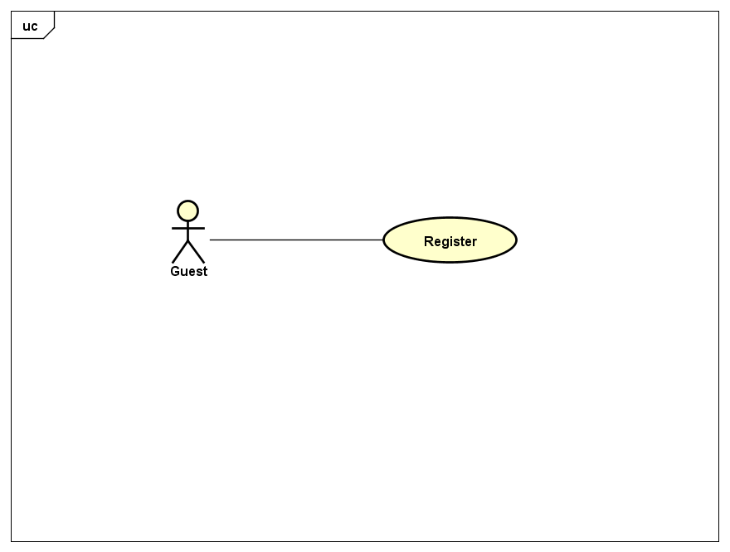

*Figure 7: User case level 1 – Guest.*

#### **3.2.3.2 Player**

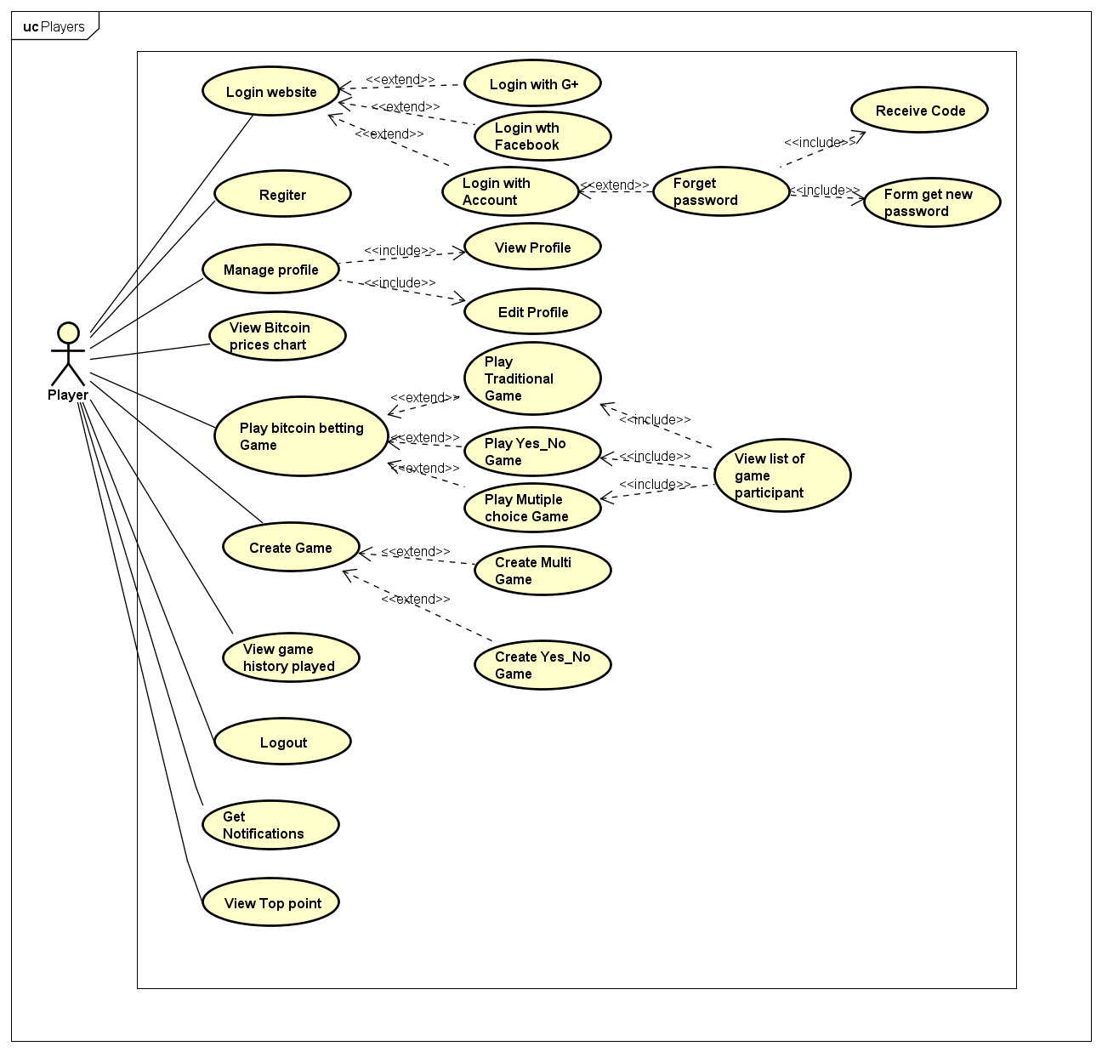

*Figure 8: User case level 1– Player.*

#### **3.2.3.3 Admin and Manager**

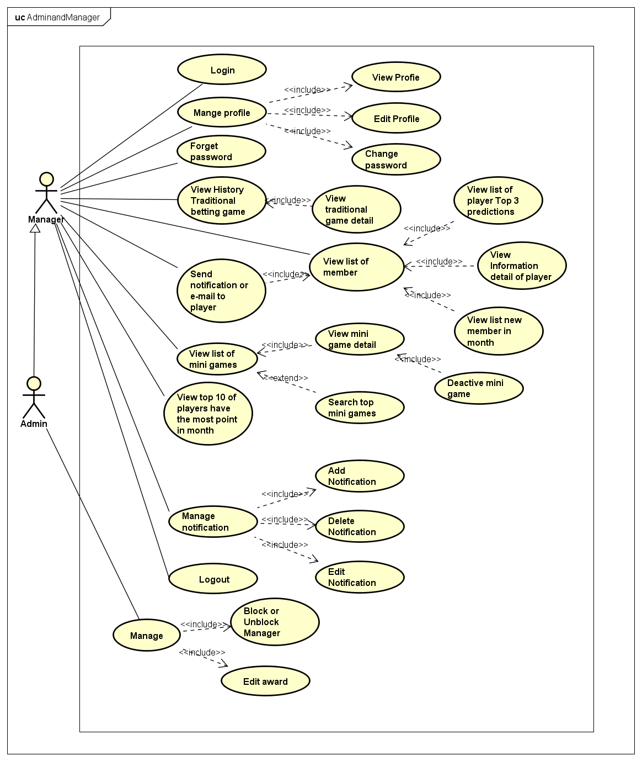

*Figure 9: User case level 1– Manager and Admin.*

## **3.3. System Requirement Specification.**

### **3.3.1. External Interface Requirement.**

#### **3.3.1.1 User Interface**

* Vietnamese is the official language of LowHope website.
* The main screen is familiar with the user.
* Each user interface element must be arranged logically, not overlapped over other, allowing user access easily.
* If any error occurs, the system displays a friendly error message.
* The interface is friendly with the user.

#### **3.3.1.2 Hardware Interfaces**

* All web browsers: Google chrome, Firefox, IE…

#### **3.3.1.3 Software Interfaces**

* LowHope run on Sublime Text 3 and My SQL.

#### **3.3.1.4 Constraints (Communications Protocol)**

* The scope of the project is not changed in the process of the project so time and funding of the project is unchanged.
* Must finish of the project work within 90 days.
* Must work within the available resources.
* The customer is not acceptable if the product delay of delivery 10 days, the product does quality, not conforming to the requirements will not be accepted.
* Risks relating to the project must be notified in advance.

### **3.3.2. System Use Case**

Below are the detail use cases for every user groups:



*Figure 9: User case level 1-Guest.*

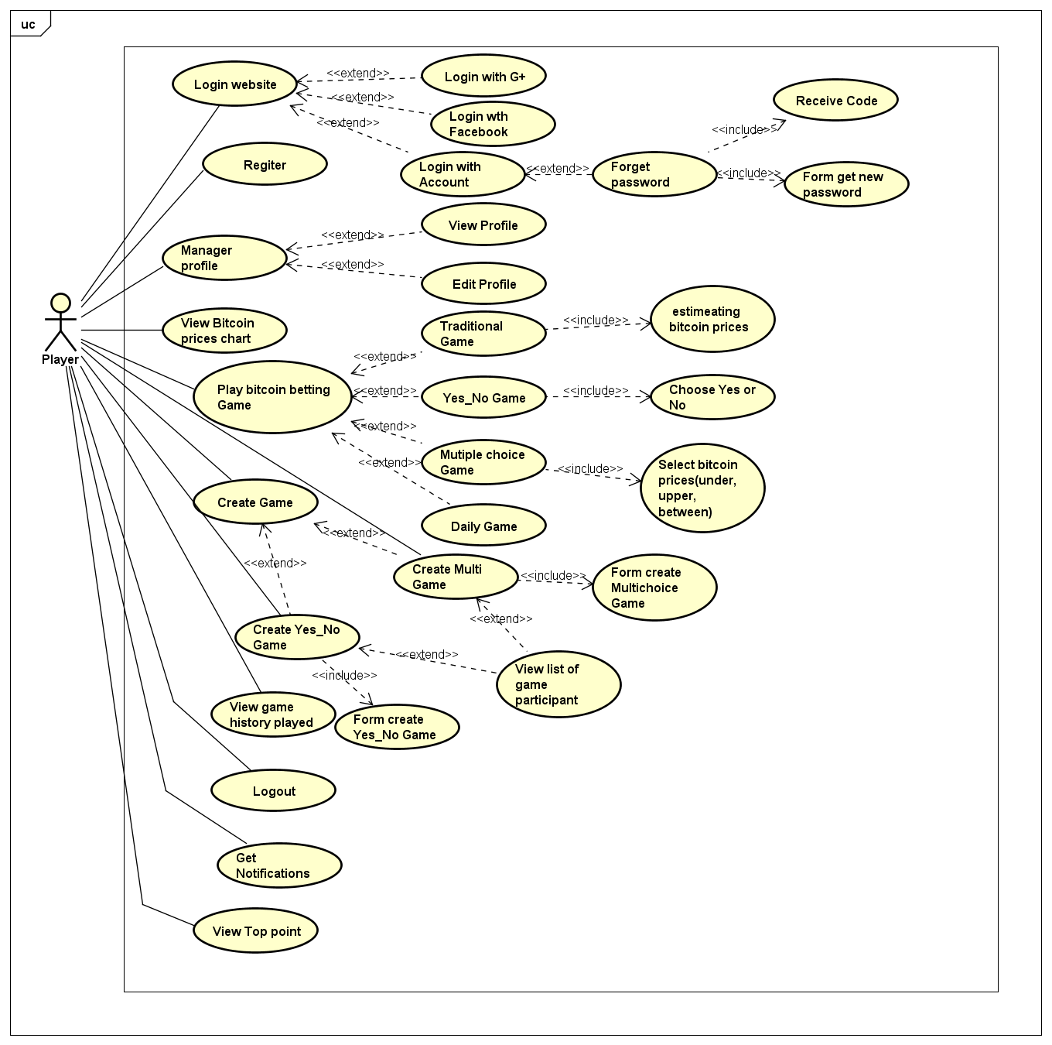

*Figure 10: User case level 2-Player*

**

*Figure 12: User case level 2-Admin and Manager*

### **3.3.3. List of Use Case**

|  |  |  |  |
| --- | --- | --- | --- |
| **No** | **Use case ID** | **Name** | **Primary Actor** |
|  | UC1.01 | Register | Guest |
|  | UC2.01 | Login | Player, Manager, Admin |
|  | UC2.02 | Forget password | Player |
|  | UC2.03 | Logout | Player, Manager, Admin |
|  | UC2.04 | View profile | Player, Manager, Admin |
|  | UC2.05 | Edit profile | Player, Manager, Admin |
|  | UC2.06 | View chart of bitcoin price | Player |
|  | UC2.07 | Play Traditional betting Game | Player |
|  | UC2.08 | Play Yes_No betting Game | Player |
|  | UC2.09 | Play Multichoice betting game | Player |
|  | UC2.10 | Create Yes_No betting game | Player |
|  | UC2.11 | Create Multichoice betting game | Player |
|  | UC2.12 | View list of participant in a game | Player |
|  | UC2.13 | View history of player | Player |
|  | UC2.14 | View notifications | Player |
|  | UC2.15 | View top points | Player |
|  | UC3.01 |  |  |
|  |  |  |  |
|  |  |  |  |
|  |  |  |  |
|  |  |  |  |
|  |  |  |  |
|  |  |  |  |
|  |  |  |  |

### **3.3.4. Business Rules**

|  |  |
| --- | --- |
| **No** | **Description** |
| **B01** | All of register textbox must not be empty. |
| **B02** | Strong passwords with min 8 - max 15 character length, at least one uppercase letter, one lowercase letter, one number, one special character (all, not just defined), space is not allowed. |
| **B03** | Phone number use for account must contains 10 or 11 numbers. And it must begin with “09” if contains 10 numbers and “01” if contains 11 numbers. |
| **B04** | Email use for account must be standard email form and exist. |
| **B05** | Google account must be exist to login. |
| **B06** | Facebook account must be exist to login. |
| **B07** | Bet amount must be greater than 0 |
| **B08** | Action must wait permission of admin or manager |
| **B09** | Banned account cannot login system. |
| **B10** | Verification code can only be used once. |
| **B11** | Player must have more than 100 points to play traditional betting game. |
| **B12** | Player are played traditional betting game when time of game is not over. |
| **B13** | The betting cost of a mini game is 10 points. |
| **B14** | A mini game allow only 40 players to play. |
| **B15** | Player mustn’t bet twice for a mini game. |
| **B16** | Player mustn’t play mini game is created by themselves. |
| **B17** | Players who want to create a mini game need to pay 50 points. |
| **B18** | Name of game must be valid. |
| **B19** | Manger can’t use Block or Unblock feature. |
| **B20** | Manger can’t use Edit Award feature. |

### **3.3.5. Use Case Specification**

*UC1 – 01 Register*

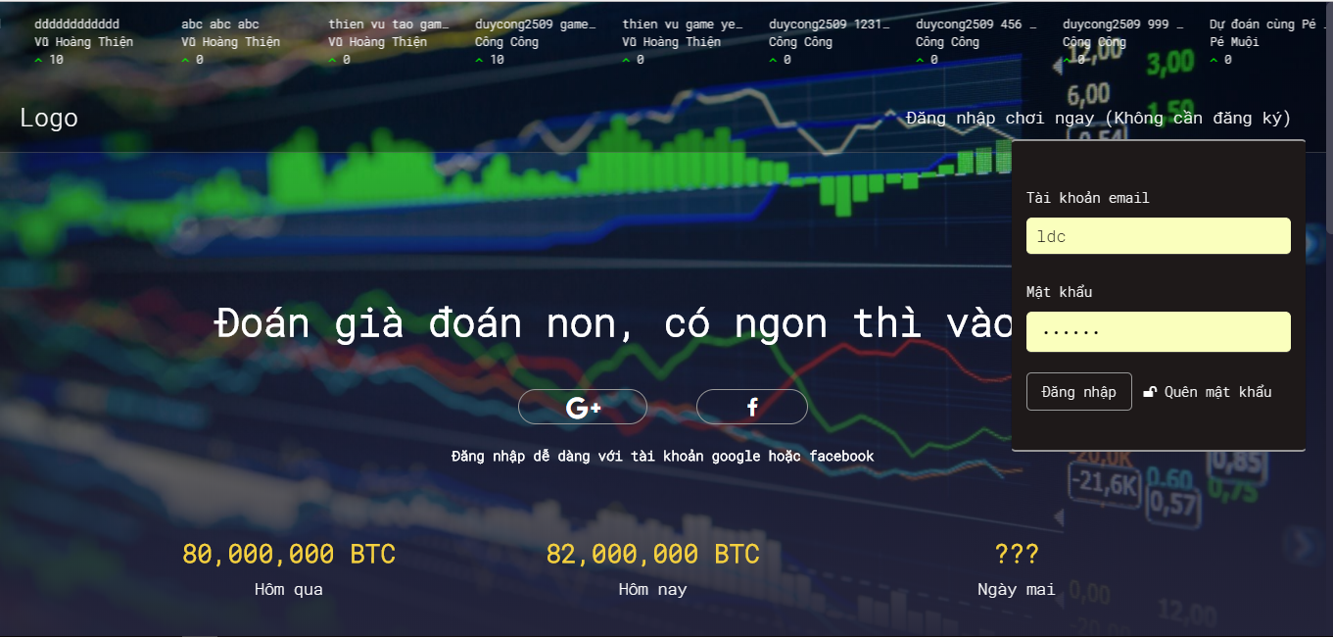

*Figure 11: Screen of UC1-01 Register*

|  |  |  |  |  |
| --- | --- | --- | --- | --- |
| **USE CASE-1 SPECIFICATION** : Register | | | | |
| **Use-case No.** | <UC1.01> | **Use-case Version** | | <1.0> |
| **Use-case Name** | Register | | | |
| **Author** | TungNT | | | |
| **Date** | 02/10/2017 | **Priority** | High | |
| **User:** Guest  **Summary:** The user uses this feature to register player account.  **Description:** Guest register an account to become player and login system to use.  **Goal:** Register account successfully.  **Triggers:** The user clicks on link “Đăng Nhập” in the login page.  **Preconditions:** Users must register with accurate personal information.  **Post Conditions:** The user has an account to login system.  **Main Success Scenario:**   |  |  | | --- | --- | | User | System | | 1. User clicks on link “Đăng Nhập” in the login page. |  | |  | 2. Login to LowHope website | | 3. User fill information in corresponding textbox and click on button “Đăng nhập”. |  | |  | 4. Check input information and Login to LowHope website |   **Alternative Scenario:** N/A  **Exceptions:**   |  |  | | --- | --- | | User | System | | 3. User does not fill standard email form. |  | |  | 4. Display error message “Tài khoản email không đúng” | | 3. User use invalid password to register |  | |  | 4. Display error message “Độ dài mật khẩu tối thiểu từ 8 ký tự- tối đa 15 ký tự, ít nhất một chữ cái viết hoa, một chữ thường, một chữ số, một ký tự đặc biệt” |   **Relationships:** N/A  **Business Rules:** B01, B02, B04. | | | | |

*UC2 – 01 Login*

|  |  |  |  |  |
| --- | --- | --- | --- | --- |
| **USE CASE-2 SPECIFICATION** : Login | | | | |
| **Use-case No.** | <UC2.01> | **Use-case Version** | | <1.0> |
| **Use-case Name** | Login | | | |
| **Author** | TungNT | | | |
| **Date** | 02/10/2017 | **Priority** | High | |
| **User:** Admin, Manager, Player.  **Summary:** The user uses this feature to login account.  **Description:** User fill email and password or user can use facebook account; google+ account to login into LowHope website.  **Goal:** Login account successfully.  **Triggers:** The user clicks on “Đăng nhập” in the login page. User can clicks on facebook or google+ account in the login page.  **Preconditions:** Users must have account in system or user have a facebook or google+ account.  **Post Conditions:** Display page matching each role account.  **Main Success Scenario:**   |  |  | | --- | --- | | User | System | | 1. User clicks on button “facebook” or “G+” in the page |  | |  | 2. Display a page to choose facebook account or google+ account. | | 3. User choose facebook account or google+ account and click on account |  | |  | 4. Accept the user to login system. | | 5 User fill email and password in login form and clicks on button “Đăng nhập” in this form. |  | |  | 6. Accept the user to login system. |   **Alternative Scenario:** N/A  **Exceptions:**   |  |  | | --- | --- | | User | System | | 5. User use invalid username or invalid password to login. |  | |  | 6. Display error message “tài khoản email không đúng; sai password vui lòng thử lại sau”. | | 5. User does not fill the username to login |  | |  | 6. Display error message “Bạn chưa điền tên tài khoản” | | 5. User does not fill the password to login |  | |  | 6. Display error message “Bạn chưa điền mật khẩu” |   **Relationships:** N/A  **Business Rules:** B01, B02, B04, B05, B06, B09 | | | | |

*UC2 – 02 Forget password*



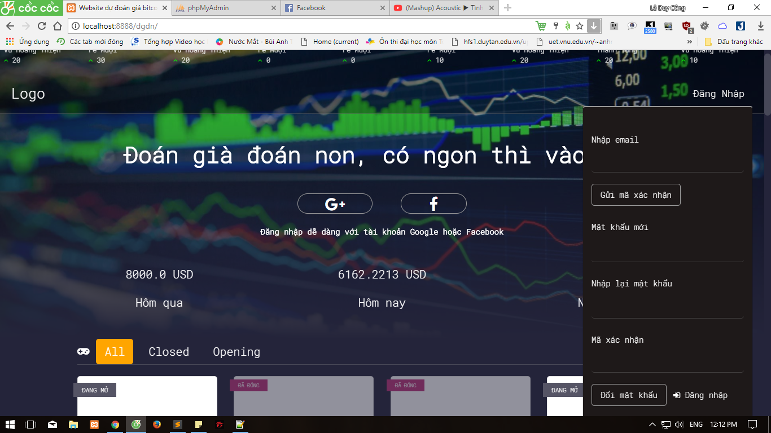

*Figure 12: Screen of UC2-02 Forget Password*

|  |  |  |  |  |
| --- | --- | --- | --- | --- |
| **USE CASE-3 SPECIFICATION** : Forget password | | | | |
| **Use-case No.** | <UC2.02> | **Use-case Version** | | <1.0> |
| **Use-case Name** | Forget password | | | |
| **Author** | TungNT | | | |
| **Date** | 02/10/2017 | **Priority** | High | |
| **User:** Player, Admin, Manager  **Summary:** The user uses this feature to get new password  **Goal:** Login account successfully.  **Description:** If user forget password, user can get new password.  **Triggers:** The user clicks on “Quên mật khẩu” in the login page.  **Preconditions:** Users must have account in system.  **Post Conditions:** Display forget password screen.  **Main Success Scenario:**   |  |  | | --- | --- | | User | System | | 1. User clicks on button “Quên mật khẩu” |  | |  | 2. Display forget password screen. | | 3. User fill valid email and clicks on button “Gửi mã xác nhận” in this form to give verification code. |  | |  | 4. Display successful sending verification code to user’s email | | 5 User fill new password; confirm new password and verification code then user clicks on button “Đổi mật khẩu” |  | |  | 6. Check information and display successful. |   **Alternative Scenario:** N/A  **Exceptions:**   |  |  | | --- | --- | | User | System | | 3. User use invalid email to get verification code. |  | |  | 4. Display error message “Email không hợp lệ”. | | 5. User fill invalid password |  | |  | 6. Display error message “Độ dài mật khẩu tối thiểu từ 8 ký tự- tối đa 15 ký tự, ít nhất một chữ cái viết hoa, một chữ thường, một chữ số, một ký tự đặc biệt”. | | 5. User fill confirm password incorrect. |  | |  | 6. Display error message “Mật khẩu mới và mật khẩu xác nhận không chính xác” | | 5.User fill verification code incorrect. |  | |  | 6. Display error message “Mã xác nhận không hợp lệ” |   **Relationships:** N/A  **Business Rules: B02, B04, B10** | | | | |

*UC2 – 03 Logout*

|  |  |  |  |  |
| --- | --- | --- | --- | --- |
| **USE CASE-4 SPECIFICATION** : Logout | | | | |
| **Use-case No.** | <UC2.03> | **Use-case Version** | | <1.0> |
| **Use-case Name** | Logout | | | |
| **Author** | Tungnt | | | |
| **Date** | 02/10/2017 | **Priority** | High | |
| **User:** Admin, Manager, Player.  **Summary:** The user uses this feature to logout account.  **Goal:** Logout account successfully.  **Description:** User logout website LowHope.  **Triggers:** The user clicks on button “Đăng xuất” in the page.  **Preconditions:** Users must login in system.  **Post Conditions:** Display login page.  **Main Success Scenario:**   |  |  | | --- | --- | | User | System | | 1. User clicks on button “Đăng xuất” in the page. |  | |  | 2. Display login page. |   **Alternative Scenario:** N/A  **Exceptions:** N/A  **Relationships:** N/A  **Business Rules:** N/A | | | | |

*UC2 – 04 View Profile*

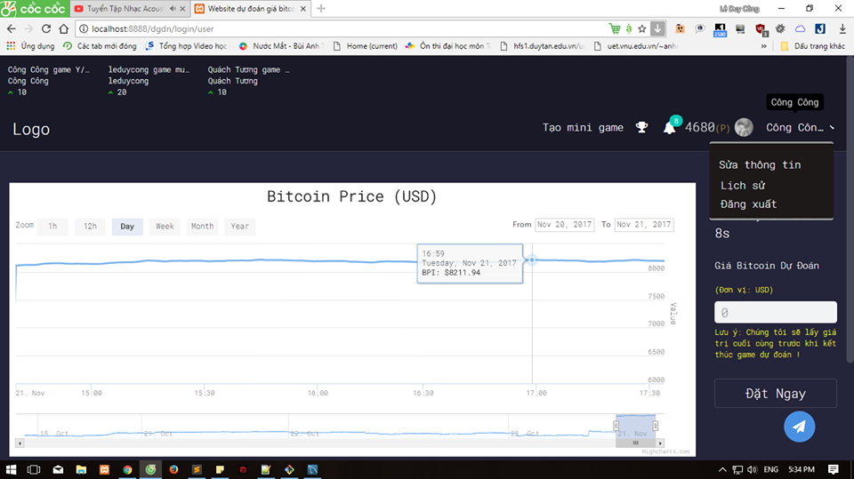

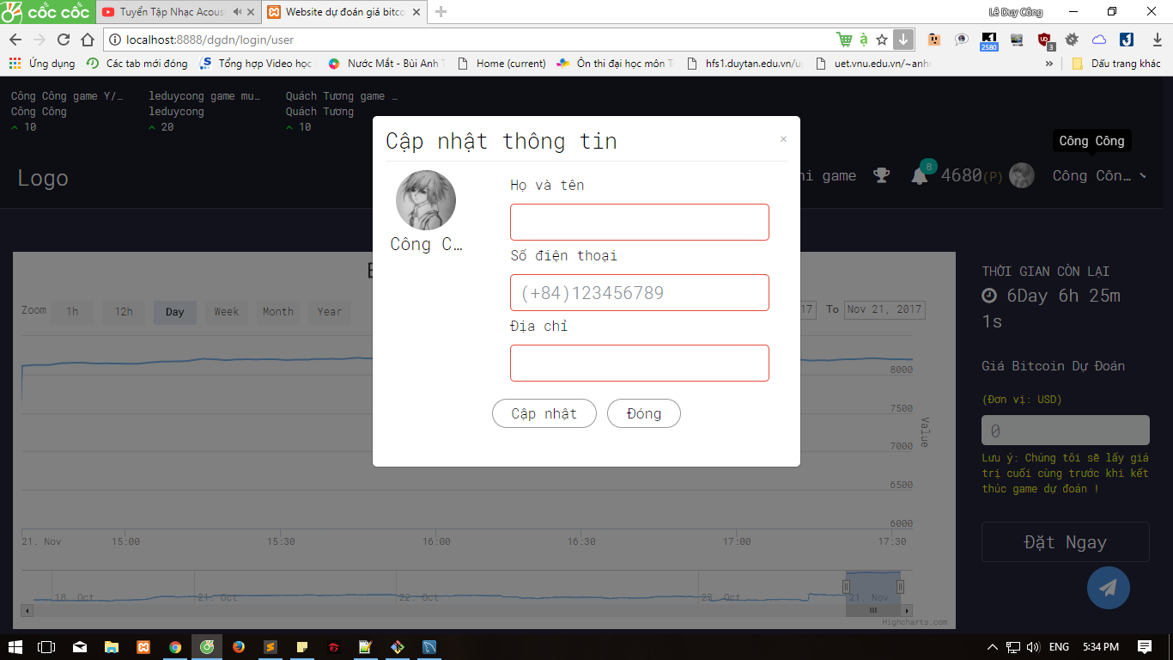

*Figure 13: Screen of UC2-04 View Profile*

|  |  |  |  |  |
| --- | --- | --- | --- | --- |
| **USE CASE-5 SPECIFICATION** : View Profile | | | | |
| **Use-case No.** | <UC2.04> | **Use-case Version** | | <1.0> |
| **Use-case Name** | View Profile | | | |
| **Author** | TungNT | | | |
| **Date** | 02/10/2017 | **Priority** | High | |
| **User:** Player, Admin, Manager.  **Summary:** The user uses this feature to view personal information.  **Goal:** View personal information.  **Description:** User view personal information.  **Triggers:** The user clicks on account name and select “Sửa thông tin” in the page.  **Preconditions:** Users must login in system.  **Post Conditions:** Display personal information screen.  **Main Success Scenario:**   |  |  | | --- | --- | | User | System | | 1. User clicks on account name option in the page and choose “Sửa thông tin” in the page. |  | |  | 2. Display personal information page. |   **Alternative Scenario:** N/A  **Exceptions:** N/A  **Relationships:** N/A  **Business Rules:** N/A | | | | |

*UC2 – 05 Edit Profile*

|  |  |  |  |  |
| --- | --- | --- | --- | --- |
| **USE CASE-6 SPECIFICATION** : Edit Profile | | | | |
| **Use-case No.** | <UC2.05> | **Use-case Version** | | <1.0> |
| **Use-case Name** | Edit profile | | | |
| **Author** | TungNT | | | |
| **Date** | 02/10/2017 | **Priority** | Low | |
| **User:** Player, Admin, Manager.  **Summary:** The user uses this feature to edit personal information.  **Goal:** Change personal information.  **Description:** User modify personal information.  **Triggers:** User clicks on account name option in the page and choose “Sửa thông tin” in the page.  **Preconditions:** Users must login in system.  **Post Conditions:** Display Edit personal information page.  **Main Success Scenario:**   |  |  | | --- | --- | | User | System | | 1. User clicks on account name option and choose “Sửa thông tin” in the page. |  | |  | 2. Display change personal information page. | | 3. User fill information want to change in corresponding textbox and click button “Cập nhật” |  | |  | 4. Check information and display notification. |   **Alternative Scenario:** N/A  **Exceptions:**   |  |  | | --- | --- | | User | System | | 3. User fill incorrect information. |  | |  | 4. Display incorrect information notification. |   **Relationships:** N/A  **Business Rules:** B03 | | | | |

*UC2 – 06 View Bitcoin price Chart*

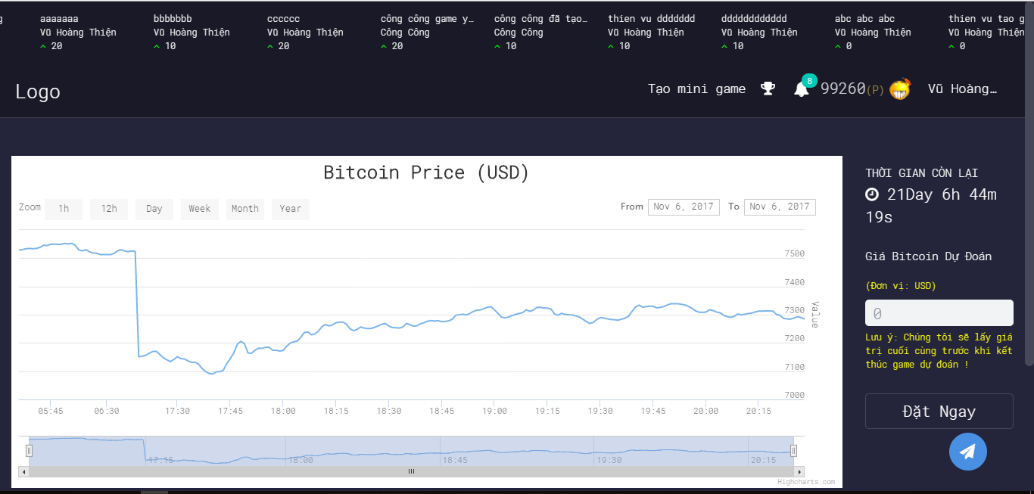

*Figure 14: Screen of UC2-06 View Bitcoin price chart*

|  |  |  |  |  |
| --- | --- | --- | --- | --- |
| **USE CASE-7 SPECIFICATION** : View Bitcoin Price Chart | | | | |
| **Use-case No.** | <UC2.06> | **Use-case Version** | | <1.0> |
| **Use-case Name** | View Bitcoin Price Chart | | | |
| **Author** | TungNT | | | |
| **Date** | 03/10/2017 | **Priority** | High | |
| **User:** Player  **Summary:** The user uses this feature to view bitcoin price chart.  **Goal:** View bitcoin price chart.  **Description:** Player view chart of bitcoin price.  **Triggers:** The user click on “Đăng nhập” or “Facebook”, “G+” to login into Home page then player will see the chart of bitcoin price.  **Preconditions:** Users must login in system.  **Post Conditions:** Display chart of bitcoin price.  **Main Success Scenario:**   |  |  | | --- | --- | | User | System | | 1. User click on “Đăng nhập” or “Facebook” , “G+” in the login page to go to Homepage |  | |  | 2. Display Home page and it will show chart of bitcoin price. |   **Alternative Scenario:** N/A  **Exceptions:** N/A  **Relationships:** N/A  **Business Rules:** N/A | | | | |

*UC2 – 07 Play Traditional Game*

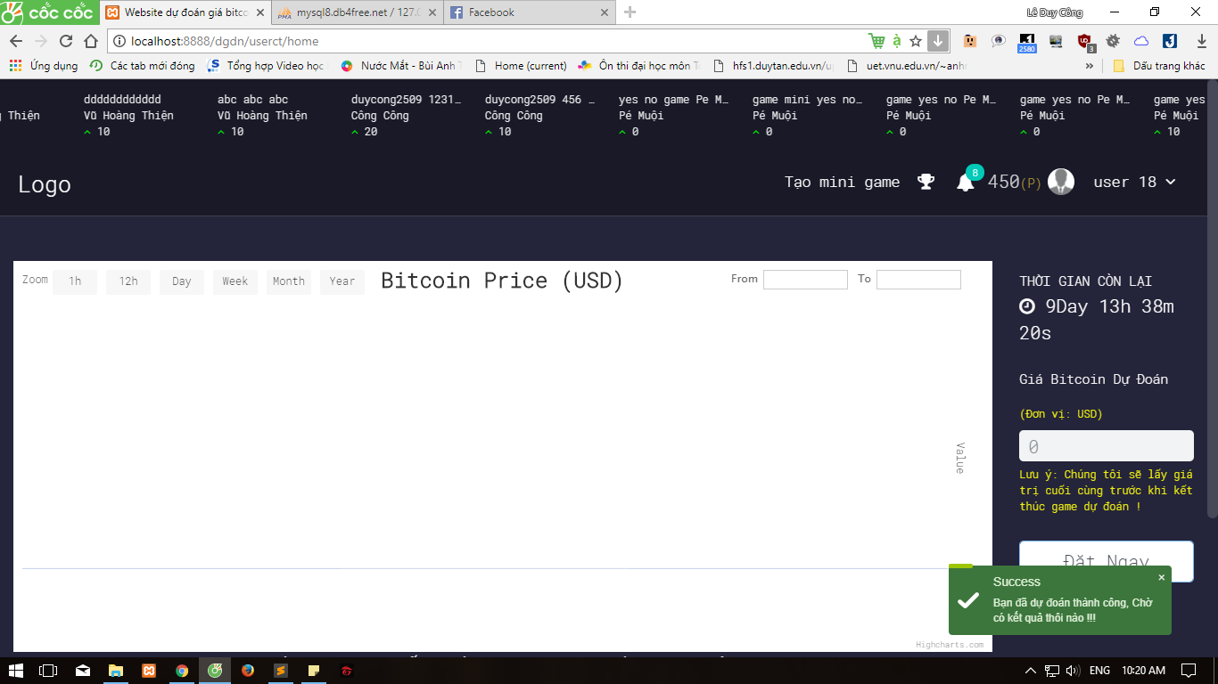

*Figure 15: Screen of UC2-07 Play Traditional Game*

|  |  |  |  |  |
| --- | --- | --- | --- | --- |
| **USE CASE-8 SPECIFICATION** : Play Traditional Game | | | | |
| **Use-case No.** | <UC2.07> | **Use-case Version** | | <1.0> |
| **Use-case Name** | Play Traditional Game | | | |
| **Author** | TungNT | | | |
| **Date** | 03/10/2017 | **Priority** | High | |
| **User:** Player  **Summary:** The player uses this feature to play traditional betting game. Game is played once a week. Winner of this game will receive attractive prizes.  **Goal:** Traditional betting game is played.  **Description:** Player play traditional betting game. The betting cost of a traditional betting game is 100 points. Game is played once a week. Winner of this game will receive attractive prizes.  **Triggers:** The user click on “Đăng nhập” or “Facebook”, “G+” to login into Home page then player will see the chart of bitcoin price and traditional betting game. Player are played traditional betting game when time of game is not over.  **Preconditions:** Player must login in system and time of game is not over. Player must have more than 100 points.  **Post Conditions:** Display Traditional betting game screen.  **Main Success Scenario:**   |  |  | | --- | --- | | User | System | | 1. Player click on “Đăng nhập” or “Facebook” , “G+” in the login page to go to Homepage |  | |  | 2. Display Home page and screen will show traditional betting game and chart of bitcoin price. | | 3. Game is played once a week. When time of game is not over. Player fill estimating bitcoin price then player wait time of game over. Player compare estimating bitcoin price with bitcoin price at time of game is over.  Player click button “. Player click button “ Đặt Ngay” to bet. |  | |  | 4. System confirm player’s estimating bitcoin price and display successfully notification “Bạn đã dự đoán thành công. Chờ có kết quả thôi nào”. |   **Alternative Scenario:** N/A  **Exceptions:**   |  |  | | --- | --- | | User | System | | 3. Player input estimating bitcoin price is less than 0 or character other number. |  | |  | 4. Display error message “Vui lòng nhập đúng định dạng trường dự đoán”. | | 3. Player estimated bitcoin price when time of game is over |  | |  |  |   **Relationships:** N/A  **Business Rules: B11, B07, B12** | | | | |

*UC2 – 08 Play Yes_No Game*

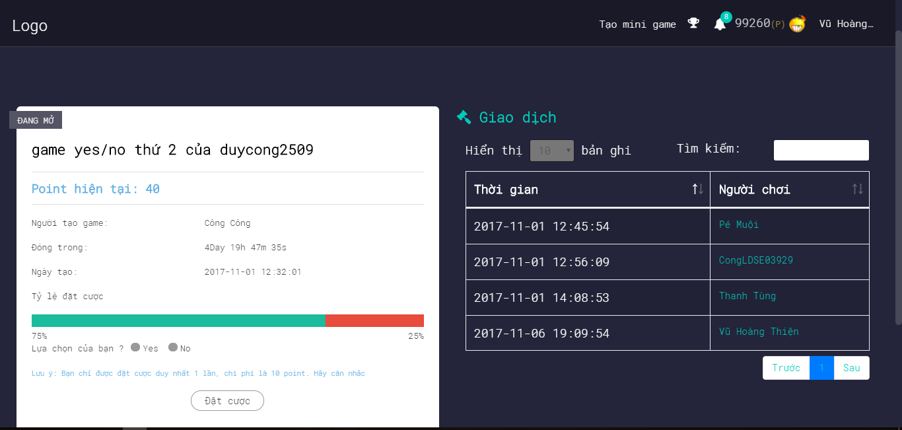

*Figure 16: Screen of UC2-08 Play Yes_No betting Game*

|  |  |  |  |  |
| --- | --- | --- | --- | --- |
| **USE CASE-9 SPECIFICATION** : Play Yes_No betting Game | | | | |
| **Use-case No.** | <UC2.08> | **Use-case Version** | | <1.0> |
| **Use-case Name** | Play Yes_No betting Game | | | |
| **Author** | TungNT | | | |
| **Date** | 03/10/2017 | **Priority** | High | |
| **User:** Player  **Summary:** The player uses this feature to play Yes_No betting game. Winner of this game will receive points to play traditional betting game.  **Goal:** Yes_No betting game is played.  **Description:** Player play Yes_No betting game. Yes_No betting game was created by a player. Players aren’t allowed to play games created by themselves. The betting cost of a Yes_No betting game is 10 points. If player win a game, player will be received 20 points. A game only allow 40 players to play game. Winner of this game will receive points to play traditional betting game.  **Triggers:** The user click on item infinite Slideshow “Yes_No game”. Player are played Yes_No betting game when time of this game is not over.  **Preconditions:** Player must login in system and time of this game is not over.  **Post Conditions:** Display Yes_No betting game screen.  **Main Success Scenario:**   |  |  | | --- | --- | | User | System | | 1. Player choose a Yes_No betting game on item infinite Slideshow then player click on item infinite Slideshow “Yes_No game” to go to Yes_No betting game screen |  | |  | 2. Display Yes_No betting game page | | 3. Player read question of game is chose by this player then player select “Yes” or “No” based on question of this game. The betting cost of a Yes_No betting game is 10 points. If player win a game, player will be received 20 points. Player click button “ Đặt Cược” to bet.  A game only allow 40 players to play game. |  | |  | 4. System confirm player’s choice and display successfully notification “Bạn đã dự đoán thành công. Chờ có kết quả thôi nào”. |   **Alternative Scenario:** N/A  **Exceptions:**   |  |  | | --- | --- | | User | System | | 3. Player bets twice for a Yes_No betting game. |  | |  | 4. Display error message “Bạn đã đặt cược game này! Vui long chọn game khác để chơi”. | | 3. Players play Yes_No betting game is created by themselves. |  | |  | 4. Display error message “Bạn không được chơi game do mình tạo ra”. | | 3. Player play a game but this game has been enough players (40 players/a game). |  | |  | 4. Display message ”Rất tiếc game này đã đủ người chơi. Vui long chọn game khác để chơi” |   **Relationships:** N/A  **Business Rules: B12, B13, B14, B15, B16** | | | | |

*UC2 – 09 Play MultiChoice Game*

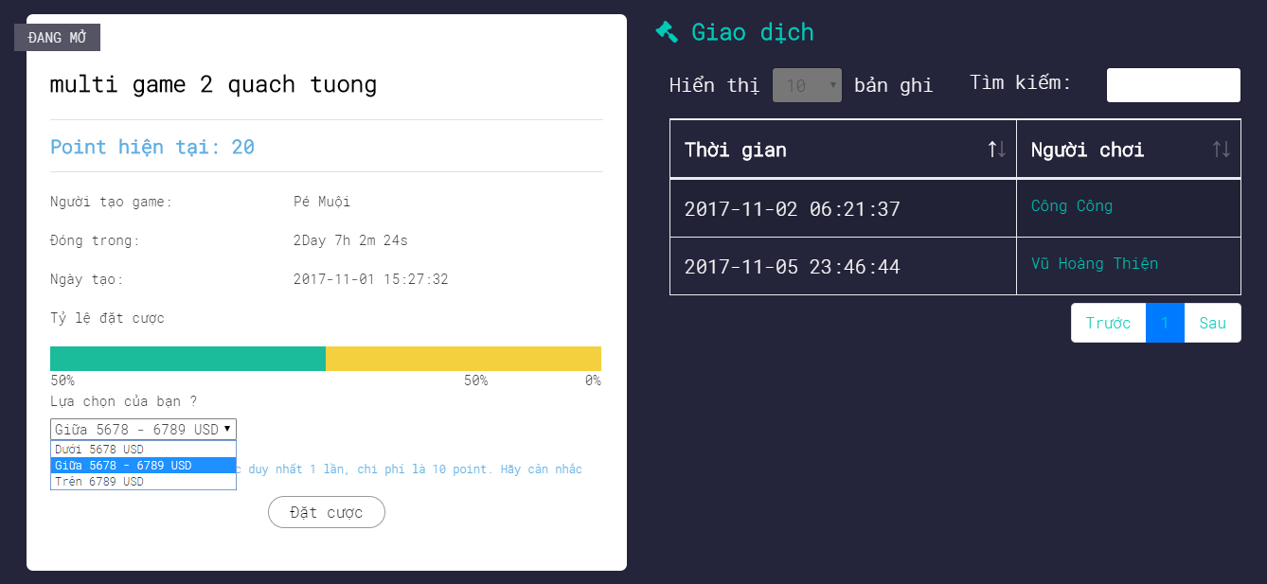

*Figure 17: Screen of UC2-09 Play MultiChoice betting Game*

|  |  |  |  |  |
| --- | --- | --- | --- | --- |
| **USE CASE-10 SPECIFICATION** : Play MultiChoice betting Game | | | | |
| **Use-case No.** | <UC2.09> | **Use-case Version** | | <1.0> |
| **Use-case Name** | Play MultiChoice betting Game | | | |
| **Author** | TungNT | | | |
| **Date** | 03/10/2017 | **Priority** | High | |
| **User:** Player  **Summary:** The player uses this feature to play Multichoice betting game. Winner of this game will receive points to play traditional betting game.  **Goal:** Multichoice betting game is played.  **Description:** Player play Multichoice betting game. Multichoice betting game was created by a player. Players aren’t allowed to play games created by themselves. The betting cost of a Multichoice betting game is 10 points. If player win a game, player will be received 20 points. A game only allow 40 players to play game. Winner of this game will receive points to play traditional betting game.  **Triggers:** The user click on item infinite Slideshow “Multichoice game”. Player are played Multichoice betting game when time of this game is not over.  **Preconditions:** Player must login in system and time of this game is not over.  **Post Conditions:** Display Multichoice betting game screen.  **Main Success Scenario:**   |  |  | | --- | --- | | User | System | | 1. Player choose a Multichoice betting game on item infinite Slideshow then player click on item infinite Slideshow “Multichoice game” to go to Multichoice betting game screen |  | |  | 2. Display Multichoice betting game page | | 3. Player read question of game is chose by this player then player select “under” or “upper” or “between” based on question of this game. The betting cost of a Multichoice betting game is 10 points. If player win a game, player will be received 20 points. Player click button “ Đặt Cược” to bet.  A game only allow 40 players to play game. |  | |  | 4. System confirm player’s choice and display successfully notification “Bạn đã dự đoán thành công. Chờ có kết quả thôi nào”. |   **Alternative Scenario:** N/A  **Exceptions:**   |  |  | | --- | --- | | User | System | | 3. Player bets twice for a Multichoice betting game. |  | |  | 4. Display error message “Bạn đã đặt cược game này! Vui long chọn game khác để chơi”. | | 3. Players play Multichoice betting game is created by themselves. |  | |  | 4. Display error message “Bạn không được chơi game do mình tạo ra”. | | 3. Player play a game but this game has been enough players (40 players/a game). |  | |  | 4. Display message ”Rất tiếc game này đã đủ người chơi. Vui long chọn game khác để chơi”. |   **Relationships:** N/A  **Business Rules: B12, B13, B14, B15, B16** | | | | |

*UC2 – 10 Create Yes_No betting Game*



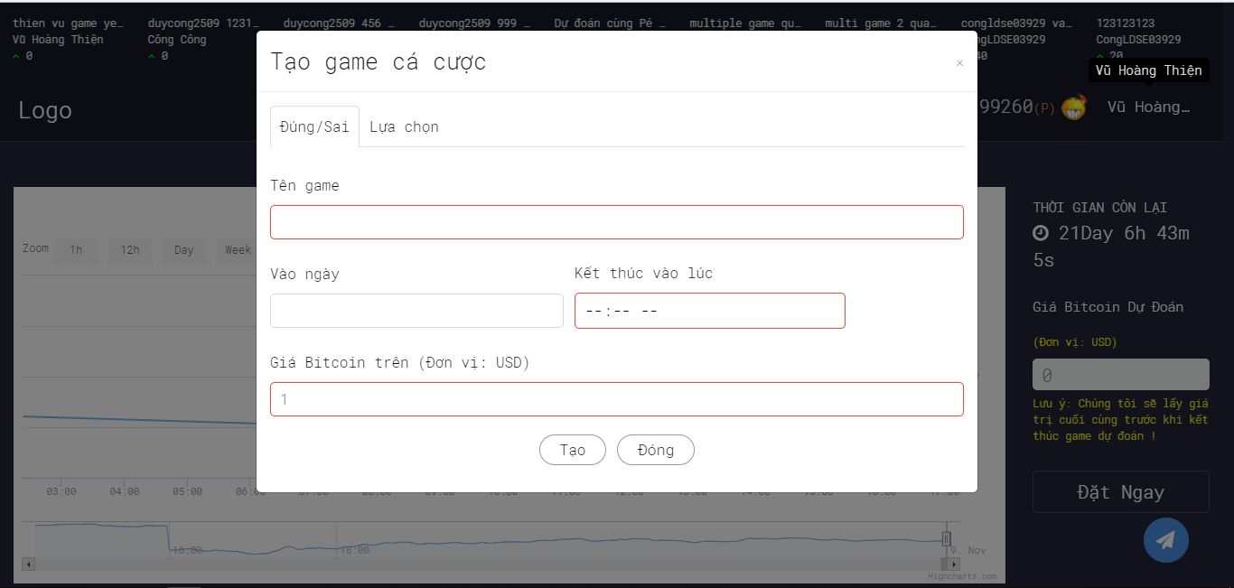

*Figure 18: Screen of UC2-10 Create Yes_No betting Game*

|  |  |  |  |  |
| --- | --- | --- | --- | --- |
| **USE CASE-11 SPECIFICATION** : Create Yes_No betting Game | | | | |
| **Use-case No.** | <UC2.10> | **Use-case Version** | | <1.0> |
| **Use-case Name** | Create Yes_No betting Game | | | |
| **Author** | TungNT | | | |
| **Date** | 03/10/2017 | **Priority** | High | |
| **User:** Player  **Summary:** The player uses this feature to Create Yes_No betting game for everyone to play.  **Goal:** Create Yes_No betting game is created.  **Description:** Player create Yes_No betting game for everyone to play. Players who want to create a Yes_No betting game need to pay 50 points. If player win a game, creator of game will be lost 20 points to a winner  **Triggers:** The player click on link “Tạo Mini game” in the home page to go to game creating form then player click link “Đúng/Sai” into Yes_No betting game creating form.  **Preconditions:** Player must login in system and Player must be at least 50 points to create Yes_No betting game.  **Post Conditions:** Display Yes_No betting game creation form.  **Main Success Scenario:**   |  |  | | --- | --- | | User | System | | 1. Player click link “Tạo mini name” in the homepage to go to game creating form then Player click link “Đúng/Sai” to go to Yes_No betting game creating form. |  | |  | 2. Display Yes_No betting game creating form. | | 3. When time of game is not over. Player fill name of game “Tên game”, start date of game “Vào ngày” and end time “Kết thúc vào lúc” then player fill estimating bitcoin price is increase “Giá bitcoin trên (Đơn vị: USD)”.  Player click button “Taọ” to create game.  If player win a game, creator of game will be lost 20 points to a winner |  | |  | 4. System confirm player’s game creating and display successfully notification “Chúc mừng bạn đã tạo game thành công”. | | 5. Player click “Đóng” to close form. |  | |  | 6. System display into Homepage. |   **Alternative Scenario:** N/A  **Exceptions:**   |  |  | | --- | --- | | User | System | | 3. Player fill invalid name of game. |  | |  | 4. Display error message “Tên game phải chứa từ 6 đến 35 ký tự”. | | 3. Player input “Giá bitcoin trên (Đơn vị : USD) is less than 0 or character other number. |  | |  | 4. Display error message “Giá Bitcoin không đúng định dạng ”. |   **Relationships:** N/A  **Business Rules: B08, B17, B18** | | | | |

*UC2 – 11 Create Multichoice betting Game*



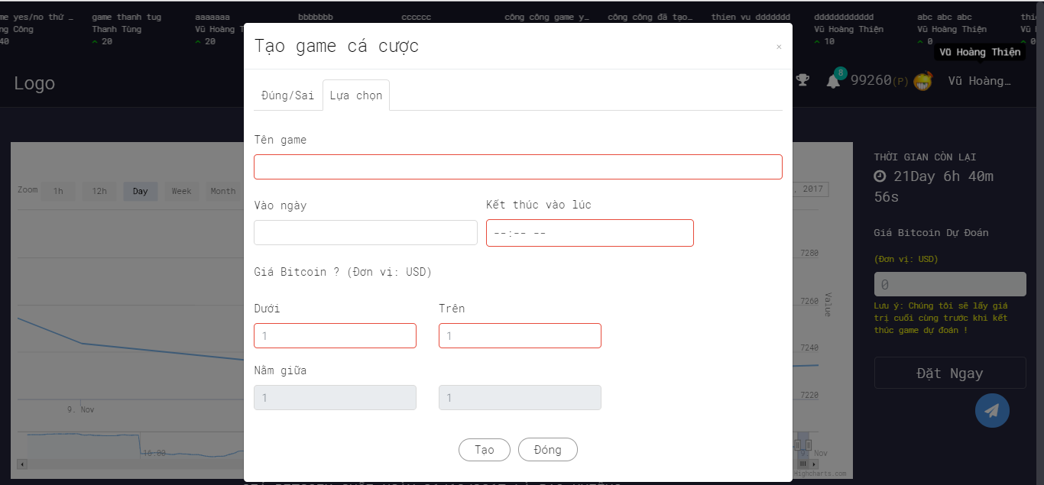

*Figure 19: Screen of UC2-11 Create Multichoice betting Game*

|  |  |  |  |  |
| --- | --- | --- | --- | --- |
| **USE CASE-12 SPECIFICATION** : Create Multichoice betting Game | | | | |
| **Use-case No.** | <UC2.11> | **Use-case Version** | | <1.0> |
| **Use-case Name** | Create Multichoice betting Game | | | |
| **Author** | TungNT | | | |
| **Date** | 03/10/2017 | **Priority** | High | |
| **User:** Player  **Summary:** The player uses this feature to Create Multichoice betting game for everyone to play.  **Goal:** Create Multichoice betting game is created.  **Description:** Player create Multichoice betting game for everyone to play. Players who want to create a Multichoice betting game need to pay 50 points. If player win a game, creator of game will be lost 20 points to a winner.  **Triggers:** The player click on link “Tạo Mini game” in the home page to go to game creating form then player click link “lựa chọn” into Multichoice betting game creating form.  **Preconditions:** Player must login in system and Player must be at least 50 points to create Multichoice betting game.  **Post Conditions:** Display Multichoice betting game creation form.  **Main Success Scenario:**   |  |  | | --- | --- | | User | System | | 1. Player click link “Tạo mini name” in the homepage to go to game creating form then Player click link “Lựa chọn” to go to Multichoice betting game creating form. |  | |  | 2. Display Multichoice betting game creating form. | | 3. When time of game is not over. Player fill name of game “Tên game”, start date of game “Vào ngày” and end time “Kết thúc vào lúc” then player fill estimating bitcoin price is increase “Giá bitcoin trên (Đơn vị: USD)”.  Player click button “Taọ” to create game. |  | |  | 4. System confirm player’s game creating and display successfully notification “Chúc mừng bạn đã tạo game thành công”. | | 5. Player click “Đóng” to close form. |  | |  | 6. System display into Homepage. |   **Alternative Scenario:** N/A  **Exceptions:**   |  |  | | --- | --- | | User | System | | 3. Player fill invalid name of game. |  | |  | 4. Display error message “Tên game phải chứa từ 6 đến 35 ký tự”. | | 3. Player input “Giá bitcoin trên (Đơn vị : USD) is less than 0 or character other number. |  | |  | 4. Display error message “Giá Bitcoin không đúng định dạng”. |   **Relationships:** N/A  **Business Rules: B08, B17, B18** | | | | |

*UC2 – 12 View list of participant in a game.*



*Figure 20: Screen of UC2-12 Vỉew list of game participant.*

|  |  |  |  |  |
| --- | --- | --- | --- | --- |
| **USE CASE-13 SPECIFICATION**: View History of participants in a game. | | | | |
| **Use-case No.** | <UC2.11> | **Use-case Version** | | <1.0> |
| **Use-case Name** | View History of participants in a game. | | | |
| **Author** | TungNT | | | |
| **Date** | 03/10/2017 | **Priority** | High | |
| **User:** Player  **Summary:** The player uses this feature to view list of participants in a game.  **Goal:** Player view who has participated in this game.  **Description:** Player view who have participated betting in a game (Multichoice betting game or Yes_No betting game).  **Triggers:** Player must choose a betting bitcoin game (Multichoice betting game or Yes_No betting game) to view who has participated in this game. The player click on item infinite Slideshow a game. Player are viewed who have participated betting in a game when time of this game is not over.  **Preconditions:** Player must login in system and time of this game is not over.  **Post Conditions:** Display list of players who have participated betting in a game screen.  **Main Success Scenario:**   |  |  | | --- | --- | | User | System | | 1. Player choose a betting game on item infinite Slideshow then player click on item infinite Slideshow “name of game to go to list of players have participated betting in a game screen. |  | |  | 2. Display list of players have participated betting in a game screen. | | 3. When time of game is not over. Player view right side of screen is a table consisting of two columns that are time column and participant column. This table include list of players who participated in this game. |  | |  | 4. System display list of players have participated betting in this game. | | 5. Player can search players who participated in this game by name or time. |  | |  | 6. System display into Homepage. |   **Alternative Scenario:** N/A  **Exceptions:** N/A  **Relationships:** N/A  **Business Rules:** N/A | | | | |

*UC2 – 13 View history of player*

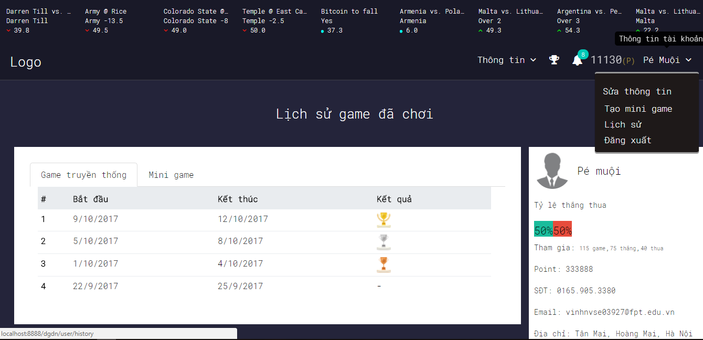

*Figure 21: Screen of UC2-13 View history of player*

|  |  |  |  |  |
| --- | --- | --- | --- | --- |
| **USE CASE-14 SPECIFICATION** : View History of player | | | | |
| **Use-case No.** | <UC2.13> | **Use-case Version** | | <1.0> |
| **Use-case Name** | View history of player | | | |
| **Author** | TungNT | | | |
| **Date** | 04/10/2017 | **Priority** | High | |
| **User:** Player.  **Summary:** The use uses this feature to view history of games are played by player.  **Goal:** View history of games are played by player.  **Description:** Player View history of games are played by player.  **Triggers:** User clicks on account name option in the homepage and choose “Lịch sử” in the homepage then Player clicks link “Game truyền thống” to view to view history of traditional bitcoin betting games are played and player clicks “Mini game” to view history of mini games are played by player.  **Preconditions:** Users must login in system.  **Post Conditions:** Display history of games are played of player page.  **Main Success Scenario:**   |  |  | | --- | --- | | User | System | | 1. Player clicks on account name option and choose “Lịch Sử” in the Homepage. |  | |  | 2. Display history of games are played of player Page. | | 3. Player clicks link “Game truyền thống” to view to view history of traditional bitcoin betting games are played |  | |  | 4. Display history table of traditional bitcoin betting games are played. Table consisting of start time, end time and award. | | 5. Player clicks link “Mini game” to view to view history of Mini games are played |  | |  | 6. Display history table of traditional bitcoin betting games are played. Table consisting of start time, end time and award. |   **Alternative Scenario:** N/A  **Exceptions:** N/A  **Relationships:** N/A  **Business Rules:** N/A | | | | |

*UC2 – 14 View Notifications*

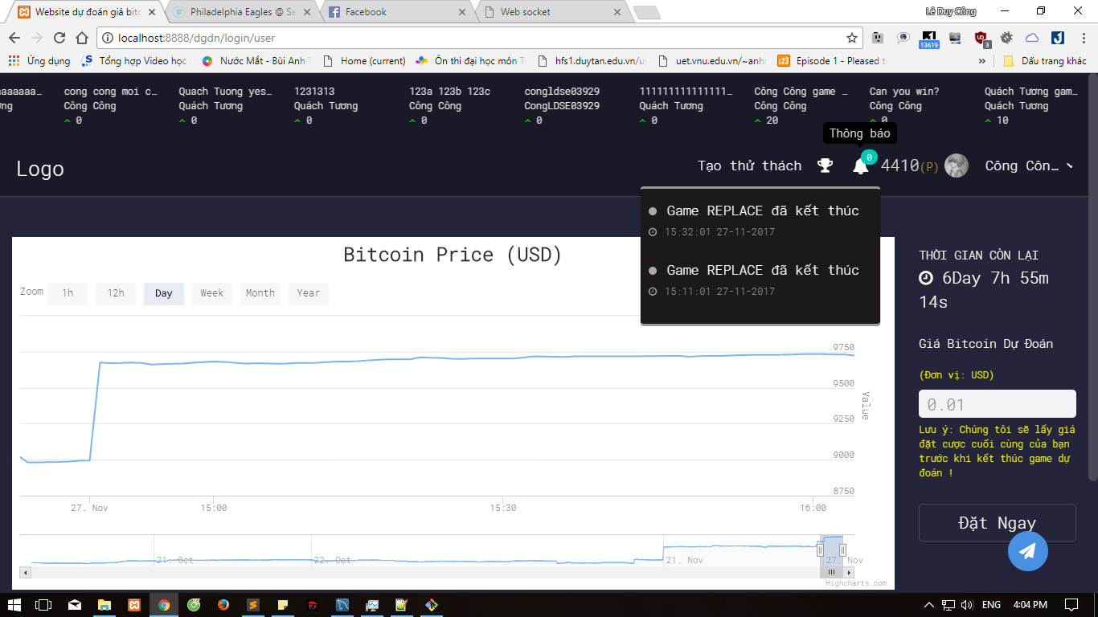

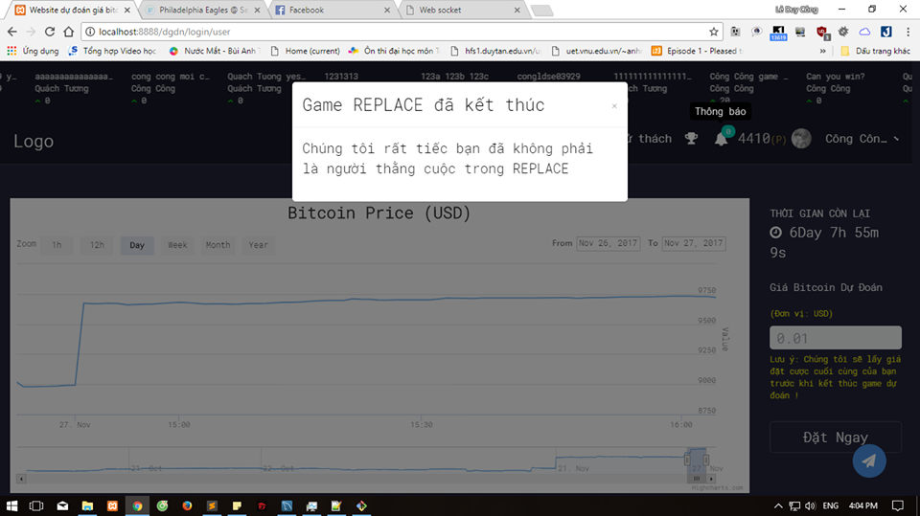

*Figure 22: Screen of UC2-14 View notification*

|  |  |  |  |  |
| --- | --- | --- | --- | --- |
| **USE CASE-15 SPECIFICATION** : View Notification | | | | |
| **Use-case No.** | <UC2.14> | **Use-case Version** | | <1.0> |
| **Use-case Name** | View Notification | | | |
| **Author** | TungNT | | | |
| **Date** | 04/10/2017 | **Priority** | Low | |
| **User:** Player.  **Summary:** The use uses this feature to view notification of manager sent a player.  **Goal:** View notification of manager.  **Description:** Player View notification of manager sent a player.  **Triggers:** Player clicks icon “Thông báo” in homepage then player chooses a notification to view.  **Preconditions:** Player must login in system and manager has sent a notification for player.  **Post Conditions:** Display list of notification of a player.  **Main Success Scenario:**   |  |  | | --- | --- | | User | System | | 1. Player clicks on icon “thông báo” in the homepage |  | |  | 2. Display list of notification of a player Popup. | | 3. Player choose a notification then player click on it to view. |  | |  | 4. Display notification details Popup. | | 5. If player don’t have a notification. |  | |  | 6. Display message “Không có thông báo nào để xem”. |   **Alternative Scenario:** N/A  **Exceptions:** N/A  **Relationships:** N/A  **Business Rules:** N/A | | | | |

*UC2 – 15 View Top points*



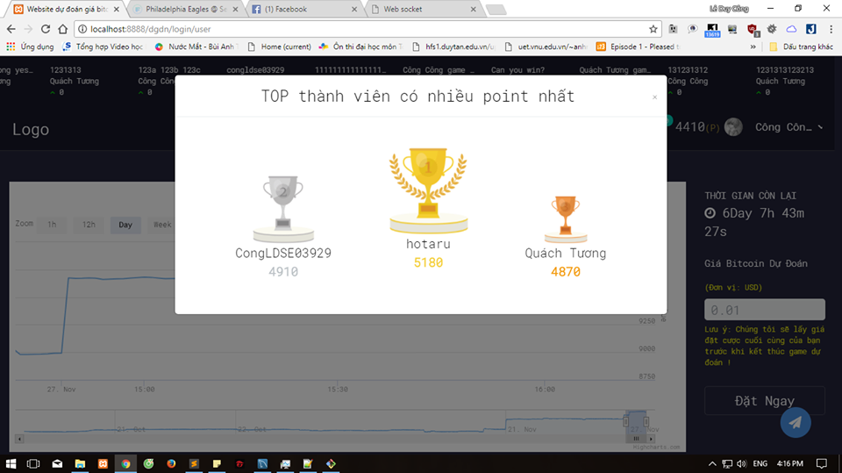

*Figure 23: Screen of UC2-15 View Top point*

|  |  |  |  |  |
| --- | --- | --- | --- | --- |
| **USE CASE-16 SPECIFICATION** : View Top points | | | | |
| **Use-case No.** | <UC2.15> | **Use-case Version** | | <1.0> |
| **Use-case Name** | View Top point | | | |
| **Author** | TungNT | | | |
| **Date** | 04/10/2017 | **Priority** | Low | |
| **User:** Player.  **Summary:** The use uses this feature to view top point  **Goal:** Player view top of players have the most point.  **Description:** Player view top of players have the most point with rank 1, 2 and 3.  **Triggers:** Player clicks icon “Top point” in the homepage  **Preconditions:** Player must login in system.  **Post Conditions:** Display list of player have the most points with rank 1, 2 and 3.  **Main Success Scenario:**   |  |  | | --- | --- | | User | System | | 1. Player clicks on icon “top point” in the homepage |  | |  | 2. Display list of player have the most points with rank 1, 2 and 3 Popup. |   **Alternative Scenario:** N/A  **Exceptions:** N/A  **Relationships:** N/A  **Business Rules:** N/A | | | | |

*UC3 – 01 Send Notification or Email to Player.*

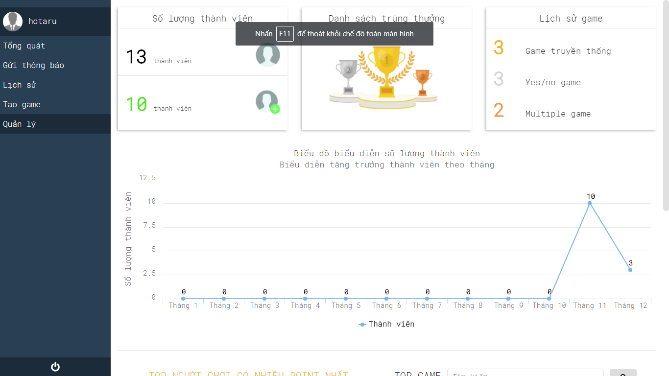

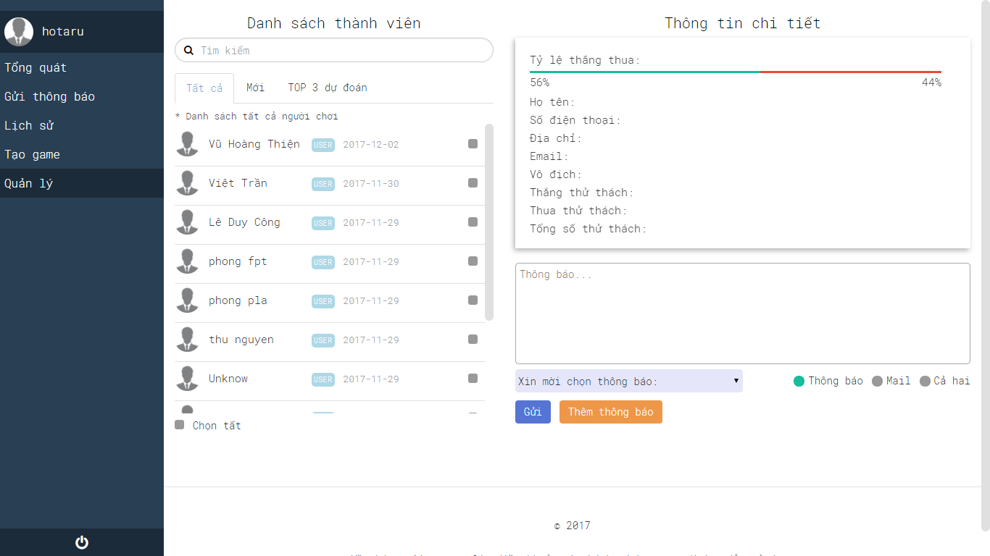

*Figure 24: Screen of UC3-01 Send Notification or Email to player*

|  |  |  |  |  |
| --- | --- | --- | --- | --- |
| **USE CASE-17 SPECIFICATION** : Send Notification or Email to player | | | | |
| **Use-case No.** | <UC3.01> | **Use-case Version** | | <1.0> |
| **Use-case Name** | Send Notification or Email to player | | | |
| **Author** | TungNT | | | |
| **Date** | 06/10/2017 | **Priority** | Low | |
| **User:** Admin, Manager.  **Summary:** The actor uses this feature to send notification or Email to player  **Goal:** Send notification or email to player successfully.  **Description:** The actor send notification or Email to player.  **Triggers:** The actor click on link “Gửi thông báo” in the homepage to go to Notification page. Actor choose players then select a notification to send and actor click on button “Gửi”.  **Preconditions:** Actor must login in system and Account of user must be admin or manager account.  **Post Conditions:** Send notification or email to player successfully.  **Main Success Scenario:**   |  |  | | --- | --- | | User | System | | 1. On sidebar menu actor clicks on link “Gửi thông báo” in the homepage |  | |  | 2. Display notification page. | | 3. On sidebar menu actor choose players then actor select a notification to send. If actor want to send email, actor click on “Mail”. |  | |  | 4. Display message success “Gửi thông báo thành công” |   **Alternative Scenario:** N/A  **Exceptions:**   |  |  | | --- | --- | | User | System | | 3. The actor don’t choose player before sending. |  | |  | 4. Display message “Bạn chưa lựa chọn người gửi thông báo” | | 3. The actor don’t select a notification before sending. |  | |  | 4. Display message “Tin nhắn gửi đi không được trống” |   **Relationships:** N/A  **Business Rules:** | | | | |

*UC3 – 02 View History Traditional betting game.*

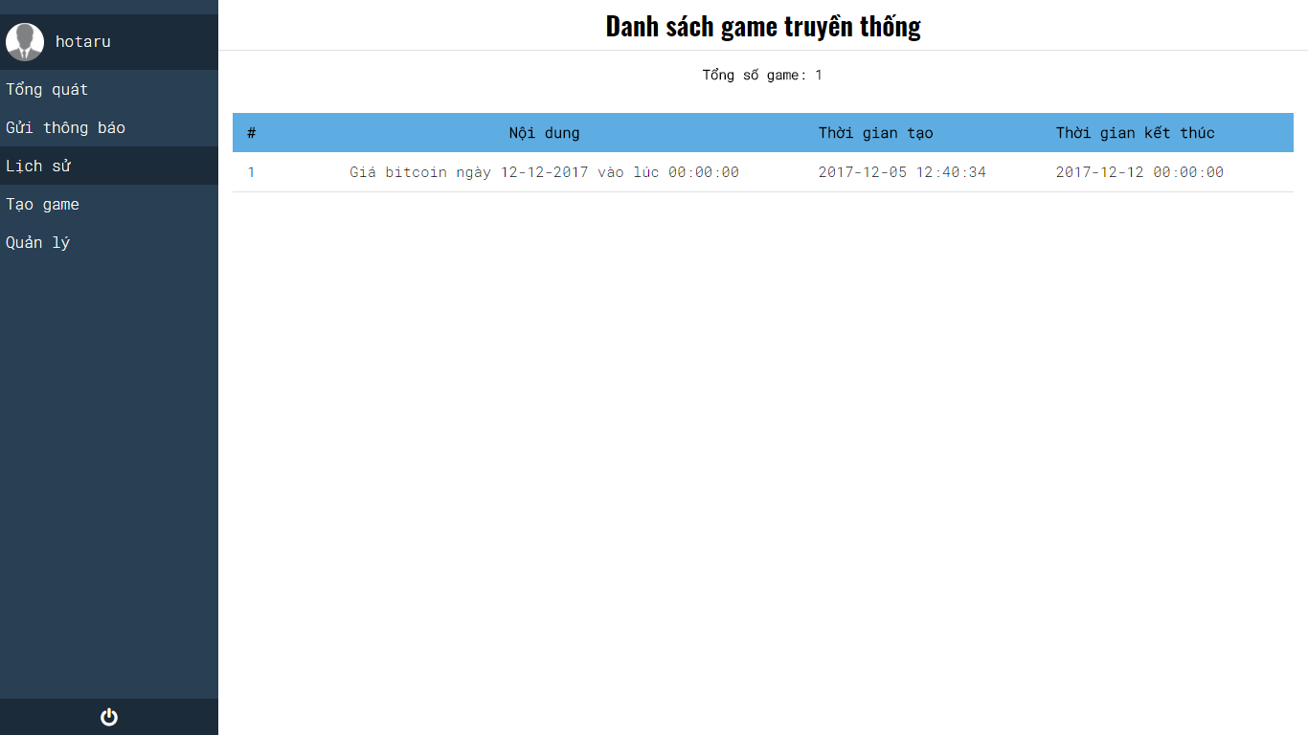

|  |  |  |  |  |
| --- | --- | --- | --- | --- |
| **USE CASE-18 SPECIFICATION** : View History Traditional Games | | | | |
| **Use-case No.** | <UC3.02> | **Use-case Version** | | <1.0> |
| **Use-case Name** | View History Traditional Games | | | |
| **Author** | VinhNV | | | |
| **Date** | 06/10/2017 | **Priority** | High | |
| **User:** Manager, Admin  **Summary:** This feature will display all of games which already created  **Goal:** Display all of games which already created  **Description:** This feature will display all of games which already created  **Triggers:** The manager clicks on link “Lịch sử” in the sidebar.  **Preconditions:** Manager must be login system  **Post Conditions:** Show all games area created  **Main Success Scenario:**   |  |  | | --- | --- | | User | System | | 1. Manager click on “Lịch sử” |  | |  | 2. Redirect to “Danh sách game truyền thống” |   **Alternative Scenario:** N/A  **Exceptions:** N/A  **Relationships:** N/A  **Business Rules:** | | | | |

*UC3 – 03 View detail of traditional game.*



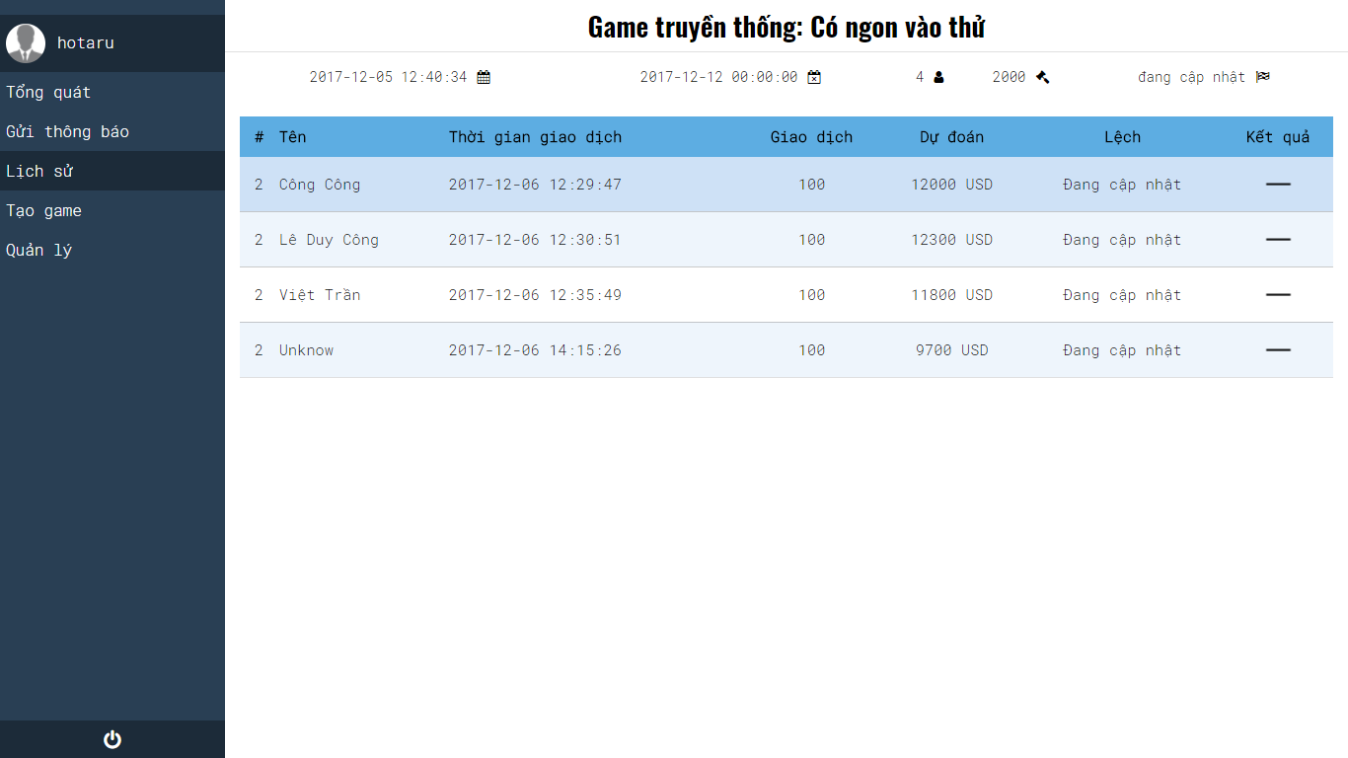

|  |  |  |  |  |
| --- | --- | --- | --- | --- |
| **USE CASE-19 SPECIFICATION:** View detail of traditional Games | | | | |
| **Use-case No.** | <UC3.03> | **Use-case Version** | | <1.0> |
| **Use-case Name** | View Detail of traditional Games | | | |
| **Author** | VinhNV | | | |
| **Date** | 06/10/2017 | **Priority** | High | |
| **User:** Manager, Admin  **Summary:** This feature allow manager can view detail traditional game in system  **Goal:** View the most recently traditional game  **Description:** It show several info such as total transaction, transaction time, etc…  **Triggers:** On sidebar menu manager click on link “Lịch sử”  **Preconditions:** Manager must be login system  **Post Conditions:** View detail traditional game  **Main Success Scenario:**   |  |  | | --- | --- | | Manager | System | | 1. On sidebar menu manager click on link “Lịch sử” |  | |  | 2. System load detail traditional game data |   **Alternative Scenario:** N/A  **Exceptions:** N/A  **Relationships:** N/A  **Business Rules:** | | | | |

*UC3 – 04 View list of member.*

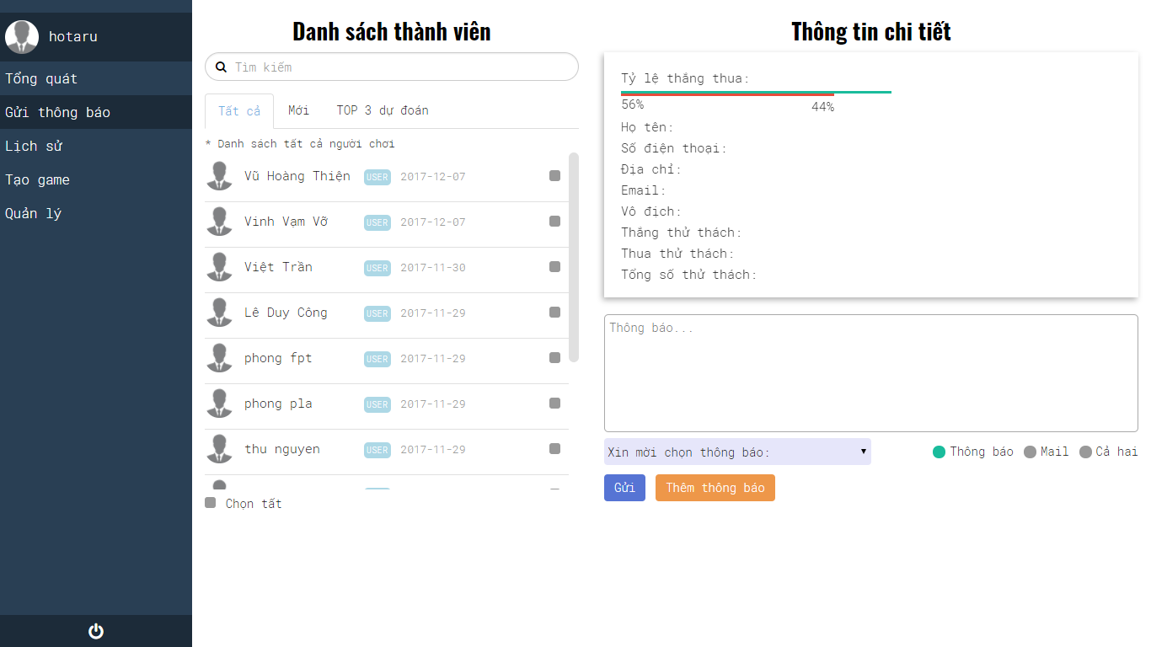

|  |  |  |  |  |
| --- | --- | --- | --- | --- |
| **USE CASE-20 SPECIFICATION** : View list of members | | | | |
| **Use-case No.** | <UC3.04> | **Use-case Version** | | <1.0> |
| **Use-case Name** | View list of members | | | |
| **Author** | VinhNV | | | |
| **Date** | 07/10/2017 | **Priority** | High | |
| **User:** Manager, Admin  **Summary:** This feature will filter member follow 3 kind of catalog which is all member, new member per month and the last one is 3 winners in the most recently traditional game  **Goal:** Show member in 3 tab which is all member, new member and 3 winners  **Description:** If there is no data system will not show anything  **Triggers:** The manager clicks on link “Tổng quát” on the sidebar.  **Preconditions:** Manager must be login system  **Post Conditions:** Display the line chart  **Main Success Scenario:**   |  |  | | --- | --- | | User | System | | 1. Manager click on link “Gửi thông báo” on the sidebar or “Số lượng thành viên” link on overview page |  | |  | 2. Get data in database on show them on “Danh sách thành viên” panel |   **Alternative Scenario:** N/A  **Exceptions:** N/A  **Relationships:** N/A  **Business Rules:** N/A | | | | |

*UC3 – 05 View list of top 3 predictions.*

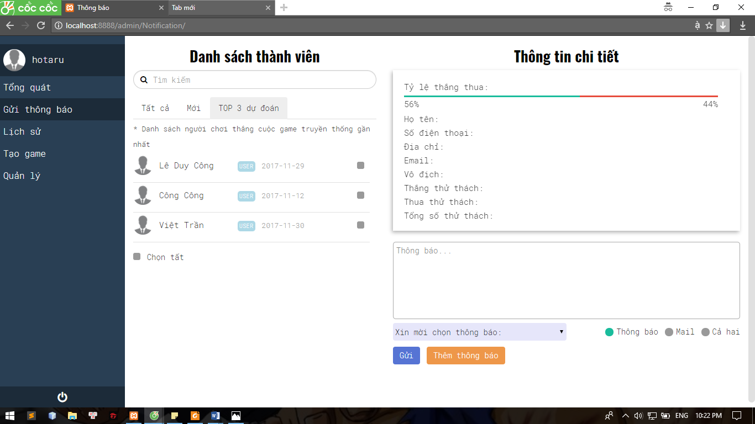

|  |  |  |  |  |
| --- | --- | --- | --- | --- |
| **USE CASE- 21 SPECIFICATION** : View List Of Player Top 3 Predictions | | | | |
| **Use-case No.** | <UC3.05> | **Use-case Version** | | <1.0> |
| **Use-case Name** | View List Of Player Top 3 Predictions | | | |
| **Author** | VinhNV | | | |
| **Date** | 07/06/2017 | **Priority** | High | |
| **User:** Manager, Admin  **Summary:** This feature will display 3 winners of the most recently traditional game  **Goal:** Display 3 winners  **Description:** This feature will display 3 winners of the most recently traditional game  **Triggers:** The manager clicks on link “Gửi thông báo” on the sidebar or “Danh sách trúng thưởng” on home page after that click on “TOP 3 dự đoán” tap.  **Preconditions:** Manager must be login system  **Post Conditions:** Display info of 3 winners  **Main Success Scenario:**   |  |  | | --- | --- | | User | System | | 1. Manager click on link “Gửi thông báo” on the sidebar or “Danh sách trúng |  | | 2. Click on “TOP 3 dự đoán” tap |  | |  | 3. Show 3 winners of the most recently traditional game |   **Alternative Scenario:** N/A  **Exceptions:** N/A  **Relationships:** N/A  **Business Rules:** N/A | | | | |

*UC3 – 06 View information detail of player*

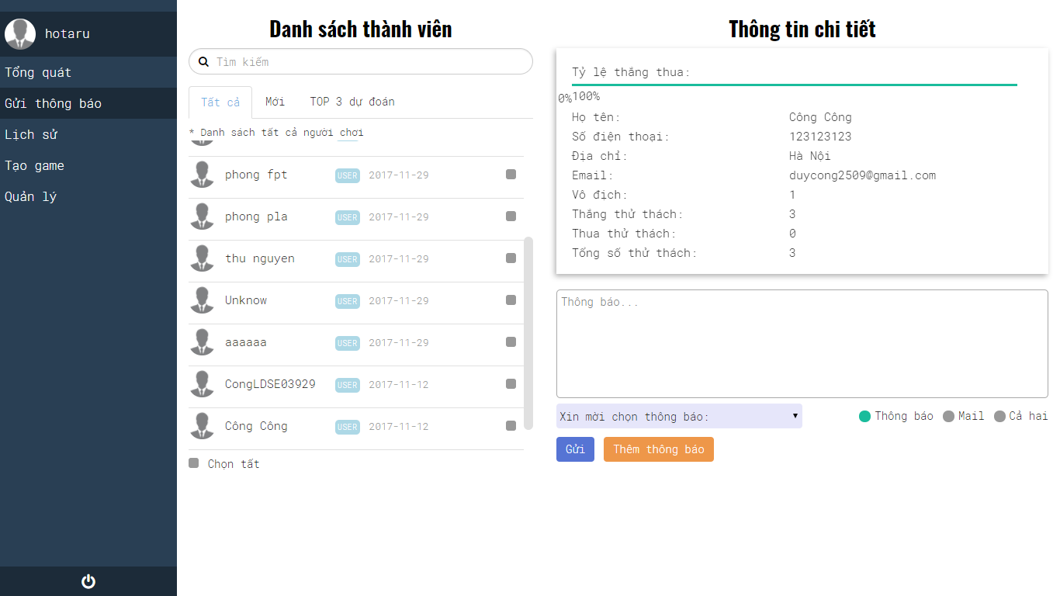

|  |  |  |  |  |
| --- | --- | --- | --- | --- |
| **USE CASE-22 SPECIFICATION** : View Information detail of player | | | | |
| **Use-case No.** | <UC3.06> | **Use-case Version** | | <1.0> |
| **Use-case Name** | View Information detail Of Player | | | |
| **Author** | VinhNV | | | |
| **Date** | 07/10/2017 | **Priority** | High | |
| **User:** Manager, Admin  **Summary:** This feature will show information of member such as name, cell phone, address, etc…  **Goal:** Show exactly information of member  **Description:** Manager click on name of member and then system will display the info of that member  **Triggers:** The manager clicks on link “Gửi thông báo” on the sidebar after that click on any member’s name on “Danh sách thành viên” panel.  **Preconditions:** Manager must be login system  **Post Conditions:** Display information of member  **Main Success Scenario:**   |  |  | | --- | --- | | User | System | | 1. Manager click name of member on “Danh sách thành viên” panel |  | |  | 2. Show information of member |   **Alternative Scenario:** N/A  **Exceptions:** N/A  **Relationships:** N/A  **Business Rules:** N/A | | | | |

*UC3 – 07 View list of mini games*

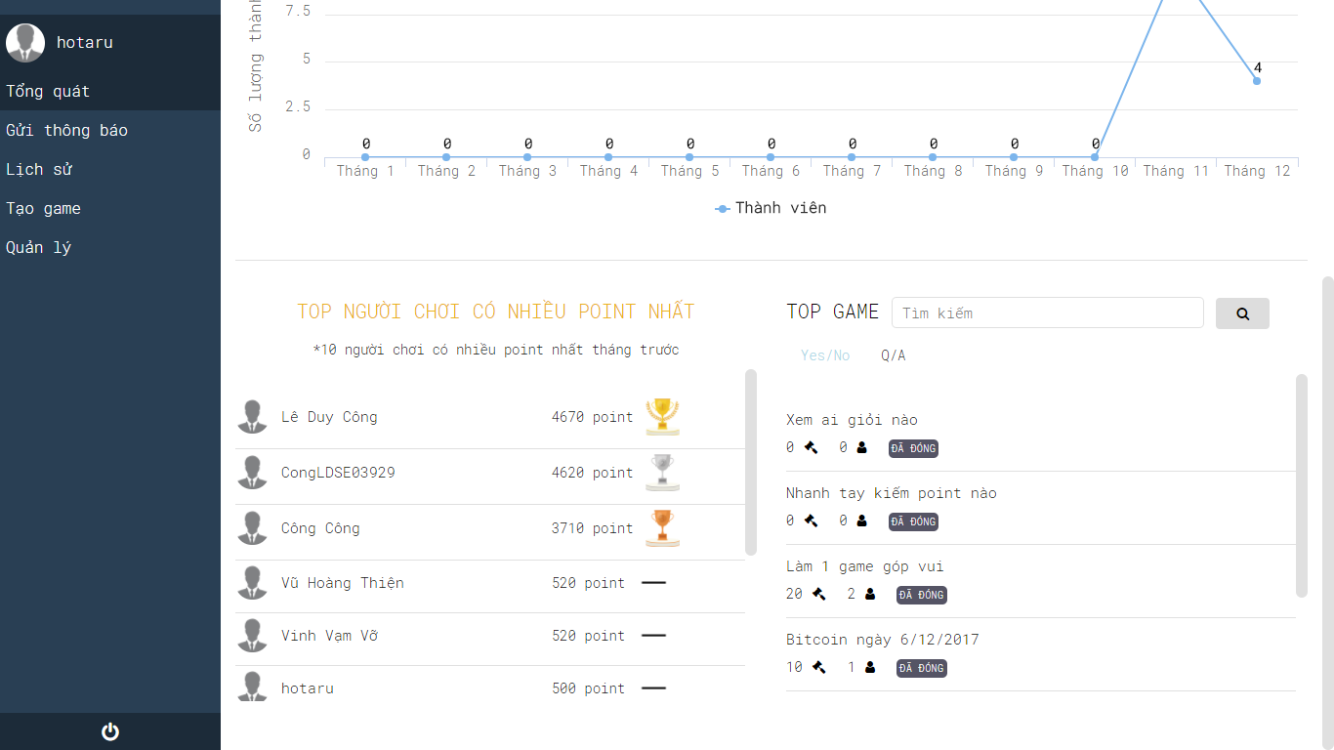

|  |  |  |  |  |
| --- | --- | --- | --- | --- |
| **USE CASE-23 SPECIFICATION** : View List Of Mini Games | | | | |
| **Use-case No.** | <UC3.07> | **Use-case Version** | | <1.0> |
| **Use-case Name** | View List Of Mini Games | | | |
| **Author** | VinhNV | | | |
| **Date** | 07/10/2017 | **Priority** | High | |
| **User:** Admin, Manager  **Summary:** This feature allow manager can view all of mini games in system  **Goal:** View mini games which are already exists  **Description:** The list of mini games have some kind of info such as amount of user which already join, game’s status is closing or opening  **Triggers:** On home page manager find TOP GAME panel  **Preconditions:** Manager must be login system  **Post Conditions:** View all mini games  **Main Success Scenario:**   |  |  | | --- | --- | | Manager | System | | 1. On Home page find TOP GAME panel |  | |  | 3. System load mini game data |   **Alternative Scenario:** N/A  **Exceptions:** N/A  **Relationships:** N/A  **Business Rules:** N/A | | | | |

*UC3 – 08 Search top mini games*



|  |  |  |  |  |
| --- | --- | --- | --- | --- |
| **USE CASE-24 SPECIFICATION** : Search top mini Game | | | | |
| **Use-case No.** | <UC3.08> | **Use-case Version** | | <1.0> |
| **Use-case Name** | Search top mini game | | | |
| **Author** | VinhNV | | | |
| **Date** | 02/06/2017 | **Priority** | High | |
| **User:** Manager, Admin  **Summary:** The manager uses this feature to search top game  **Goal:** Display game’s name that manager need  **Description:** This function will display game’s name if that exist in system otherwise doesn’t show anything  **Triggers:** The manager clicks on “Search” icon in the homepage.  **Preconditions:** Manager must be login system  **Post Conditions:** Show game’s name need to find  **Main Success Scenario:**   |  |  | | --- | --- | | User | System | | 1. Fill game’s name |  | | 2. The manager clicks on “Search” icon in the homepage. |  | |  | 3. Show users match input |   **Alternative Scenario:** N/A  **Exceptions:**  **1.1**   |  |  | | --- | --- | | User | System | | 1. The manager clicks on “Search” icon in the homepage. |  | |  | 2. Show all games |   **1.2**   |  |  | | --- | --- | | User | System | | 1. Fill game’s name but it doesn’t exist |  | | 2. The manager clicks on “Search” icon in the homepage. |  | |  | 3. Doesn’t show anything |   **Relationships:** N/A  **Business Rules:** N/A | | | | |

*UC3 – 09 View mini game detail*





|  |  |  |  |  |
| --- | --- | --- | --- | --- |
| **USE CASE-25 SPECIFICATION:** View Mini Game Detail | | | | |
| **Use-case No.** | <UC3.09> | **Use-case Version** | | <1.0> |
| **Use-case Name** | View Mini Game Detail | | | |
| **Author** | VinhNV | | | |
| **Date** | 07/10/2017 | **Priority** | High | |
| **User:** Admin, Manager  **Summary:** This feature allow manager can view detail mini game in system  **Goal:** View detail mini games which are already exists  **Description:** In detail mini it show several info about that mini game such as total transaction, kind of mini game, time created, etc…  **Triggers:** On home page manager find TOP GAME panel and click on game’s name  **Preconditions:** Manager must be login system  **Post Conditions:** View detail mini games  **Main Success Scenario:**   |  |  | | --- | --- | | Manager | System | | 1. On Home page find TOP GAME panel and click on game’s name |  | |  | 2. System load detail mini game data and redirect to Game Detail page |   **Alternative Scenario:** N/A  **Exceptions:** N/A  **Relationships:** N/A  **Business Rules:** N/A | | | | |

*UC3 – 10 Deactivate Mini game*



|  |  |  |  |  |
| --- | --- | --- | --- | --- |
| **USE CASE-26 SPECIFICATION:** Deactivate Mini Game | | | | |
| **Use-case No.** | <UC3.10> | **Use-case Version** | | <1.0> |
| **Use-case Name** | Deactivate Mini Game | | | |
| **Author** | VinhNV | | | |
| **Date** | 03/10/2017 | **Priority** | High | |
| **User:** Admin, Manager  **Summary:** This feature allow manager can deactivate any mini game if they want  **Goal:** Deactivate game successfully  **Description:** In situation any mini game have informal content or illegal act manager can deactivate that mini game  **Triggers:** On home page manager find TOP GAME panel and click on game’s name in this screen manager click on “Deactive” link  **Preconditions:** Manager must be login system  **Post Conditions:** View detail mini games  **Main Success Scenario:**   |  |  | | --- | --- | | Manager | System | | 1. On Home page find TOP GAME panel and click on game’s name |  | |  | 2. System load detail mini game data and redirect to Game Detail page | | 3. Manager click on “Deactive” link |  | |  | 4. System display authentication form | | 5. Manager authentication and click “Chắc chắn” button |  | |  | 6. System request to database |   **Alternative Scenario:** N/A  **Exceptions:** N/A  **Relationships:** N/A  **Business Rules:** N/A | | | | |

*UC3 – 11 View top 10 of players have the most points in month*



|  |  |  |  |  |
| --- | --- | --- | --- | --- |
| **USE CASE-27 SPECIFICATION:** View Top 10 Of Player Have The Highest Point In Month | | | | |
| **Use-case No.** | <UC3.11> | **Use-case Version** | | <1.0> |
| **Use-case Name** | View Top 10 Of Player Have The Highest Point In Month | | | |
| **Author** | VinhNV | | | |
| **Date** | 07/10/2017 | **Priority** | High | |
| **User:** Manager, Admin  **Summary:** This feature allow manager can view top 10 of player have the highest point in month  **Goal:** View top 10 of player have the highest point in month  **Description:** System show list of 10 players have the highest point in month on “TOP NGƯỜI CHƠI” panel  **Triggers:** On Home page manager find “TOP NGƯỜI CHƠI” panel  **Preconditions:** Manager must be login system  **Post Conditions:** Show list of 10 players have the highest point in month  **Main Success Scenario:**   |  |  | | --- | --- | | Manager | System | | 1. On Home page manager find “TOP NGƯỜI CHƠI” panel |  | |  | 2. System load data from database |   **Alternative Scenario:** N/A  **Exceptions:** N/A  **Relationships:** N/A  **Business Rules:** N/A | | | | |

*UC3 – 12 Add Notification*





|  |  |  |  |  |
| --- | --- | --- | --- | --- |
| **USE CASE-28 SPECIFICATION** : Add Notification | | | | |
| **Use-case No.** | <UC3.12> | **Use-case Version** | | <1.0> |
| **Use-case Name** | Add Notification | | | |
| **Author** | VinhNV | | | |
| **Date** | 07/10/2017 | **Priority** | High | |
| **User:** Manager, Admin  **Summary:** The manager uses this feature to add new notification into database.  **Goal:** Add a new notification successfully  **Description:** This function will add new notification into database if data process have something wrong it will display error  **Triggers:** The manager clicks on link “Lưu thông báo” on CRUD notification page  **Preconditions:** Manager must be login system  **Post Conditions:** Have a new notification in database  **Main Success Scenario:**   |  |  | | --- | --- | | User | System | | 1. Fill title and content of new notification |  | | 2. The manager clicks on link “Lưu thông báo” on CRUD notification page |  | |  | 3. Check input information and show confirm dialog "Bạn có chắc chắn muốn cập nhật nội dung thông báo này?”. | | 4. Manger click on button “chắc chắn” on popup |  | |  | 5. Display successfully message. Add new notification into database |   **Alternative Scenario:** N/A  **Exceptions:**  **1.1**   |  |  | | --- | --- | | User | System | | 1. The manager clicks on link “Lưu thông báo” on CRUD notification page |  | |  | 2. Check input information and display invalid message. |   **1.2**   |  |  | | --- | --- | | User | System | | 1. Fill title and content of new notification but these data are invalid format |  | | 2. The manager clicks on link “Lưu thông báo” on CRUD notification page |  | |  | 3. Check input information and display invalid message. |   **Relationships:** N/A  **Business Rules:** N/A | | | | |

*UC3 – 13 Delete Notification*

|  |  |  |  |  |
| --- | --- | --- | --- | --- |
| **USE CASE-29 SPECIFICATION** : Delete Notification | | | | |
| **Use-case No.** | <UC3.13> | **Use-case Version** | | <1.0> |
| **Use-case Name** | Delete Notification | | | |
| **Author** | VinhNV | | | |
| **Date** | 07/10/2017 | **Priority** | High | |
| **User:** Manager, Admin  **Summary:** The manager uses this feature to delete notification which is already exists in database.  **Goal:** Delete notification successfully  **Description:** If delete notification successfully system will display message on screen else for some reason system can’t perform requested it will display error message on screen  **Triggers:** The manager clicks on link “Xóa thông báo” on CRUD notification page  **Preconditions:** Manager must be login system  **Post Conditions:** System will deactive the notification in database  **Main Success Scenario:**   |  |  | | --- | --- | | User | System | | 1. Select a notification on “Thông báo” panel that display on right hand side of browser screen |  | |  | 2. Fill data of the notification that manager selected into fields data on left hand side of browser screen | | 3. Change content of the notification and clicks on link “Xóa thông báo” |  | |  | 4. Show confirm dialog | | 5. Manager clicks on “Chắc chắn” button |  | |  | 6. System request to database. Display successfully message “Xóa thông báo thành công”. |   **Alternative Scenario:** N/A  **Exceptions:** N/A  **Relationships:** N/A  **Business Rules:** N/A | | | | |

*UC3 – 14 Edit Notification*

|  |  |  |  |  |
| --- | --- | --- | --- | --- |
| **USE CASE-30 SPECIFICATION** : Edit Notification | | | | |
| **Use-case No.** | <UC3.14> | **Use-case Version** | | <1.0> |
| **Use-case Name** | Edit Notification | | | |
| **Author** | VinhNV | | | |
| **Date** | 07/10/2017 | **Priority** | High | |
| **User:** Manager, Admin  **Summary:** The manager uses this feature to edit notification which is already exists in database.  **Goal:** Edit notification successfully  **Description:** If edit notification successfully system will display message on screen  **Triggers:** The manager clicks on link “Lưu thông báo” on CRUD notification page  **Preconditions:** Manager must be login system  **Post Conditions:** The content of notification will be update into database  **Main Success Scenario:**   |  |  | | --- | --- | | User | System | | 1. Select a notification on “Thông báo” panel that display on right hand side of browser screen |  | |  | 2. Fill data of the notification that manager selected into fields data on left hand side of browser screen | | 3. Change content of the notification and clicks on link “Lưu thông báo” |  | |  | 4. Show confirm dialog | | 5. Manager clicks on “Chắc chắn” button |  | |  | 6. System request to database. Display successfully message “Cập nhật thông báo thành công”. |   **Alternative Scenario:** N/A  **Exceptions:** N/A  **Relationships:** N/A  **Business Rules:** N/A | | | | |

*UC3 – 15 Block or Unblock manager*

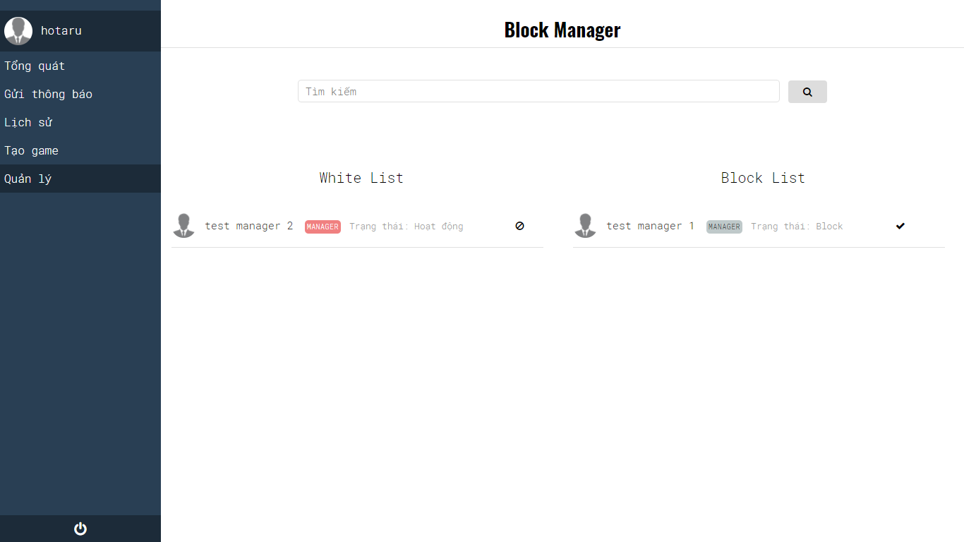

|  |  |  |  |  |
| --- | --- | --- | --- | --- |
| **USE CASE-31 SPECIFICATION** : Block or Unblock manager | | | | |
| **Use-case No.** | <UC3.15> | **Use-case Version** | | <1.0> |
| **Use-case Name** | Block or Unblock manager | | | |
| **Author** | VinhNV | | | |
| **Date** | 07/10/2017 | **Priority** | High | |
| **User:** Admin  **Summary:** This feature allow admin can block or unblock any manager if he/she want  **Goal:** Block or unblock manager  **Description:** Block manager mean their account will be disable therefore they cannot login or do anything else relate to this system  **Triggers:** On “Quản lý” menu click on “Block or Unblock manager” link after that choose manager admin want to block or unblock  **Preconditions:** Admin must be login system  **Post Conditions:** Block or unblock successfully  **Main Success Scenario:**   |  |  | | --- | --- | | Admin | System | | 1. On “Quản lý” menu click on “Block or Unblock manager” link after that choose manager admin want to block or unblock |  | |  | 2. Show confirm dialog | | 3. Admin clicks on “Chắc chắn” button. |  | |  | 4. System request to database. Display message “Khóa người quản lý thành công” or message “Mở người quản lý thành công”. |   **Alternative Scenario:** N/A  **Exceptions:** N/A  **Relationships:** N/A  **Business Rules:** B19, B20 | | | | |

*UC3 – 16 Edit Award*

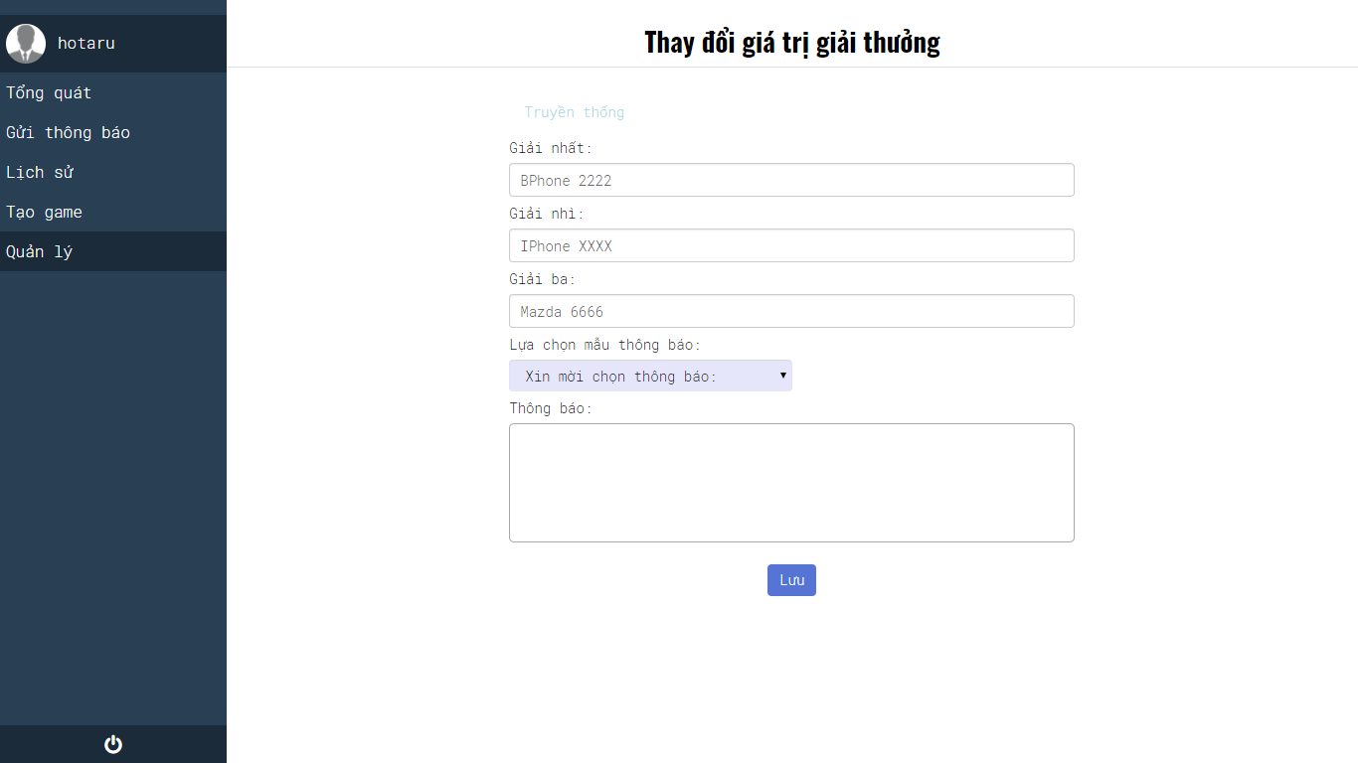

|  |  |  |  |  |
| --- | --- | --- | --- | --- |
| **USE CASE-32 SPECIFICATION** : Edit Award | | | | |
| **Use-case No.** | <UC3.16> | **Use-case Version** | | <1.0> |
| **Use-case Name** | Edit Award | | | |
| **Author** | VinhNV | | | |
| **Date** | 07/10/2017 | **Priority** | High | |
| **User:** Admin  **Summary:** This feature allow admin can change award for the winner if they want  **Goal:** Change award successfully  **Description:** If change award successfully system will send notification to all user.  **Triggers:** On “Quản lý” menu click on “Giải thưởng” link after that fill award data to requirement fields  **Preconditions:** Admin must be login system  **Post Conditions:** Change award successfully  **Main Success Scenario:**   |  |  | | --- | --- | | Admin | System | | 1. On “Quản lý” menu click on “Giải thưởng” link |  | |  | 2. Display Edit award page | | 3. Admin fill award data to requirement fields then admin click “Lưu” |  | |  | 4. Show confirm dialog. | | 5. Admin must confirm identity. Admin fill email’s admin and correct password. |  | |  | 6. System request to database. Display successfully message. |   **Alternative Scenario:** N/A  **Exceptions:**  **1.1**   |  |  | | --- | --- | | Admin | System | | 1. On “Quản lý” menu click on “Giải thưởng” link |  | | 2. Fill award data to requirement fields but invalid format |  | |  | 3. Show invalid message |   **Relationships:** N/A  **Business Rules: B19, B20** | | | | |

### **3.3.6. Non-functional Requirements**

#### **3.3.6.1 Usability**

- User interface should be clear and easy to user.

- User need medium 10 minutes to learn how to use the application

- User need medium 10 minutes to learn how to use manager page, admin page.

#### **3.3.6.2 Reliability**

* All inputs are validated to make sure of data that format be correct
* Data related to player information and bitcoin price information in LowHope website is controlled by Admin and Manager to avoid bad content and bad member in the system.
* Close all transactions from clients 10 seconds before the game ends to process system correctly.

#### **3.3.6.3 Performance**

N/A

#### **3.3.6.4 Interface**

##### **3.3.6.4.1 User Interface**

* User interface for application must be simple and clear to be suitable for project’s target customer.

##### **3.3.6.4.2 Hardware Interface**

- The LowHope website can run all web browsers: Google chrome, Firefox, IE…

##### **3.3.6.4.3 Security**

* Secure user accounts on Player page, Admin page and Manage page.
* Anti-cheating.

# CHAPTER 4: SOFTWARE DESIGN DESCRIPTION

## **4.1. Introduction**

### **4.1.1. Purpose**

## **4.2. Architecture Overview**

### **4.2.1. System Architecture**

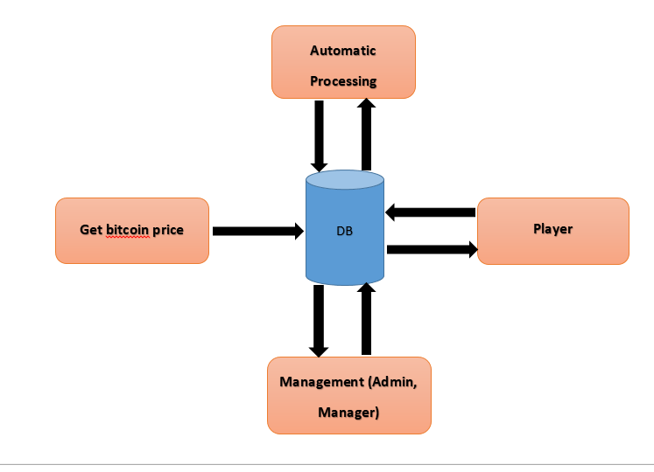

- **Database:** Database is used data storage. It include:

* Bitcoin price.
* Data of player.
* Data of game.

- **Get bitcoin price**: Web data collection from API under JSON on bitcoin prices then save to database.

- **Automatic Processing:** Automatic processing include

* Automatic processing create traditional betting game.
* Automatic processing close game, increase or decrease player’s points based on rule of game.

- **Player:** Allow user to participate in system game including:

* Create mini game.
* Play game.
* View chart of bitcoin price.

- **Management:** Allow admin or manager to manage system such as:

* Manage user.
* Manage game.
* View game detail.
* Send notification to player.
* Number of games created.
* Number of member…

**MVC model**

Model–view–controller (MVC) is a software architectural pattern for implementing user interfaces on computers. It divides a given application into three interconnected parts. This is done to separate internal representations of information from the ways information is presented to, and accepted from, the user

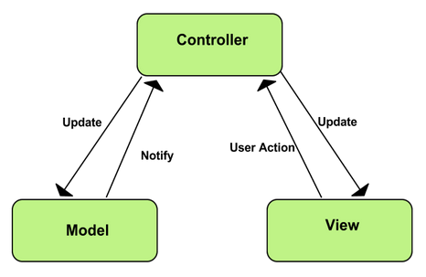

MVC Model

* **Model:** Model represents shape of the data and business logic. It maintains the data of the application. Model objects retrieve and store model state in a database.
* **View:** View is a user interface. View display data using model to the user and also enables them to modify the data.
* **Controller:** Controller handles the user request. Typically, user interact with View, which in-tern raises appropriate URL request, this request will be handled by a controller. The controller renders the appropriate view with the model data as a response.

**Advantages and disadvantages of MVP model**

* **Advantages**
  + **Faster development process:** MVC supports rapid and parallel development. With MVC, one programmer can work on the view while other can work on the controller to create business logic of the web application. The application developed using MVC can be three times faster than application developed using other development patterns.
  + **Ability to provide multiple views:** In the MVC Model, you can create multiple views for a model. Code duplication is very limited in MVC because it separates data and business logic from the display.
  + **Support for asynchronous technique:** MVC also supports asynchronous technique, which helps developers to develop an application that loads very fast.
  + **Modification does not affect the entire model:** Modification does not affect the entire model because model part does not depend on the views part. Therefore, any changes in the Model will not affect the entire architecture.
  + **MVC model returns the data without formatting:** MVC pattern returns data without applying any formatting so the same components can be used and called for use with any interface.
  + **SEO friendly Development platform**: Using this platform, it is very easy to develop SEO-friendly URLs to generate more visits from a specific application.
* **Disadvantages**
  + Increased complexity
  + Inefficiency of data access in view
  + Difficulty of using MVC with modern user interface.
  + Need multiple programmers
  + Knowledge on multiple technologies is required.
  + Developer have knowledge of client side code and html code.

## **4.3. Component Diagram**

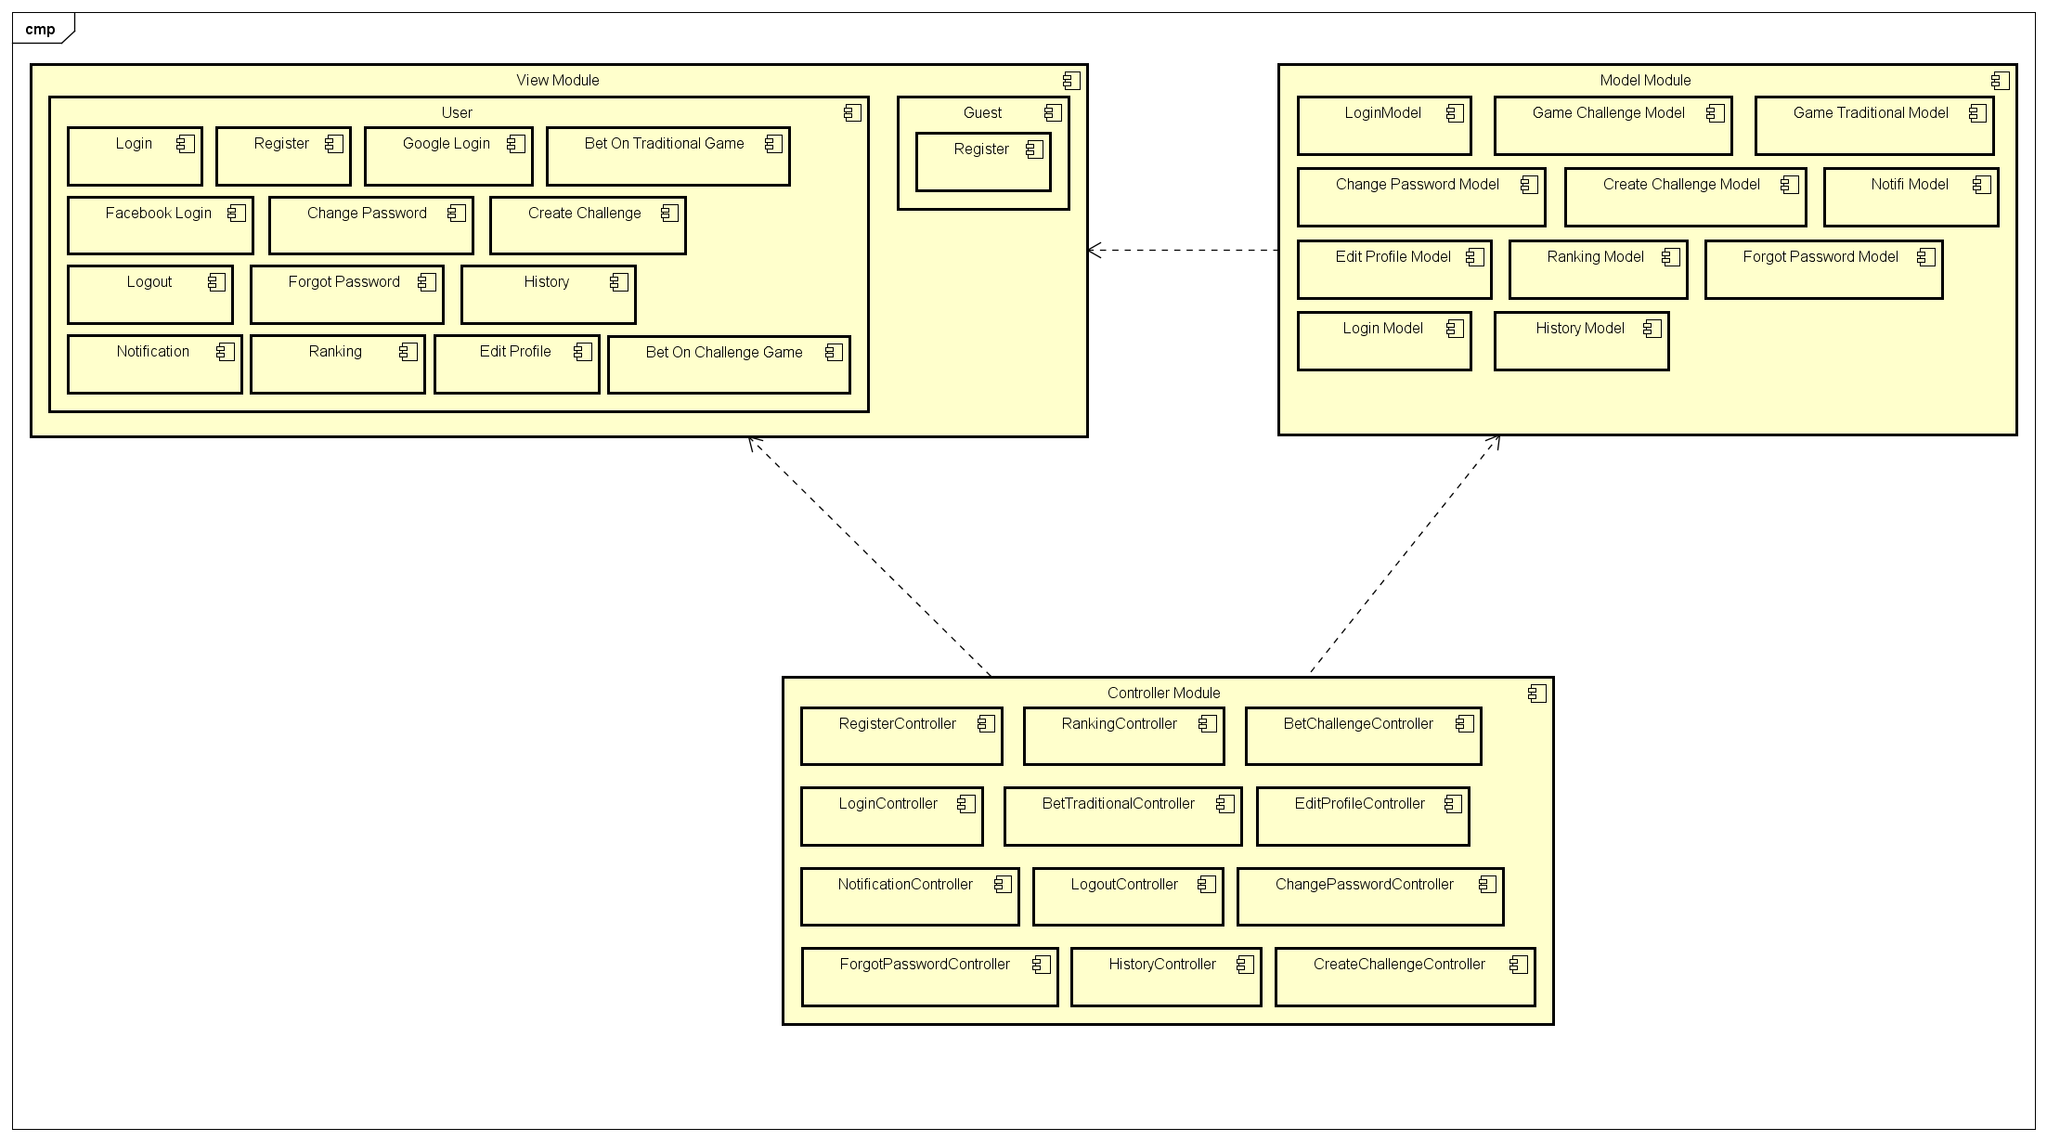

## **4.4. Sequence Diagram**

Several sequence diagrams are shown in the following:

### **4.4.1. Register**

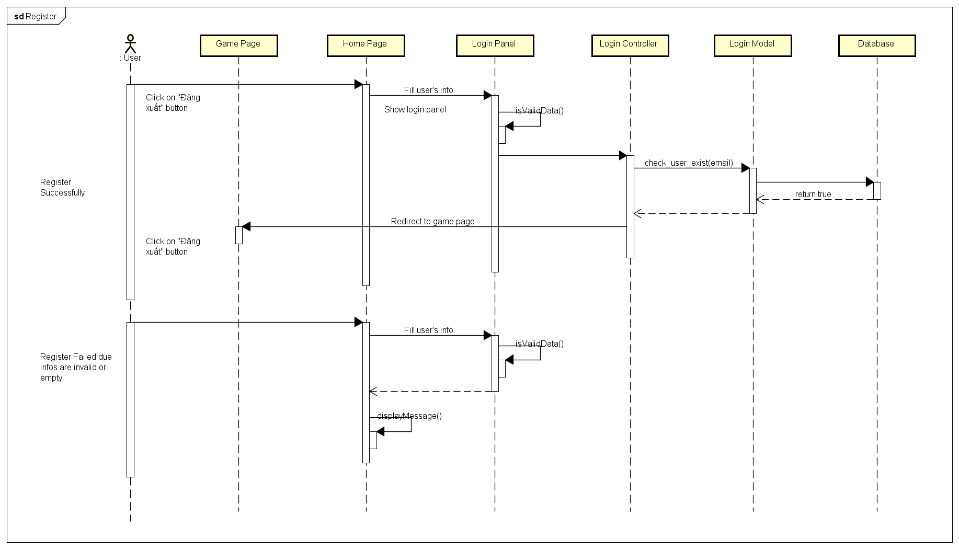

### **4.4.2. Login**

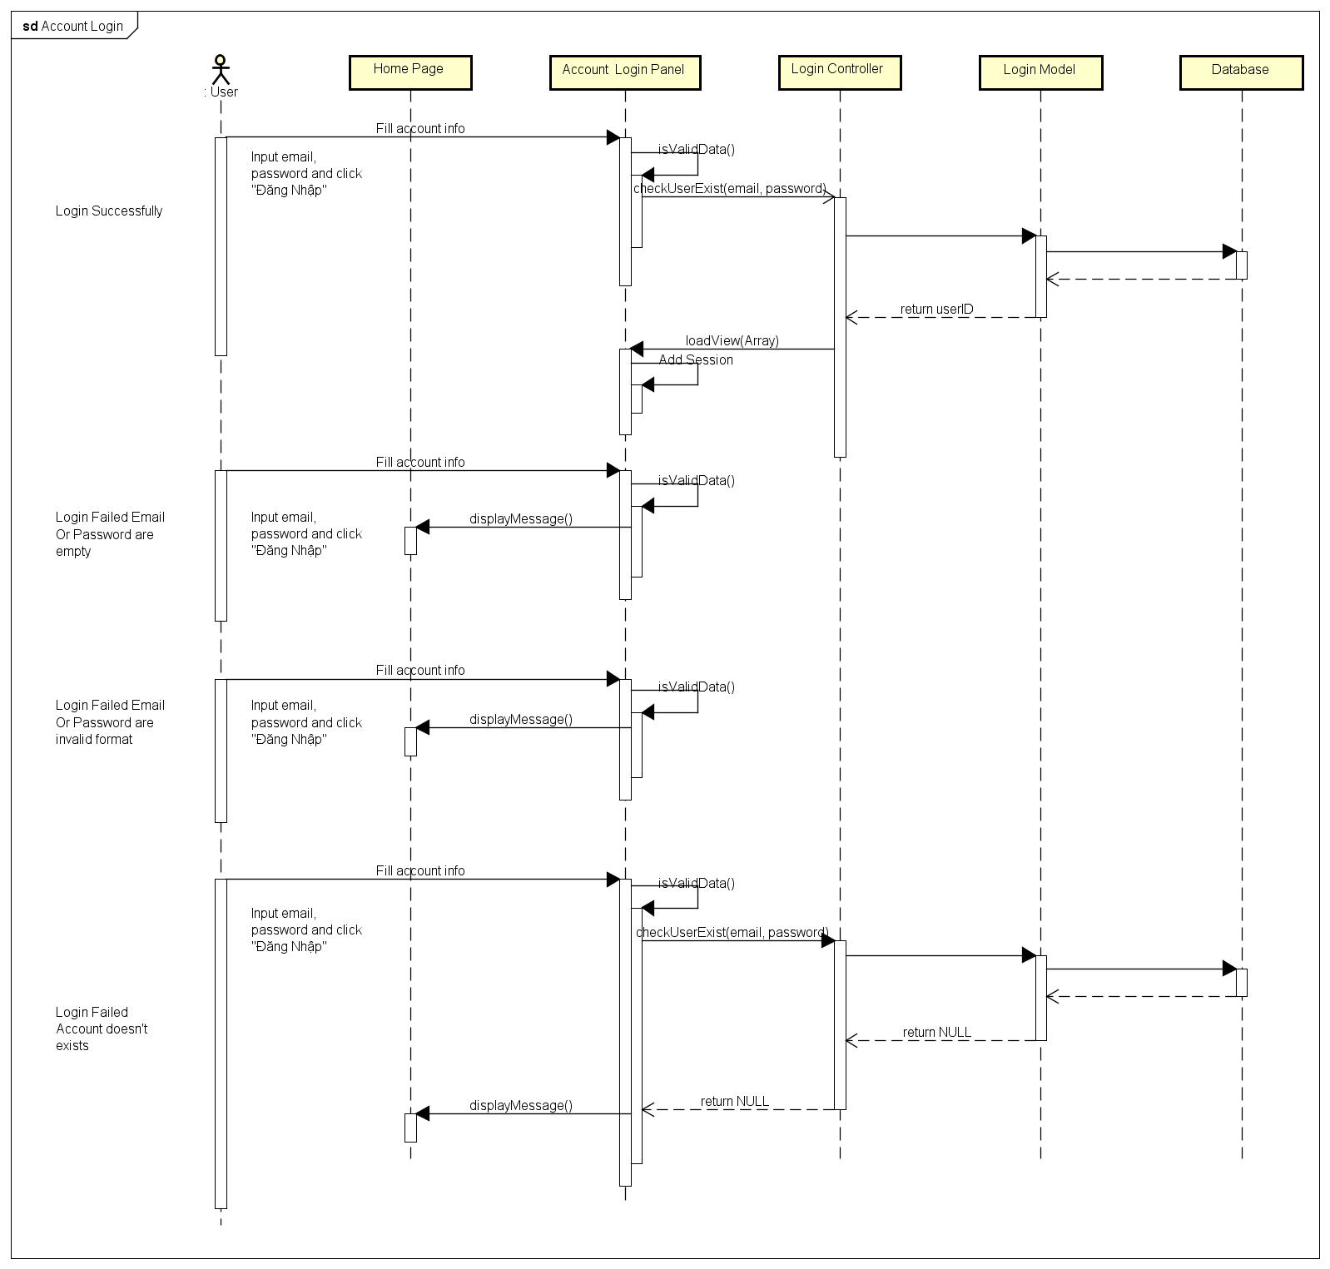

### **4.4.3. Login Using Facebook**

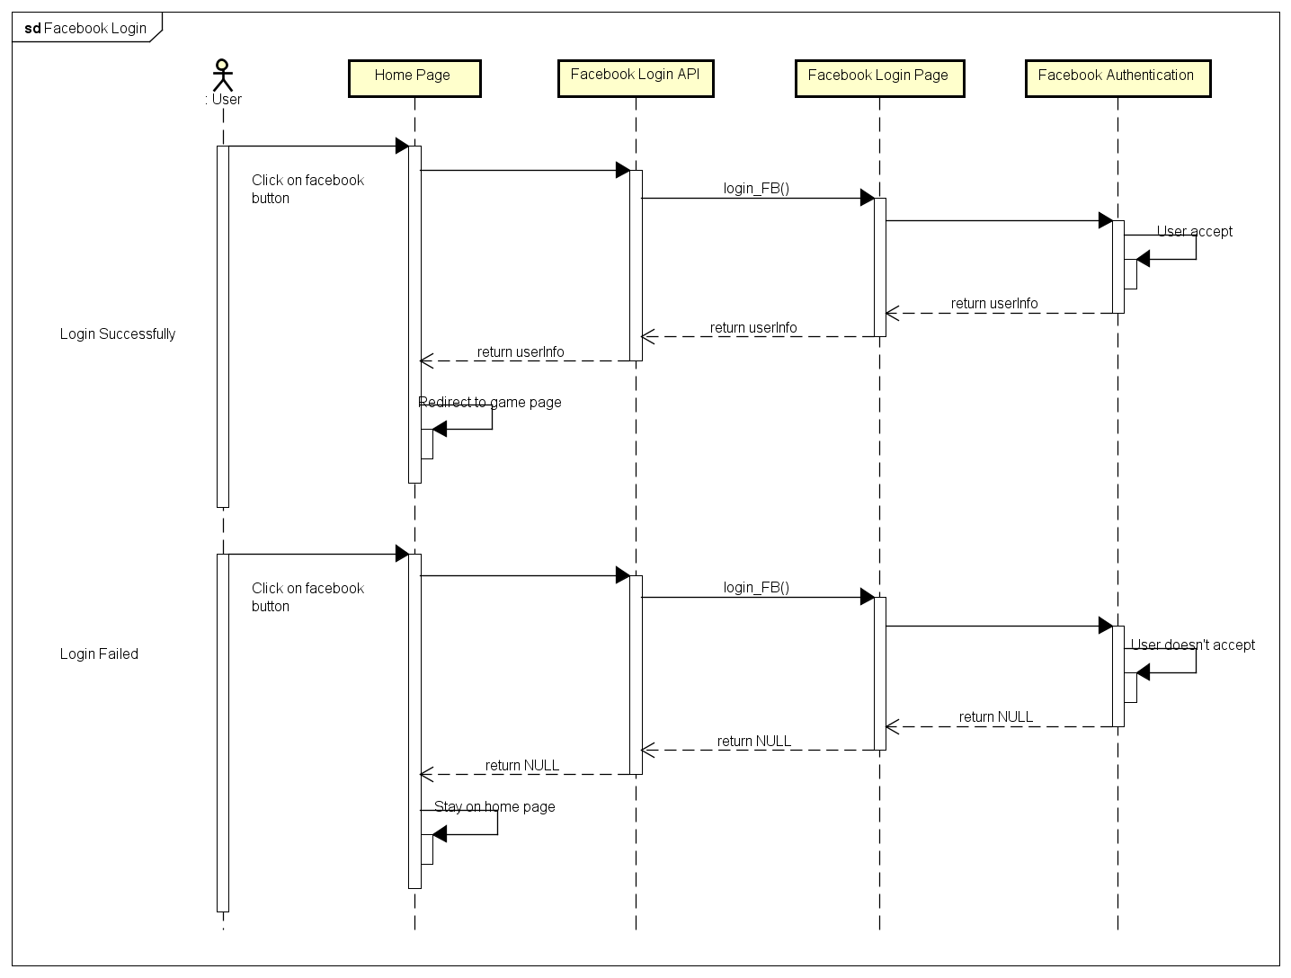

### **4.4.4. Login Using Google Plus**

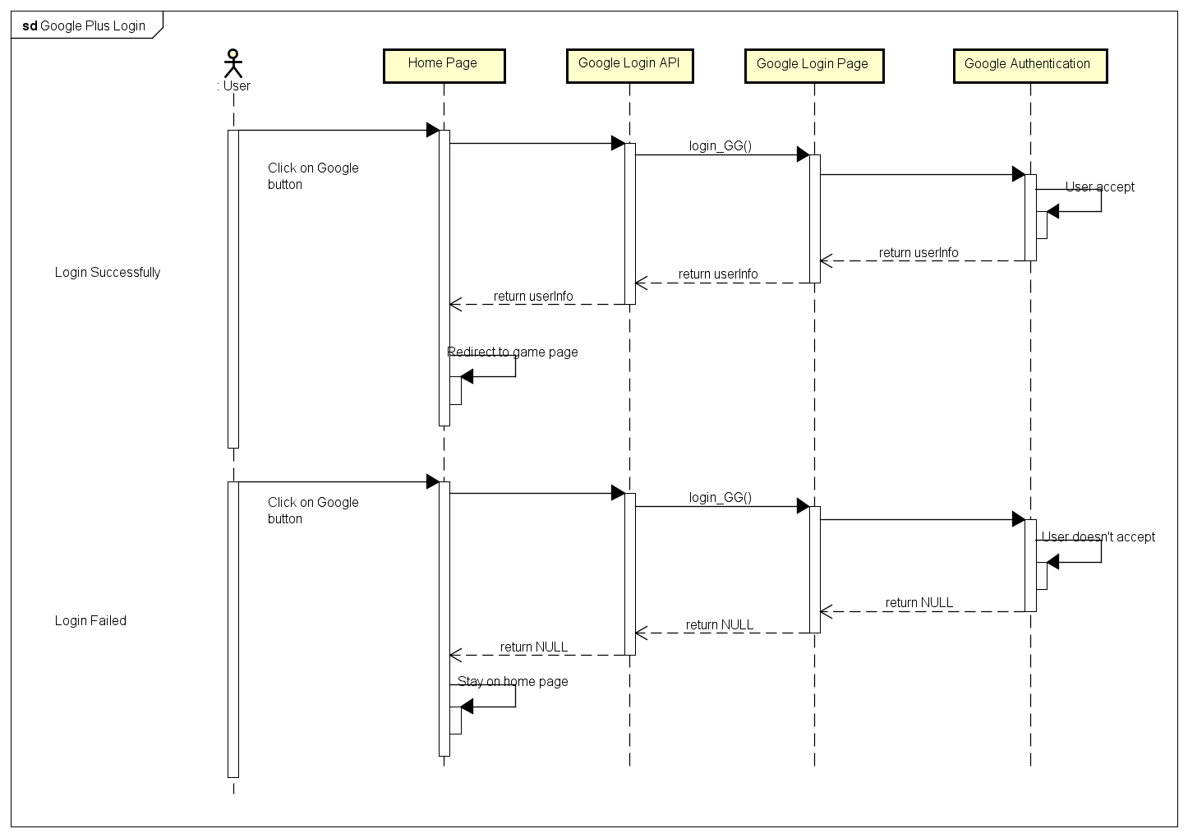

4.4.A.5. Logout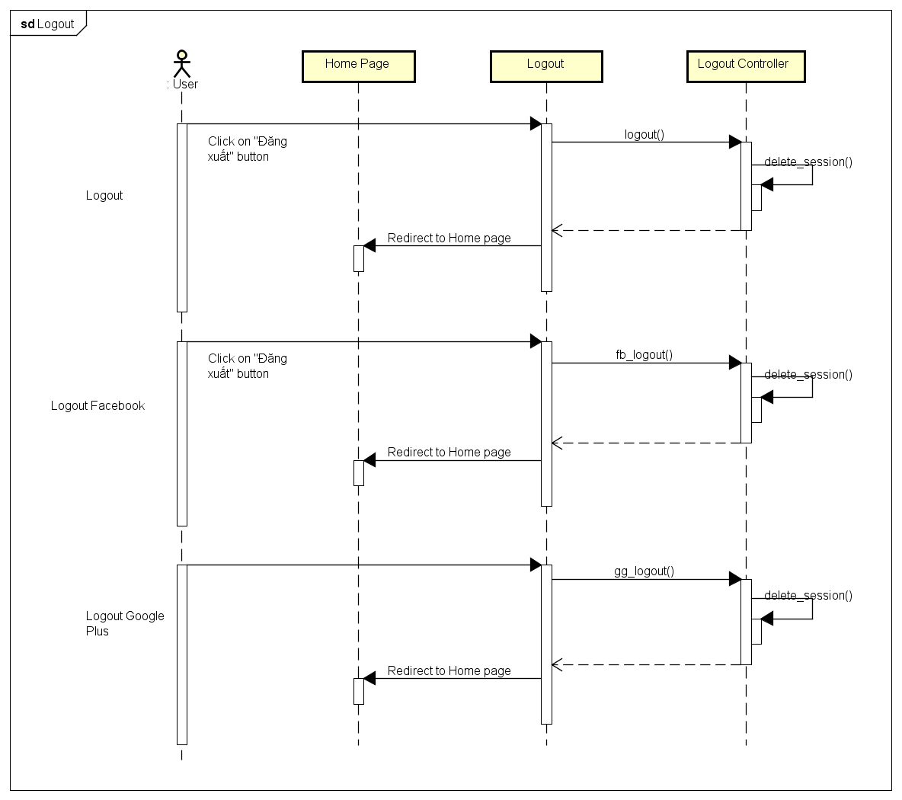

4.4.A.6. Change Password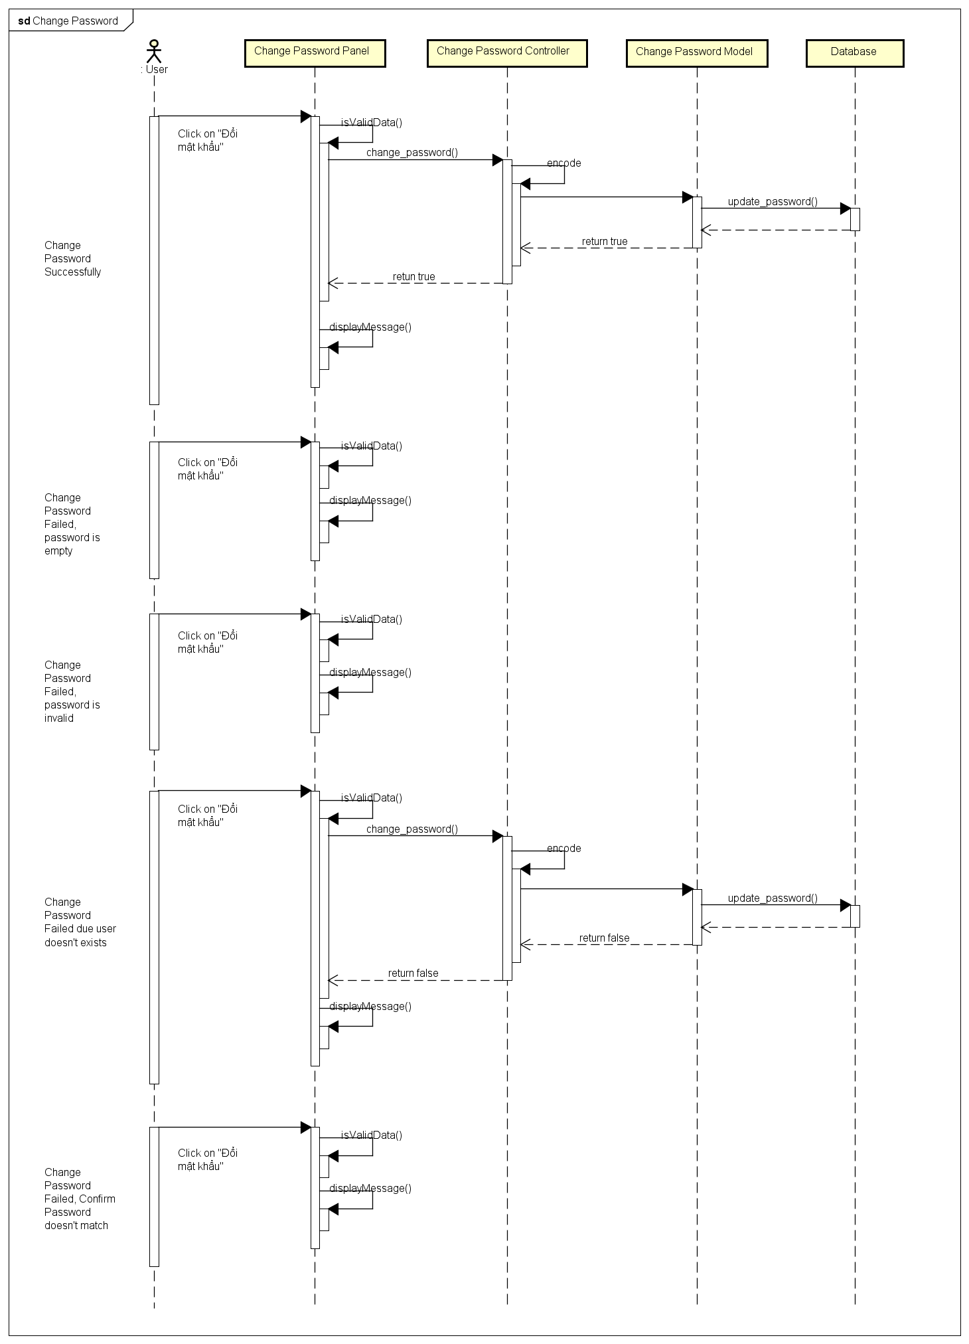

4.4.A.7. Forgot Password

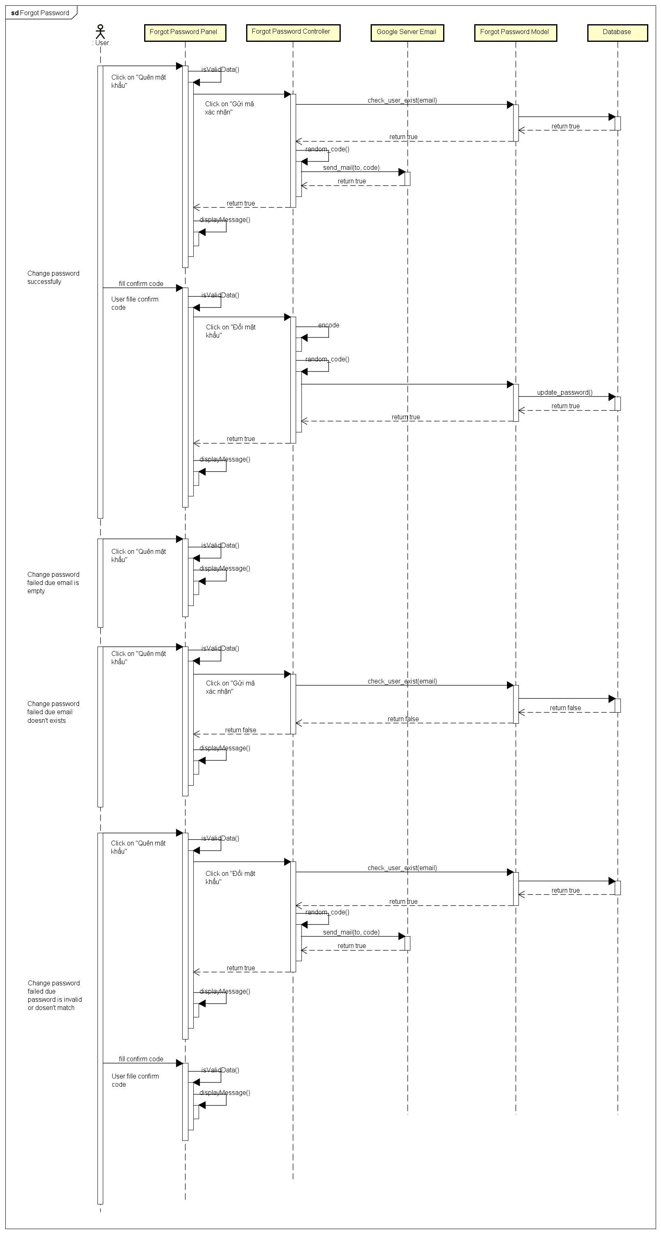

4.4.A.8. Edit Profile

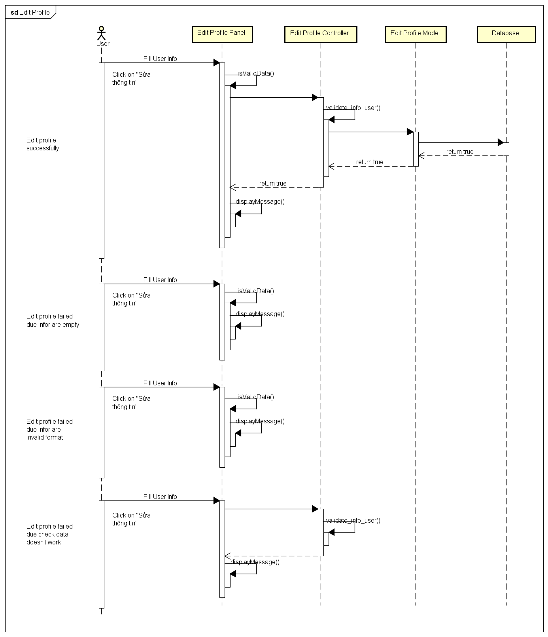

4.4.A.9. History

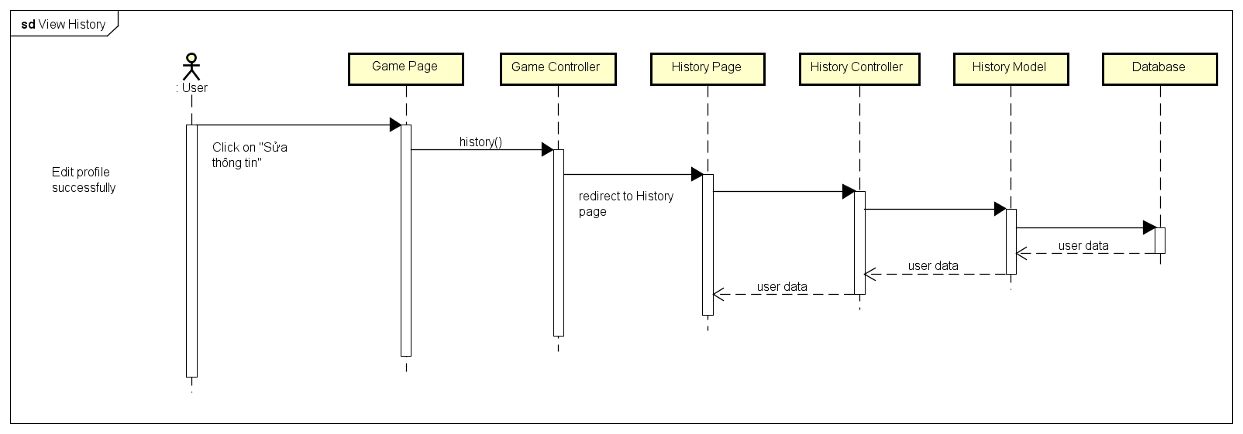

4.4.A.10. Notification

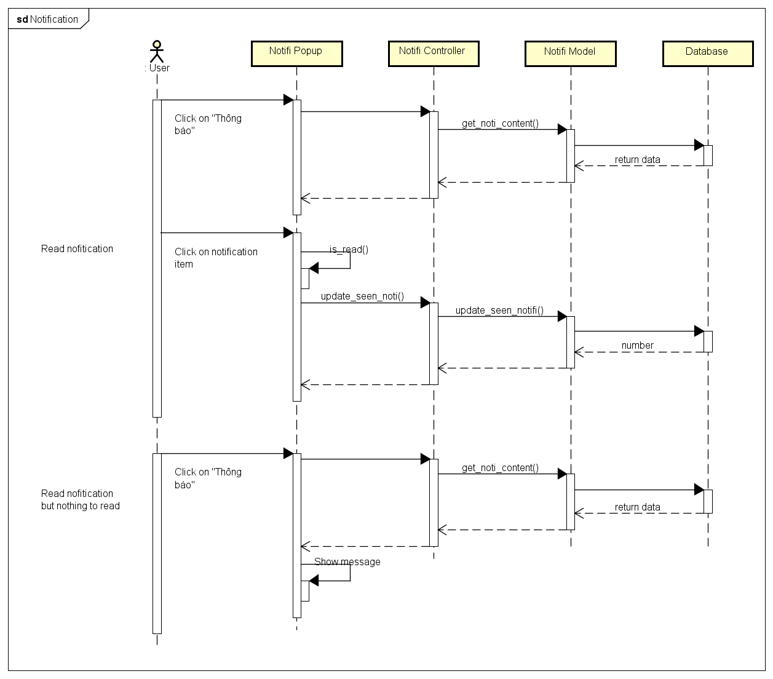

4.4.A.11. User Rankings

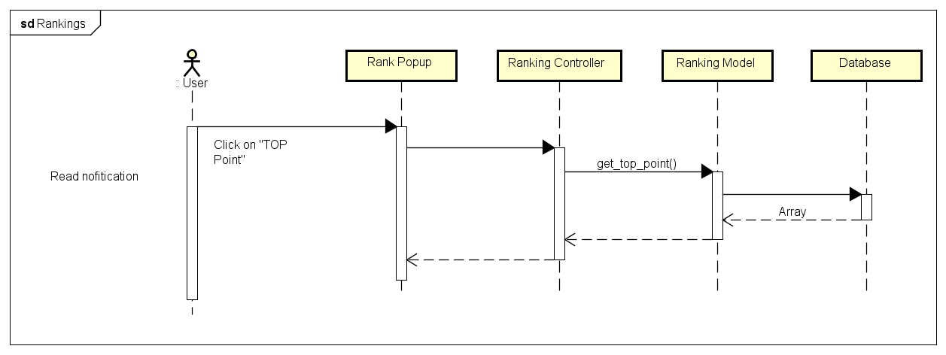

4.4.A.12. Create Challenges

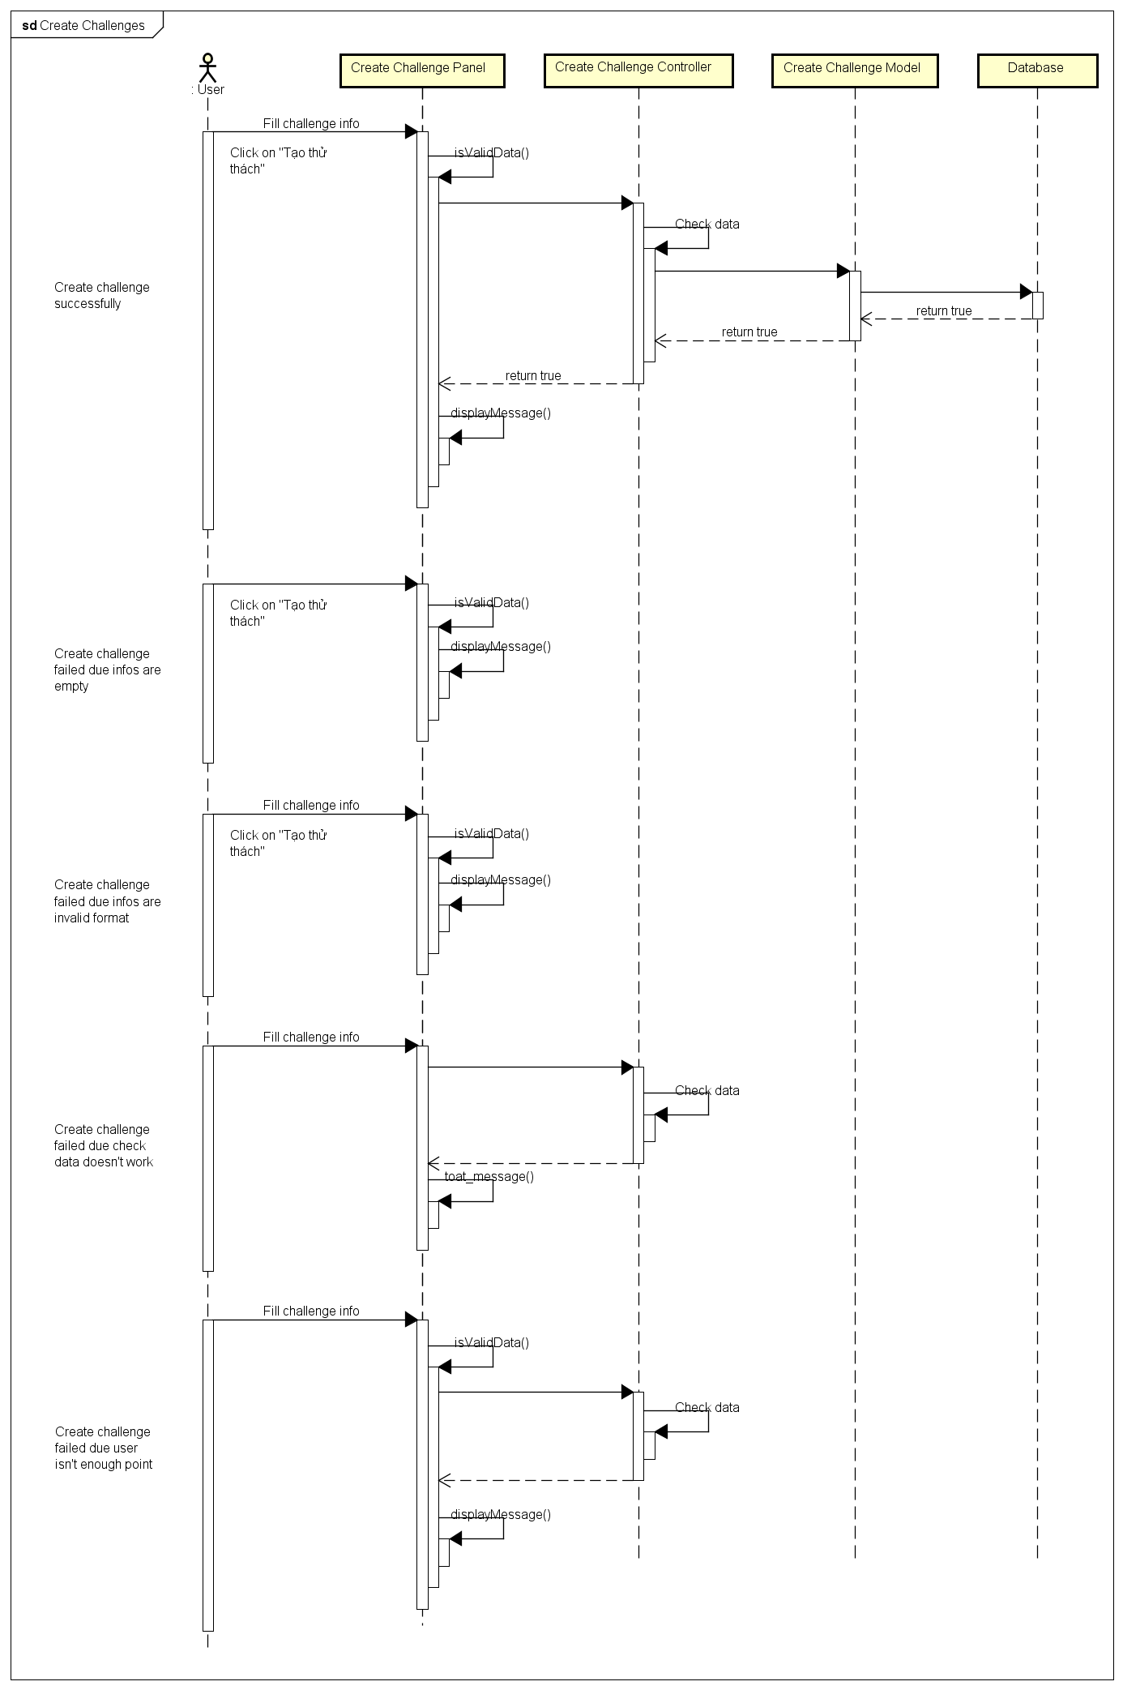

4.4.A.13. Bet On Traditional Game

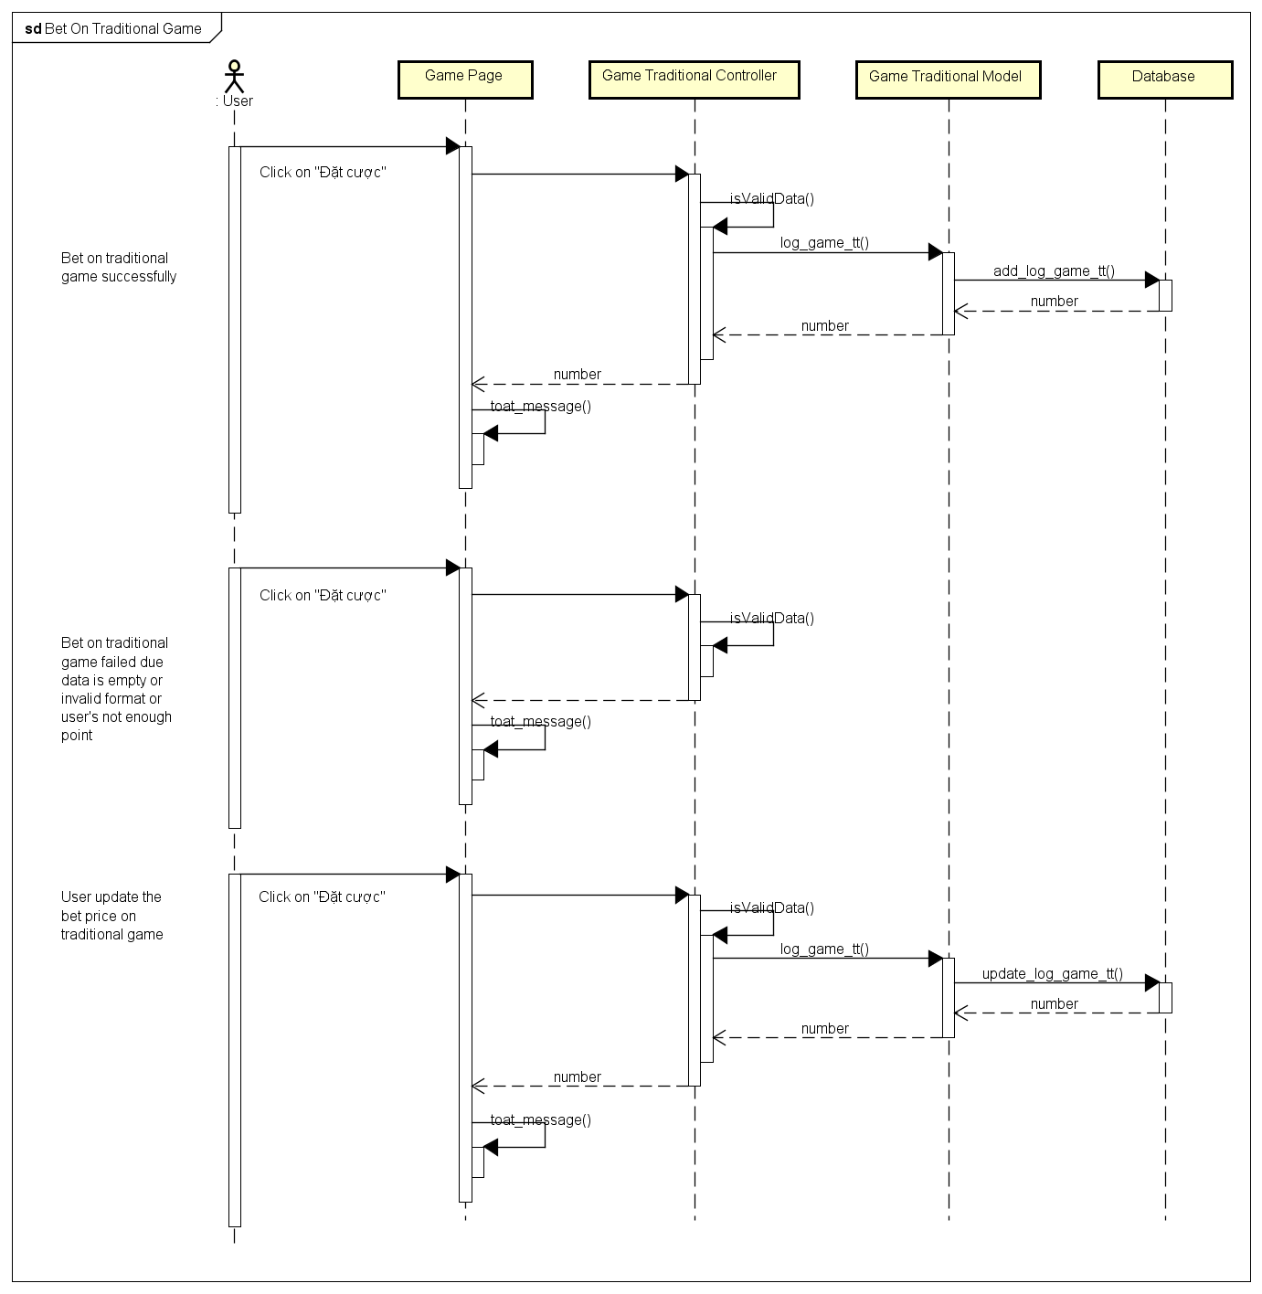

4.4.A.14. Bet On Challenge Game

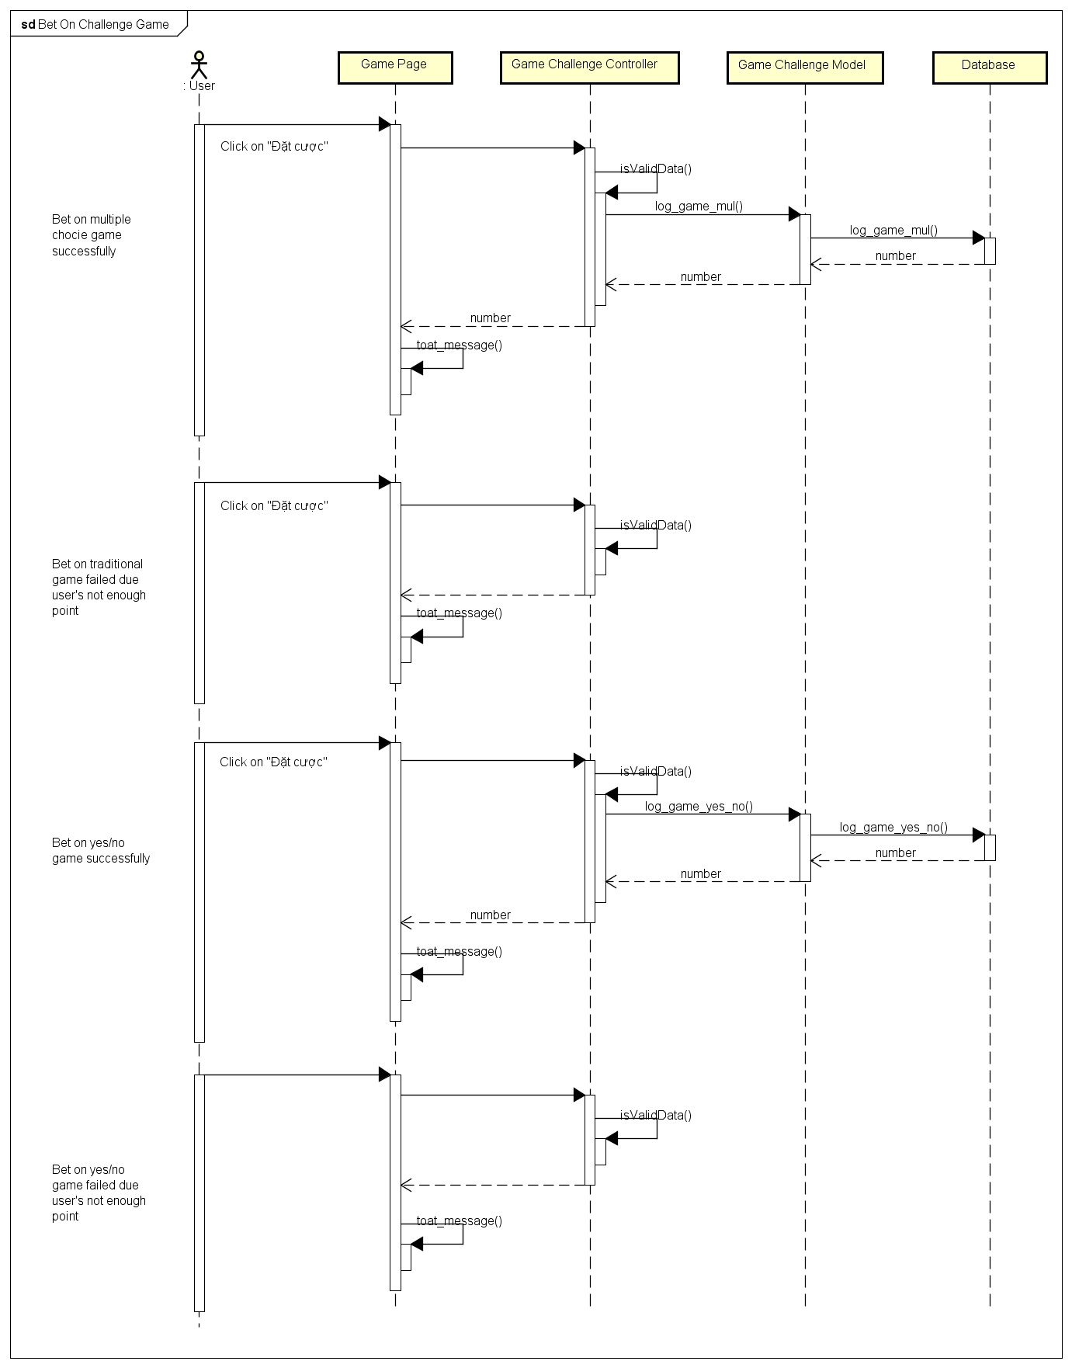

4.4.B. Admin Sequence Diagram

4.4.B.1. Login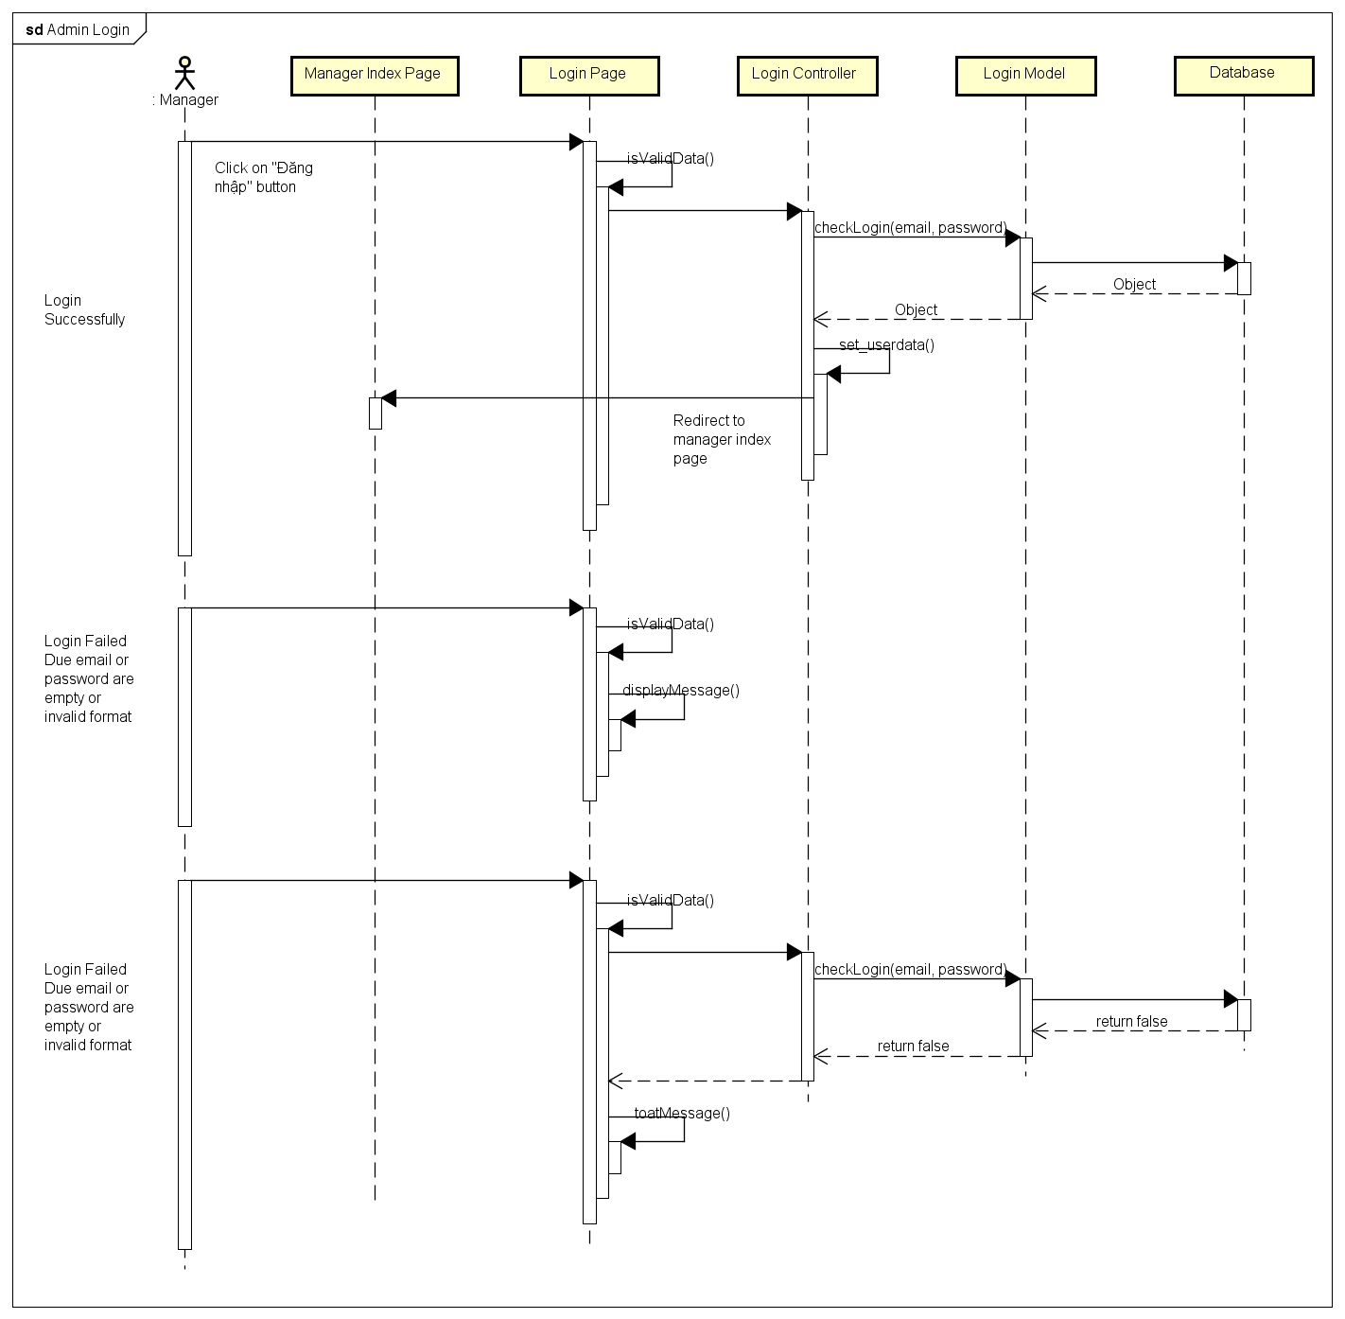

4.4.B.2. Notification

4.4.B.3. Send Notification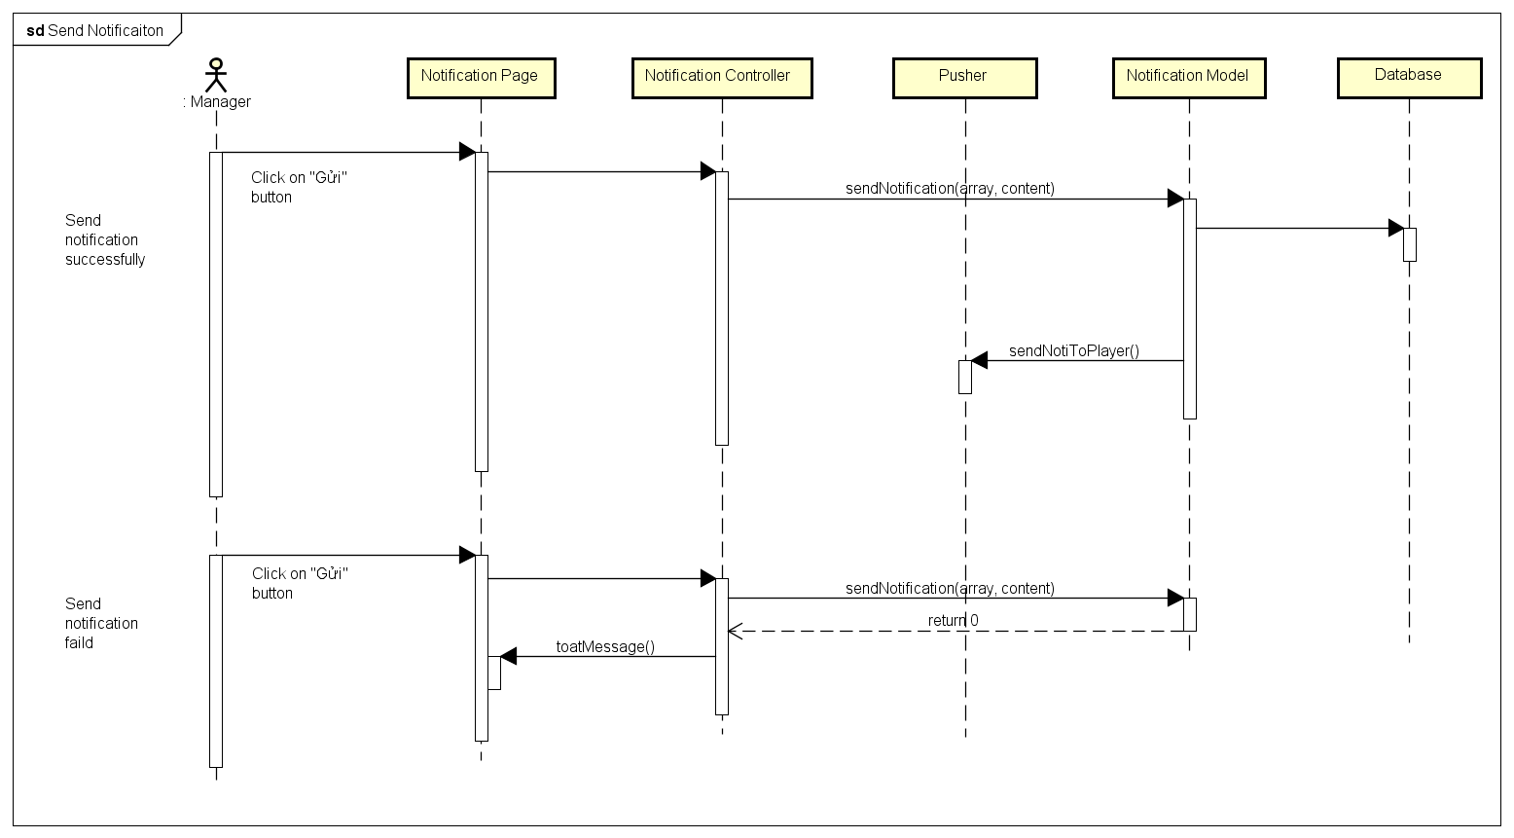

4.4.B.4. Delete Notification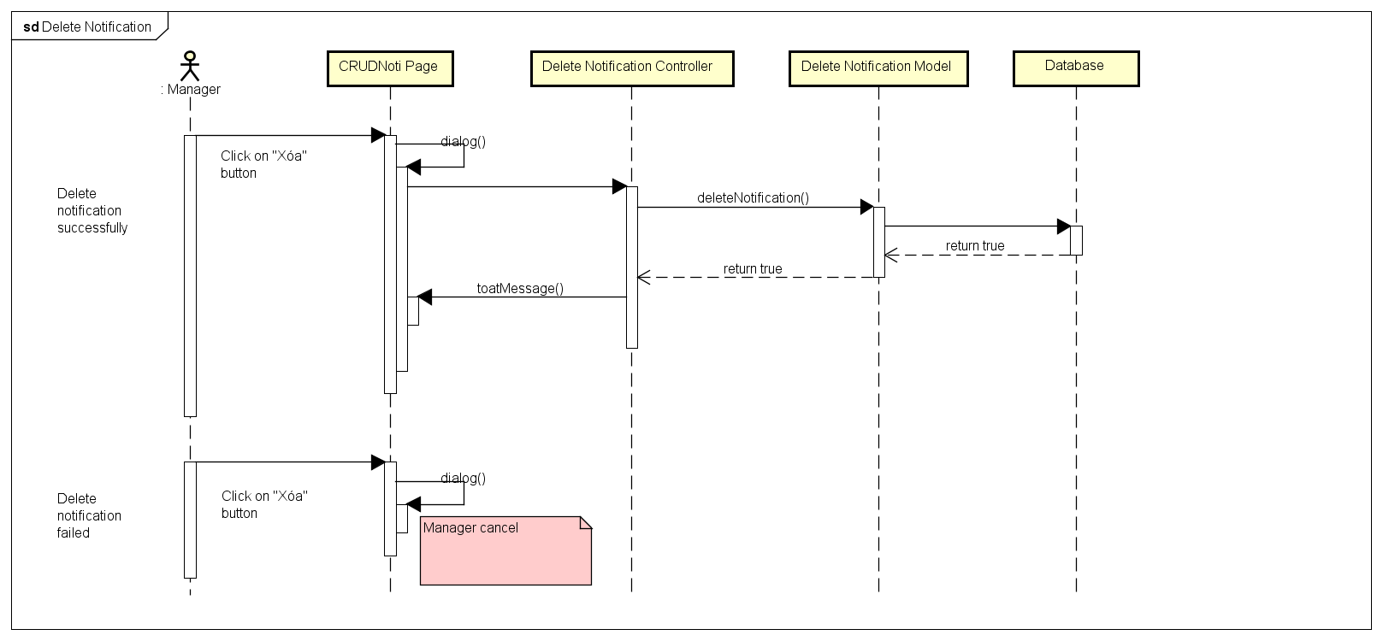

4.4.B.5. Edit Notification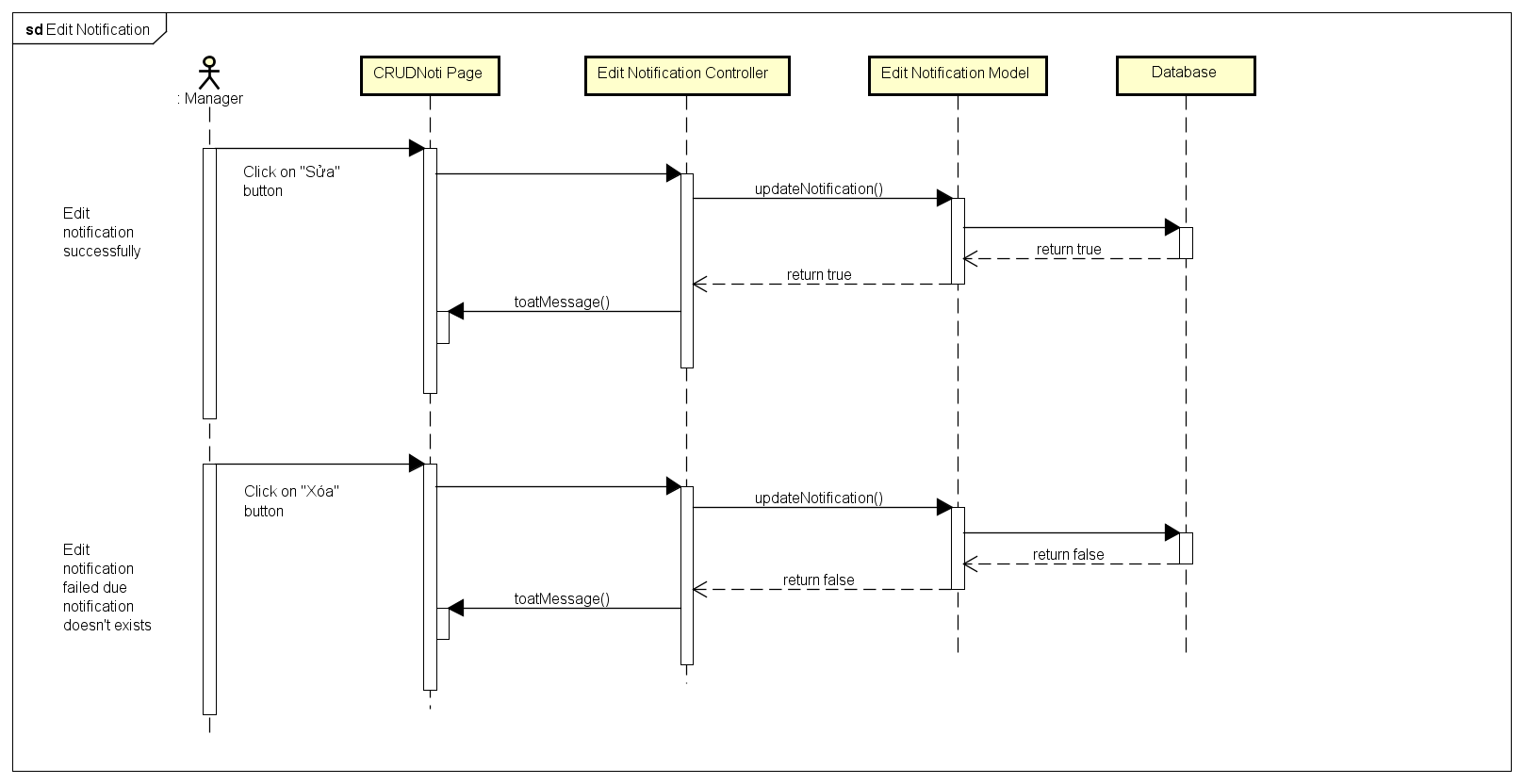

4.4.B.6. Search Game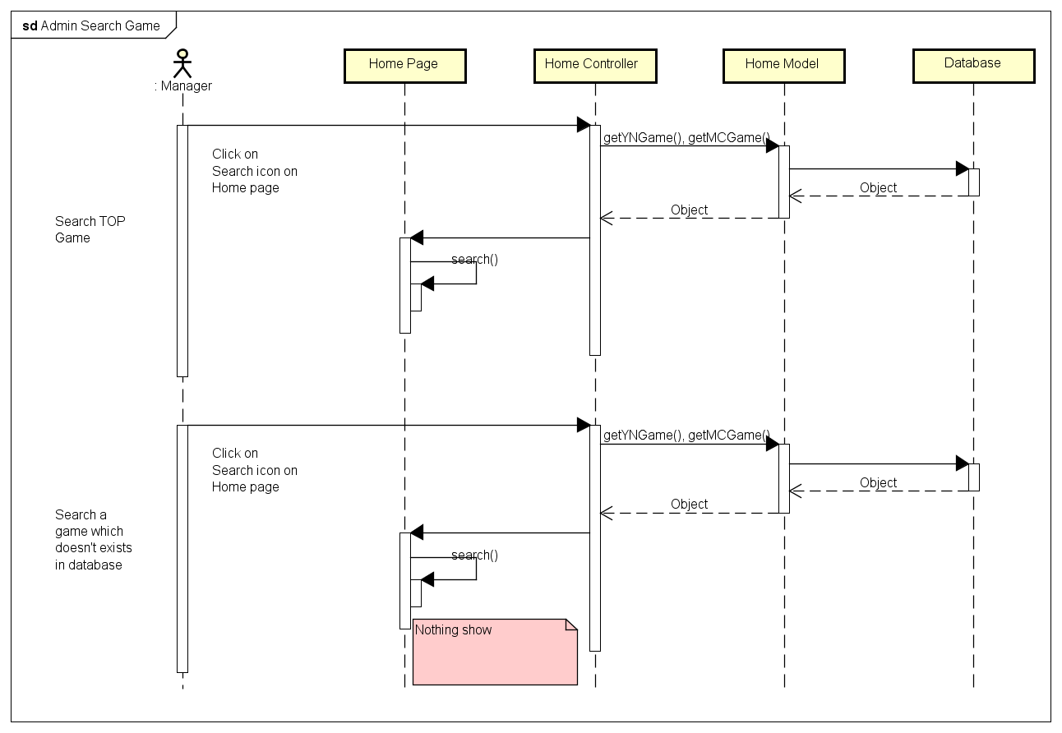

4.4.B.7. Search Member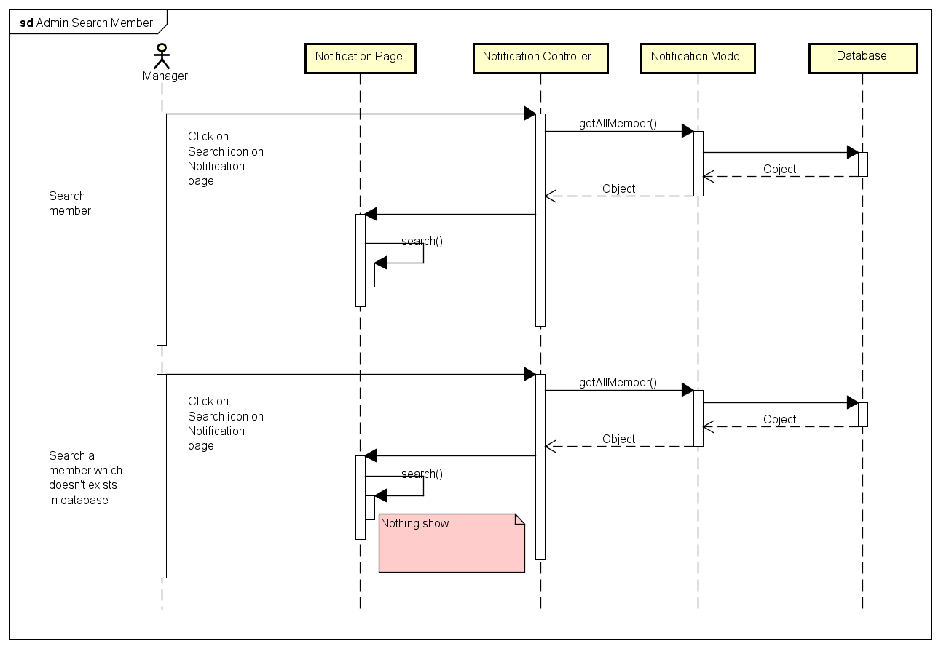

4.4.B.8. Block Manager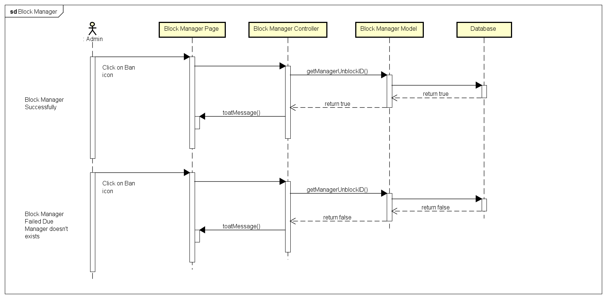

4.4.B.9. Unblock Manager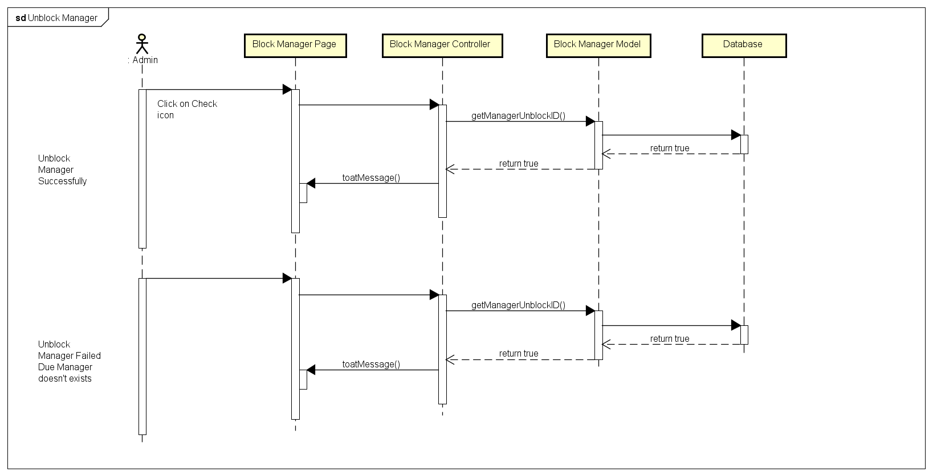

4.4.B.10. Change Gift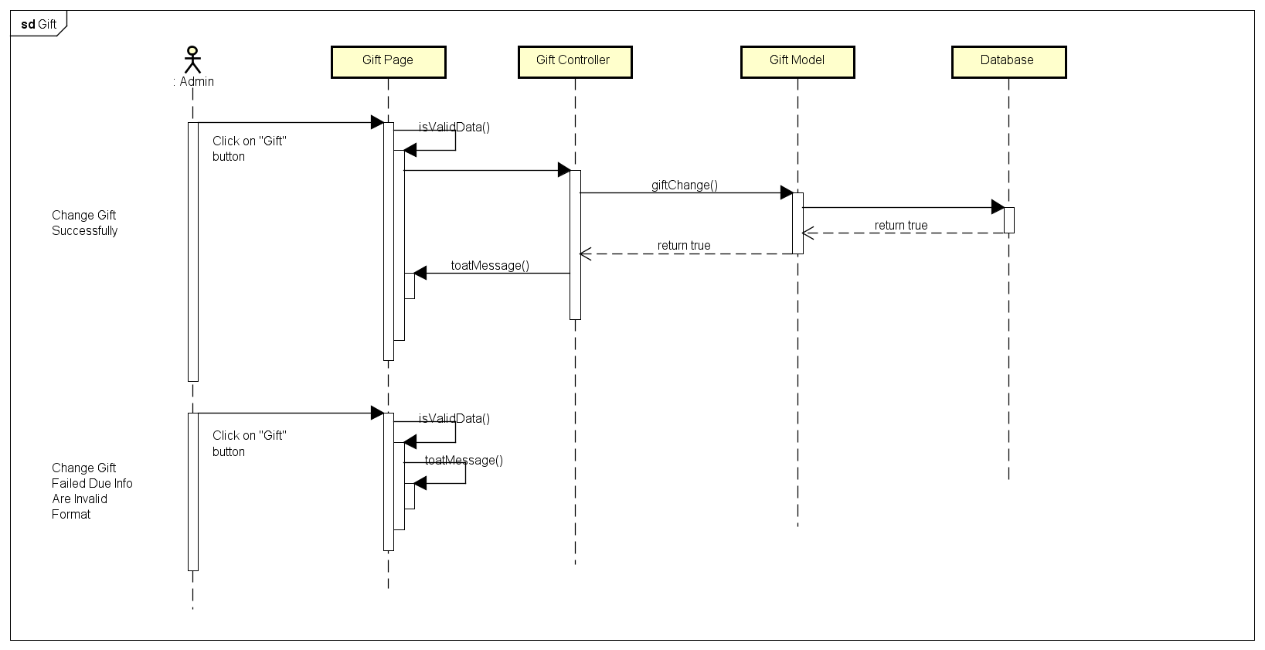

4.4.B.11. History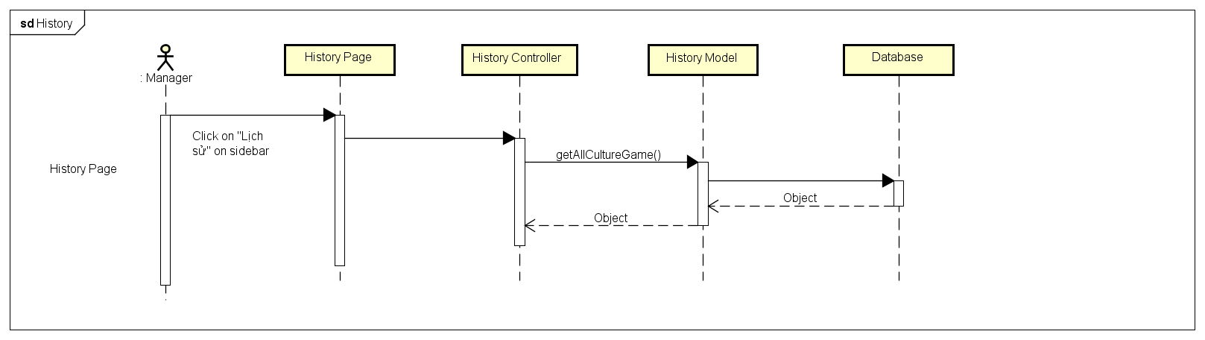

4.4.B.12. Create Game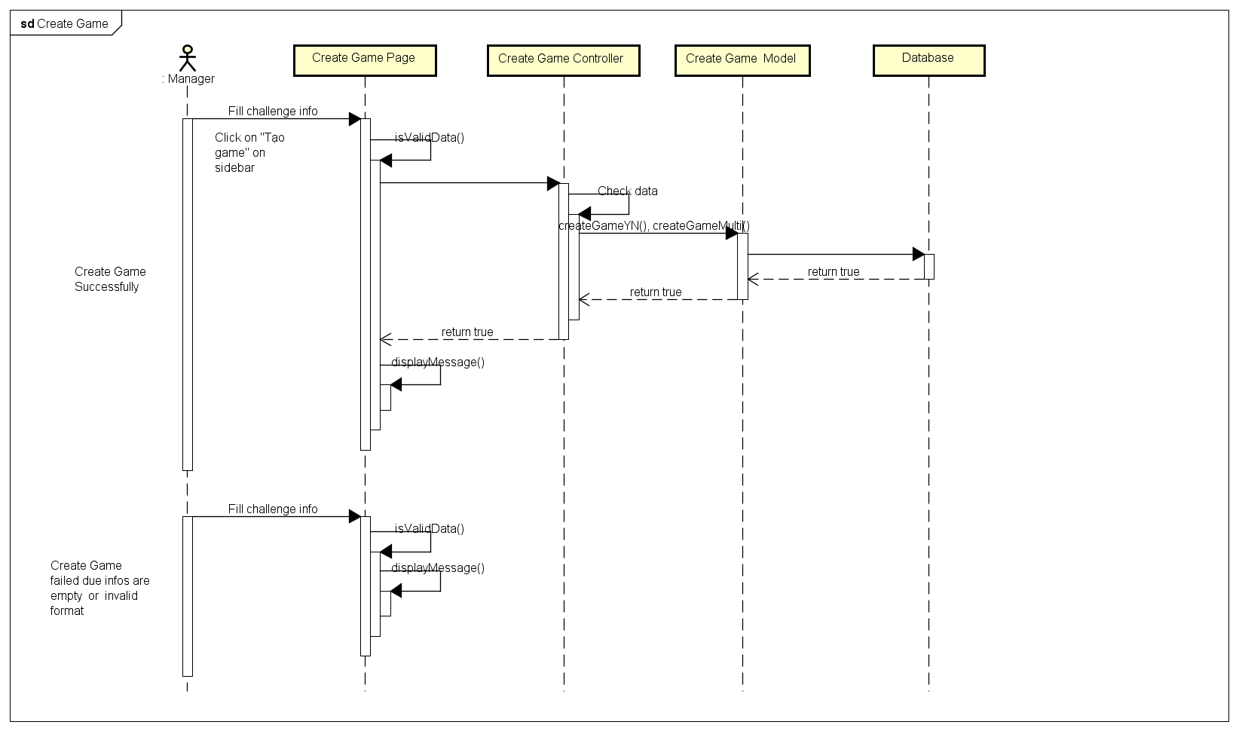

4.4.B.13. Edit Manager Information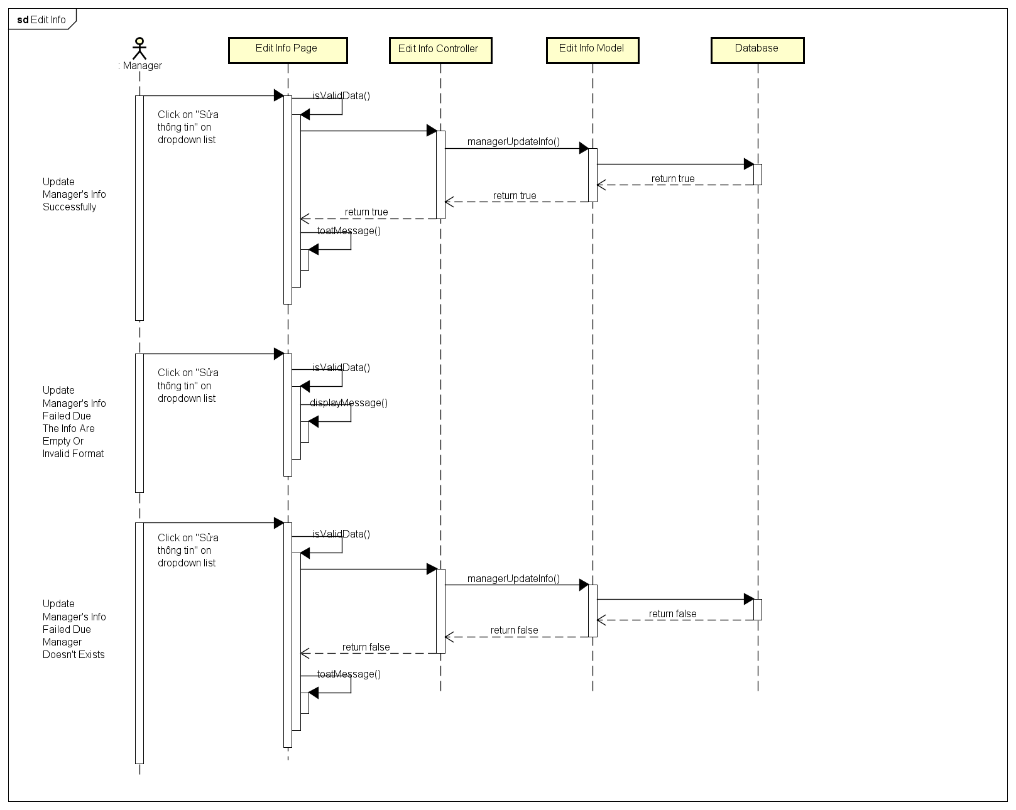

4.4.B.14. View Manager Information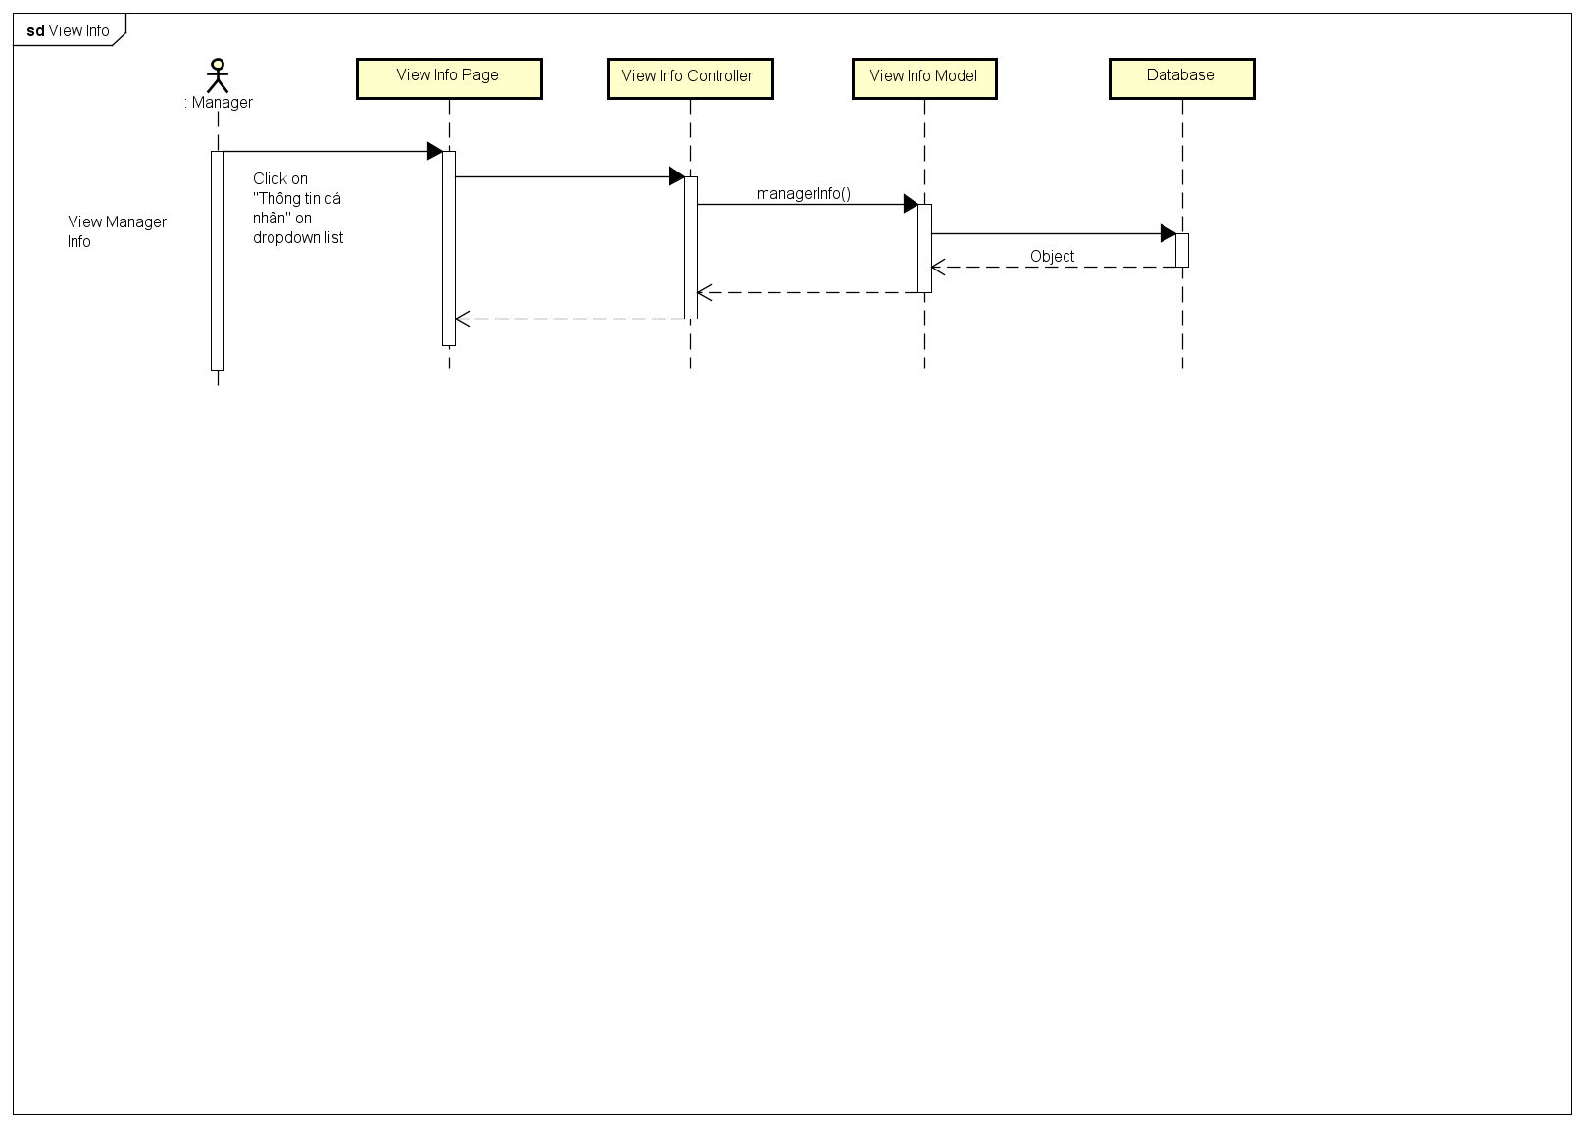

4.4.B.15. Change Password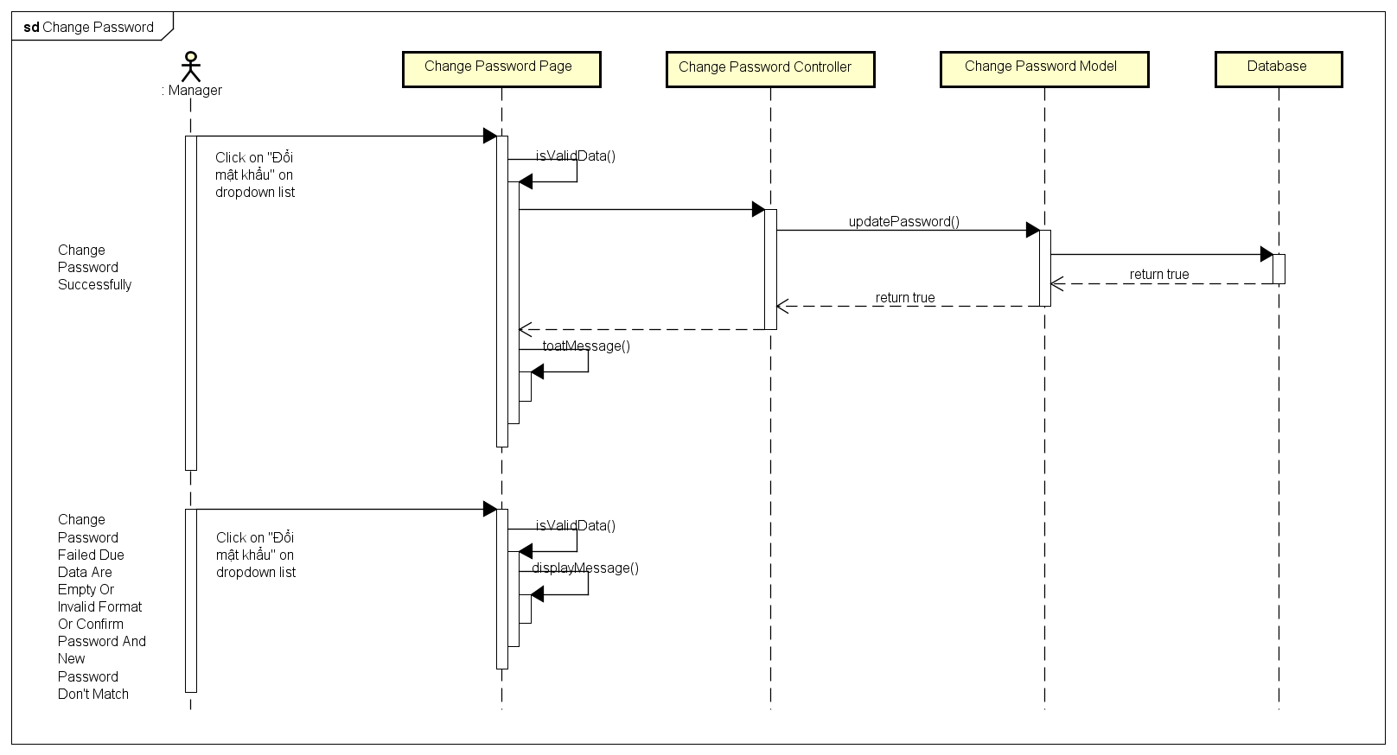

4.4.B.16. Forgot Password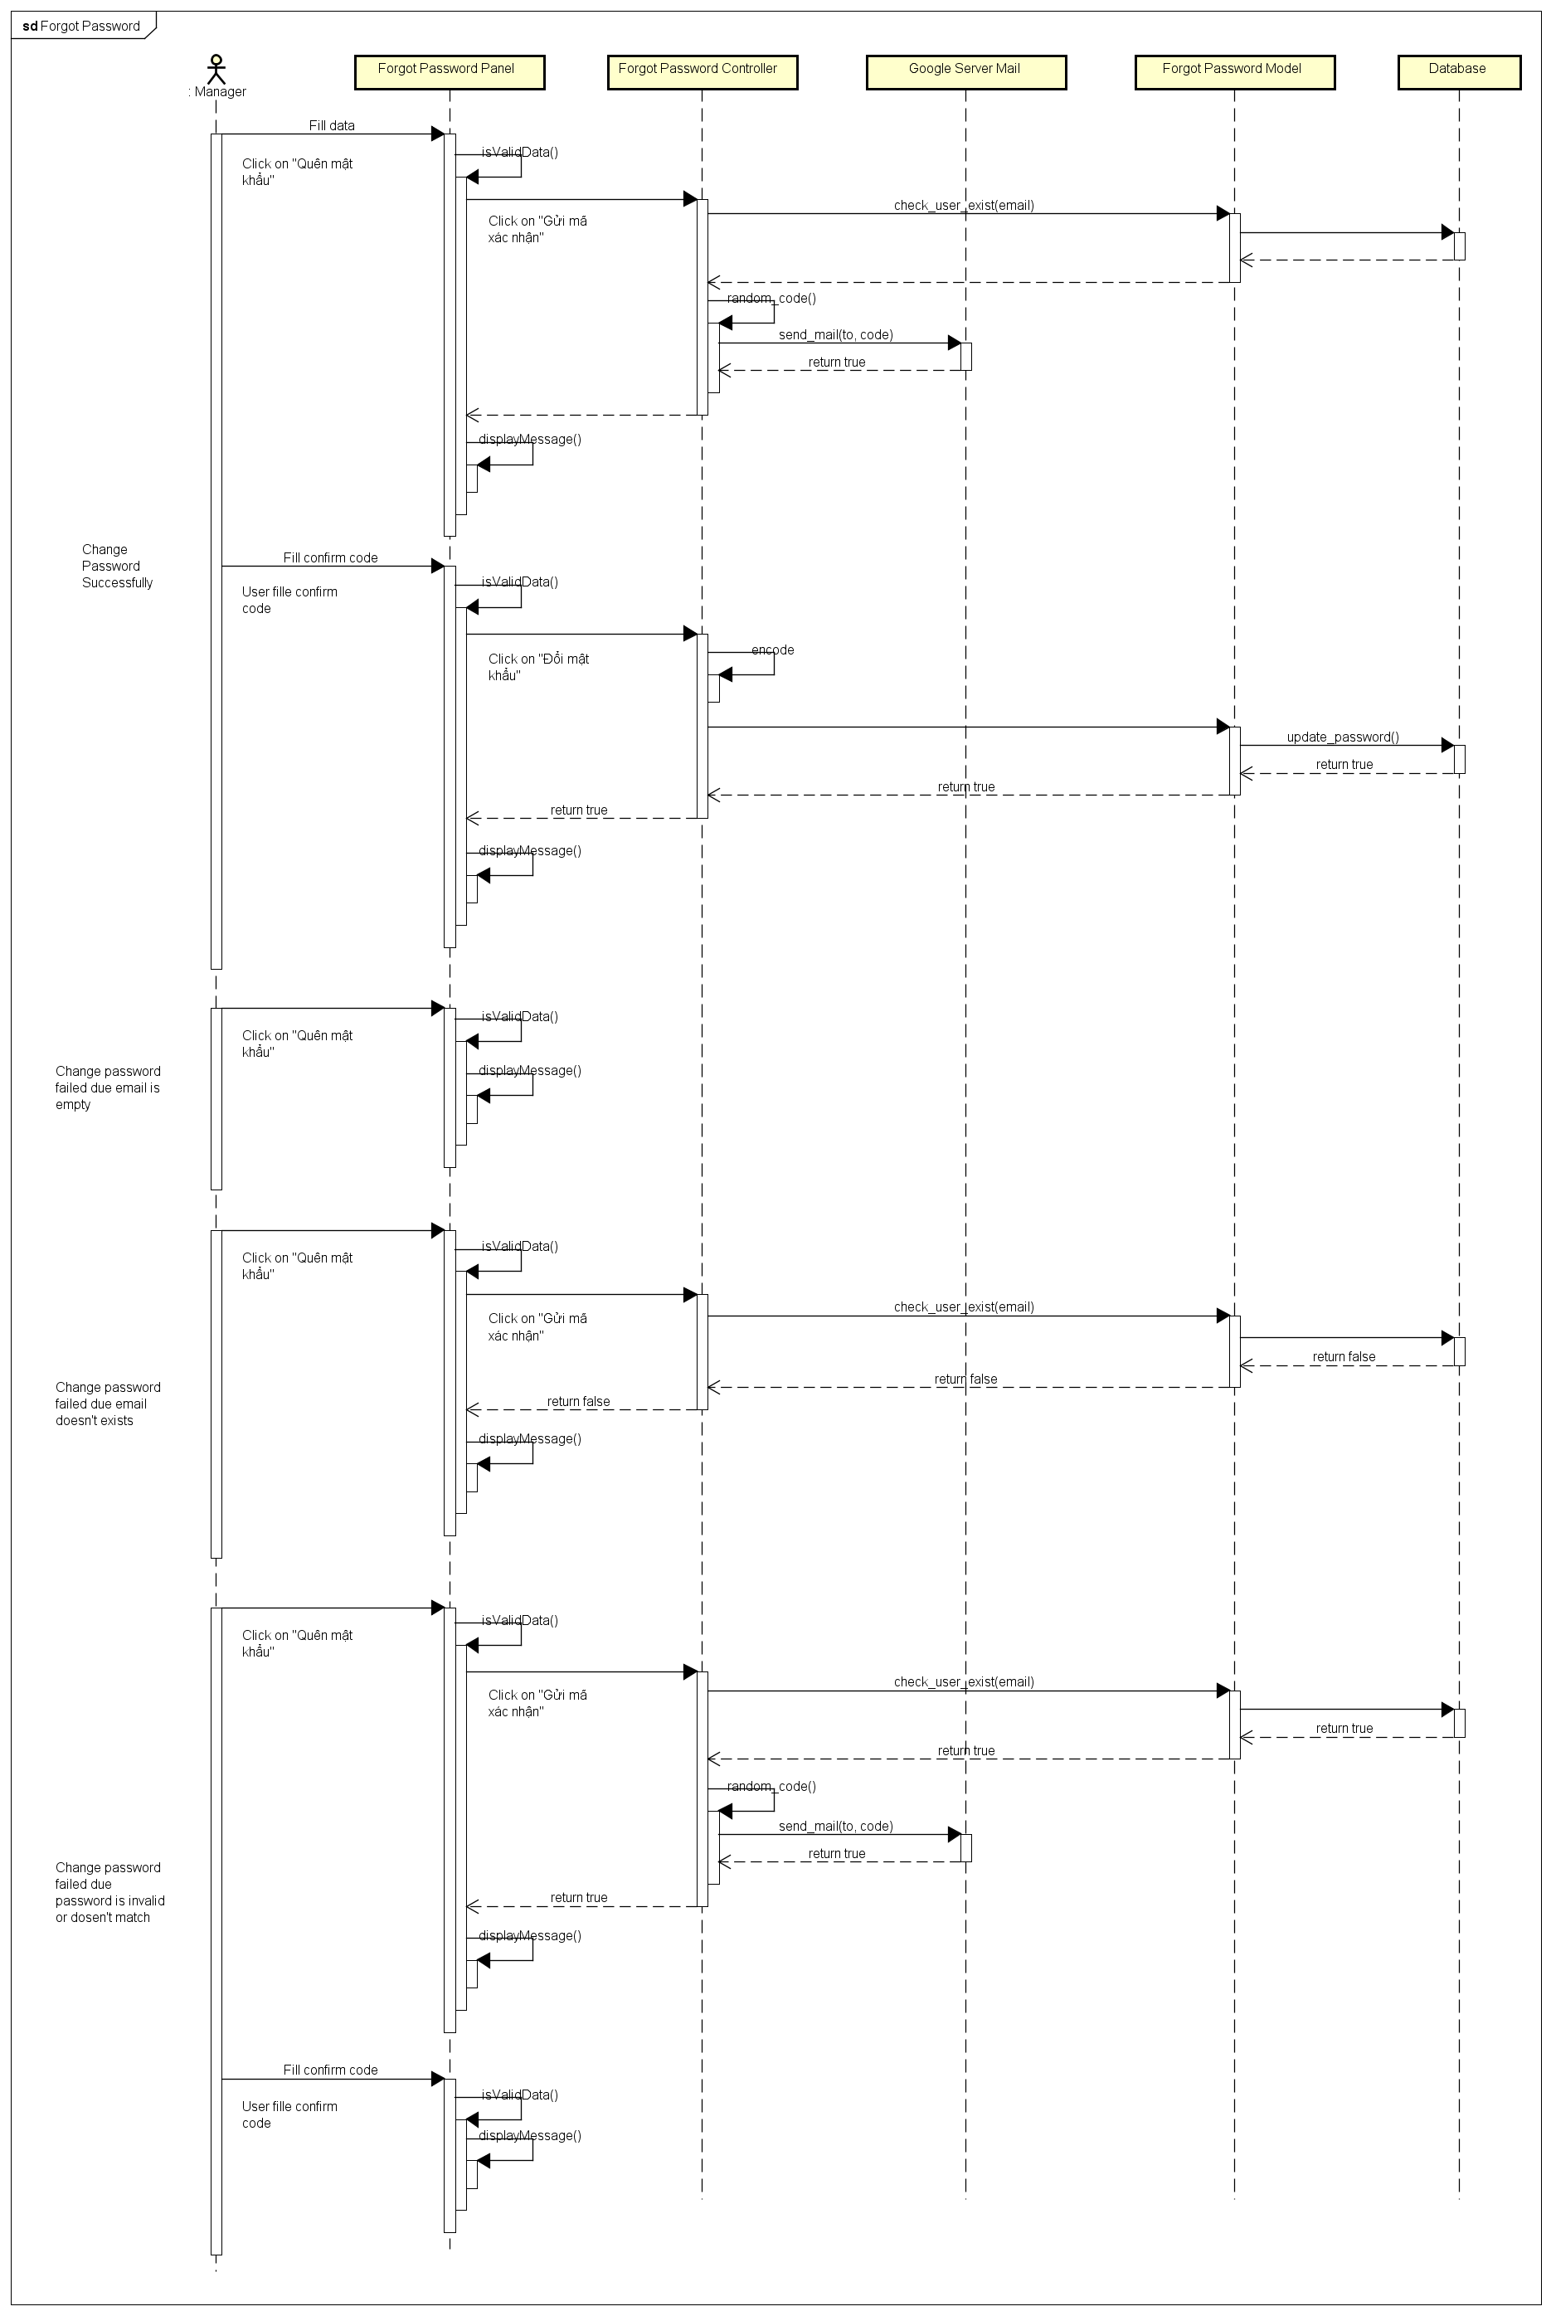

4.5.A. Activities Diagram

4.5.A.1. Register and Login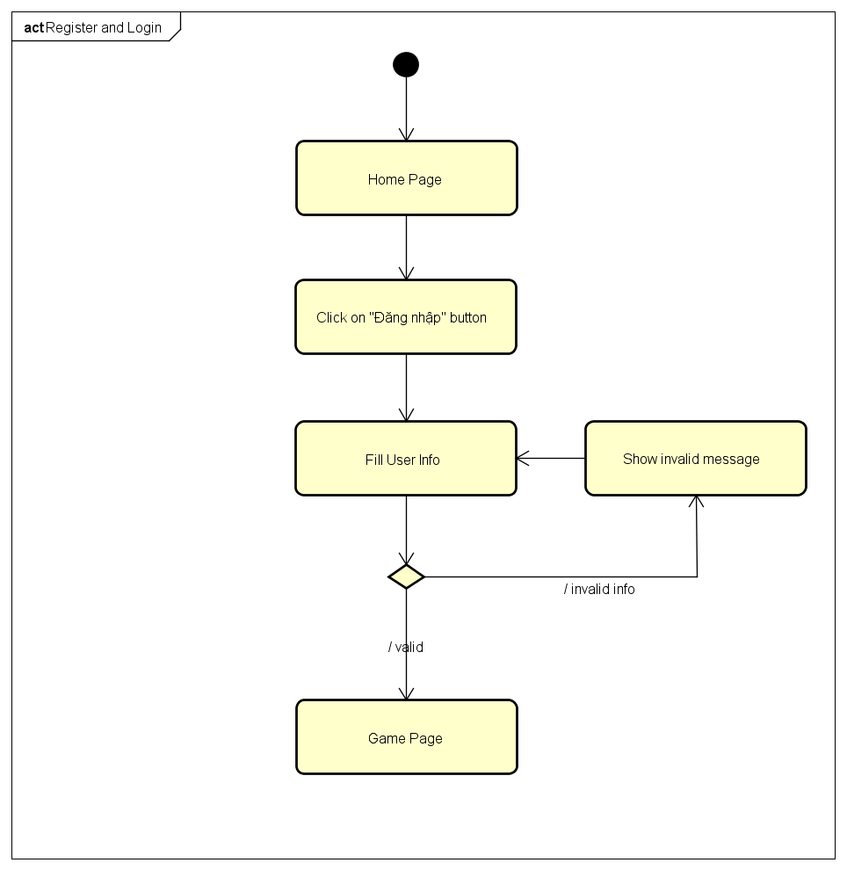

4.5.A.2. Login Using Facebook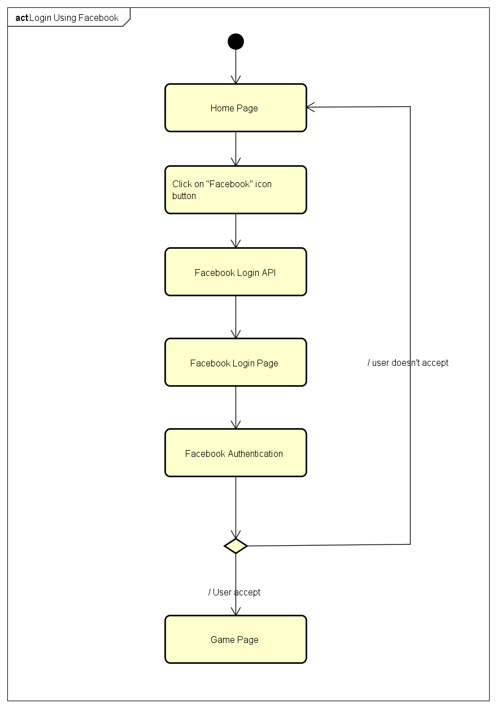

4.5.A.3. Login Using Google Plus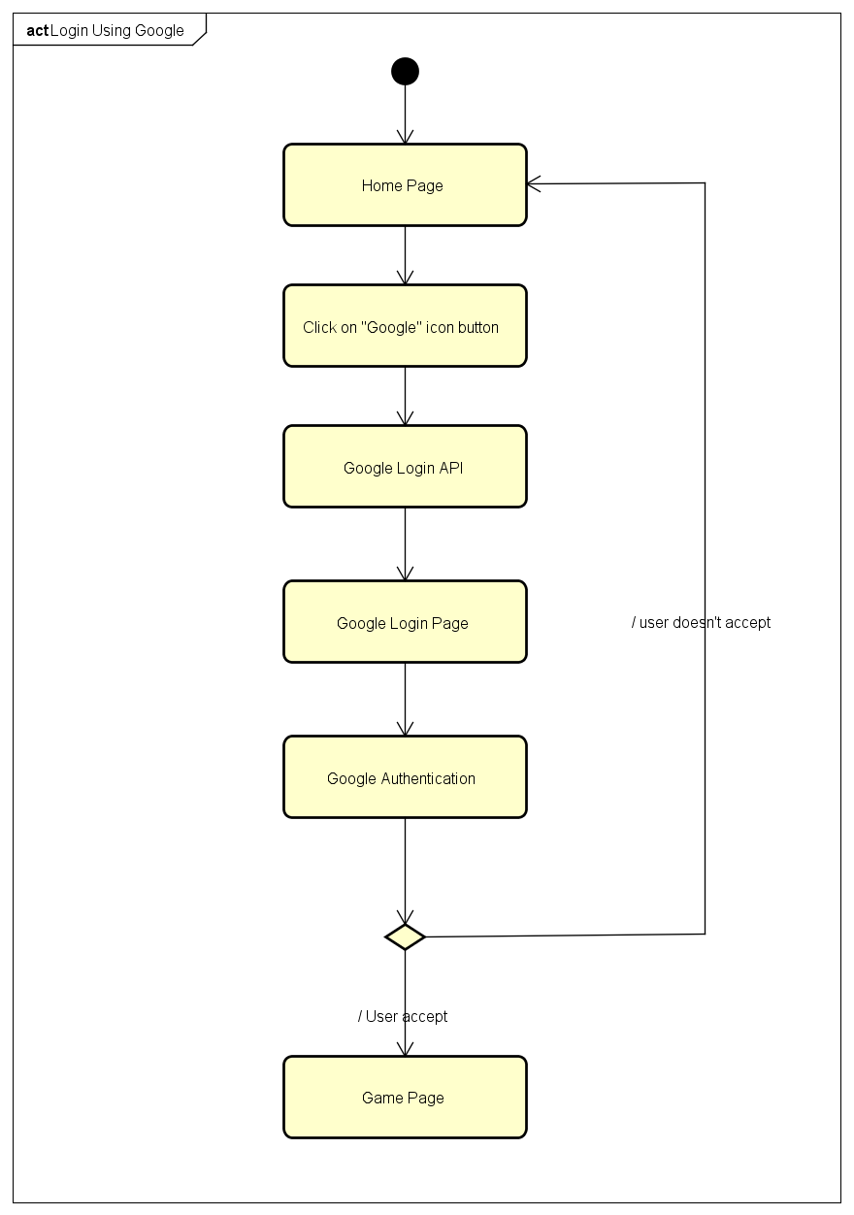

4.5.A.4. Logout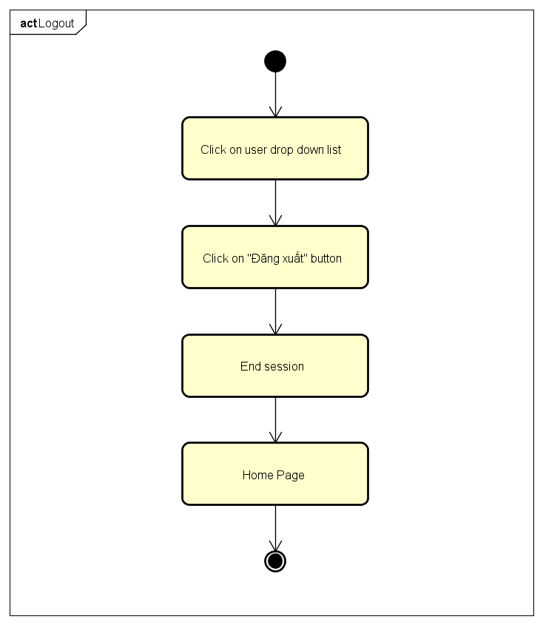

4.5.A.5. Change Password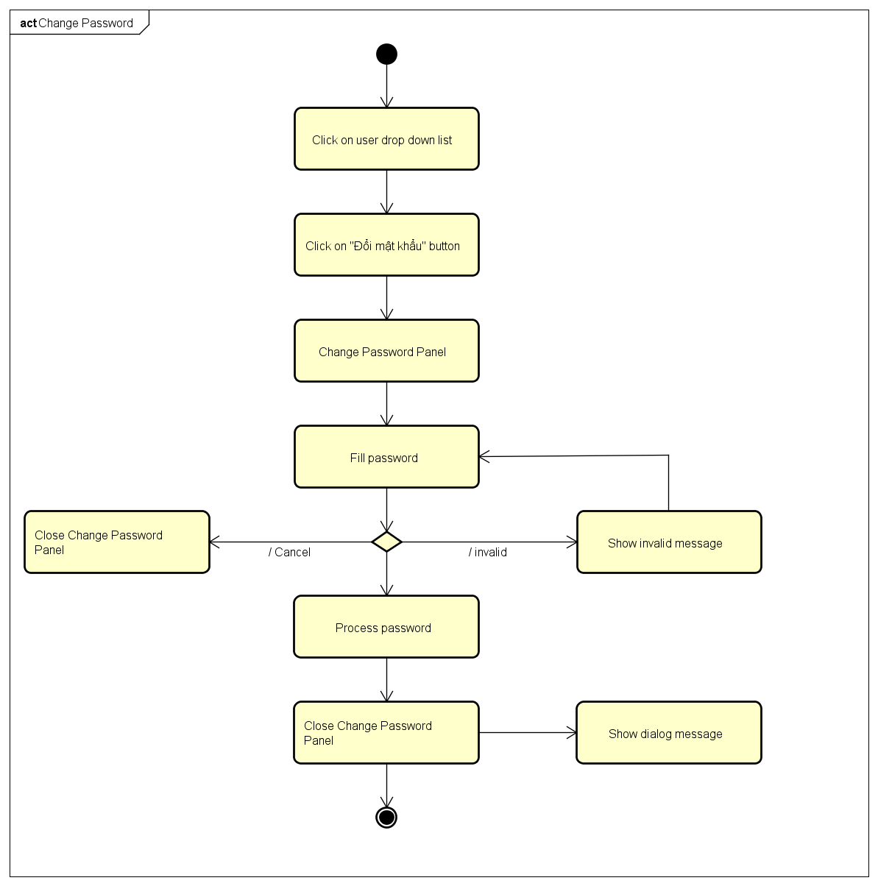

4.5.A.6. Forgot Password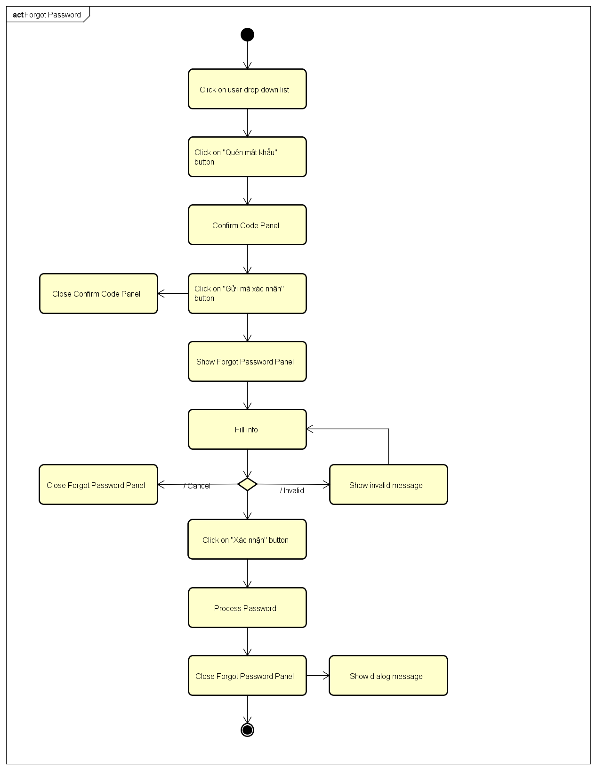

4.5.A.7. Edit Profile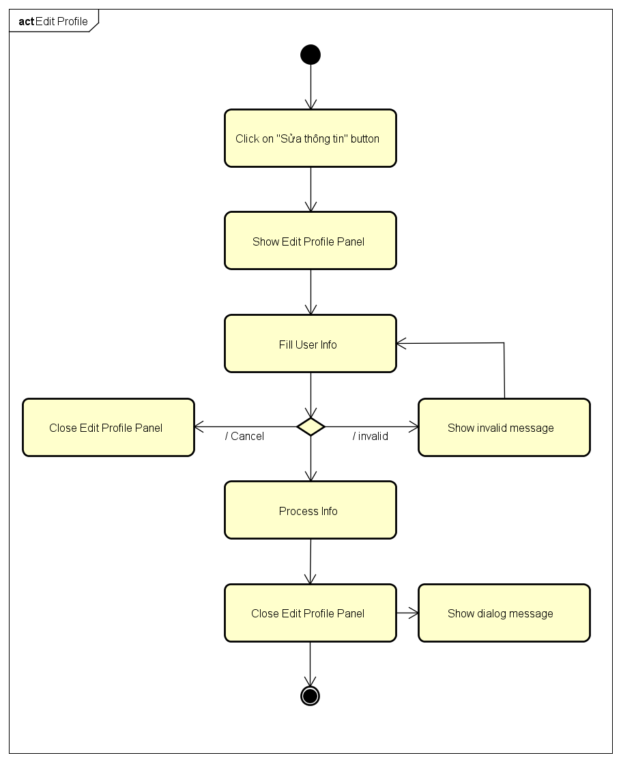

4.5.A.8. History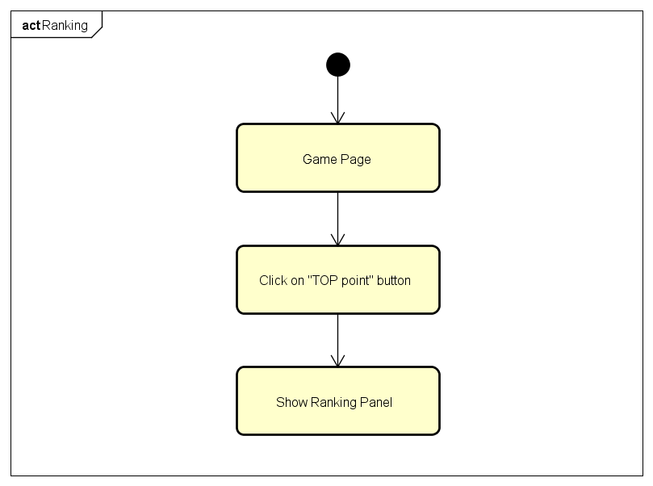

4.5.A.9. Notification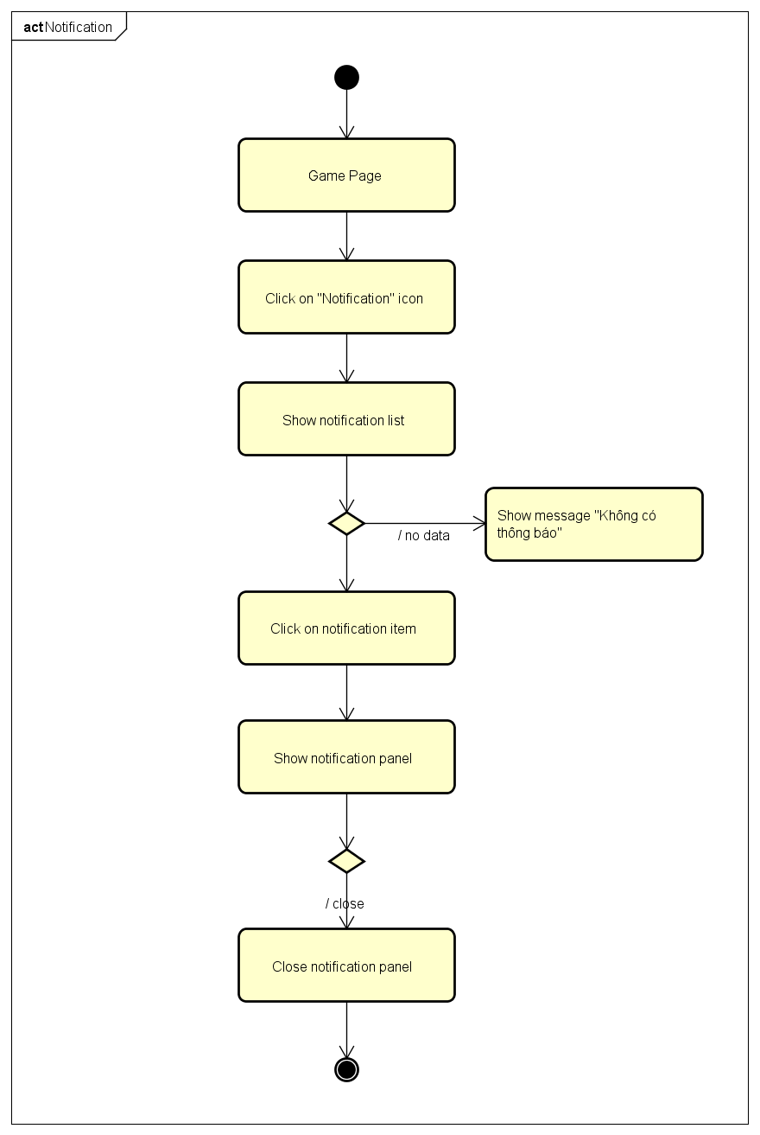

4.5.A.10. Ranking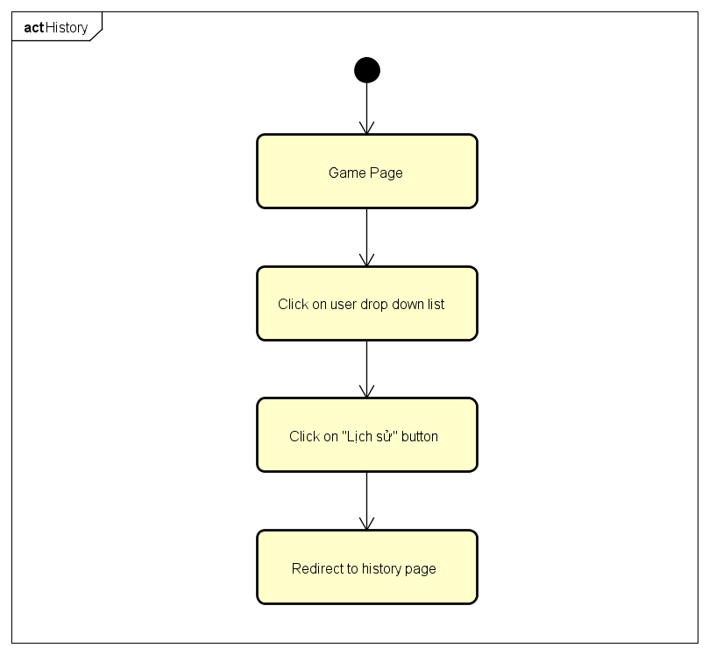

4.5.A.11. Create Challenges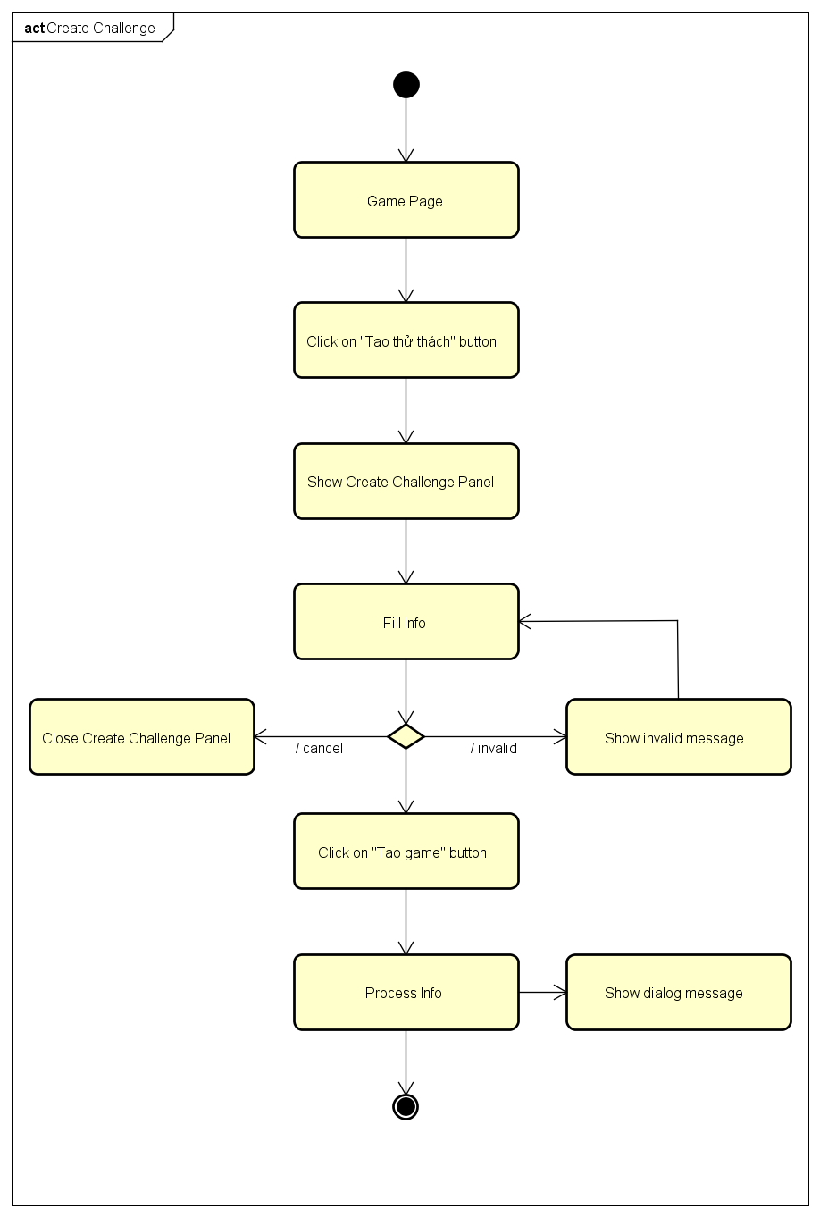

4.5.A.12. Bet On Traditional Game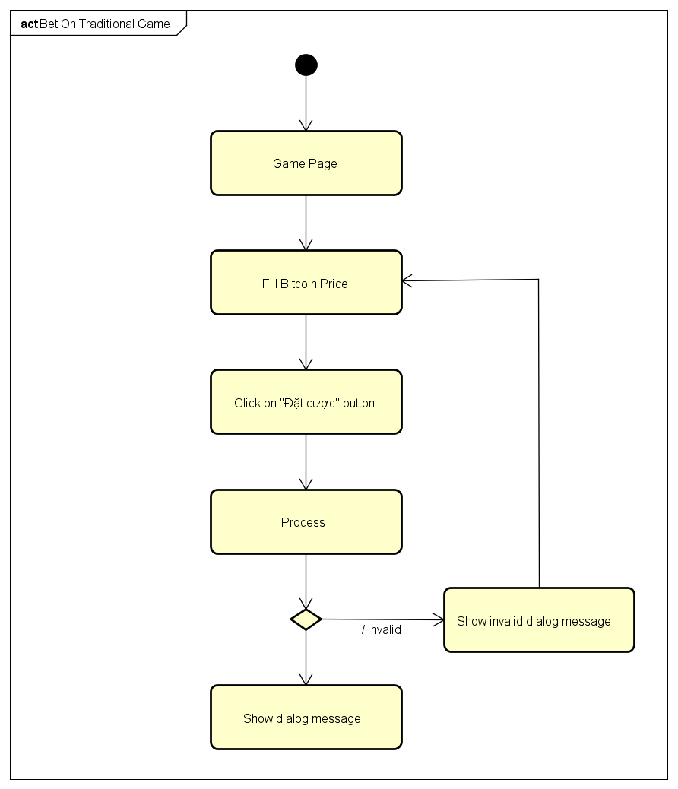

4.5.A.13. Bet On Challenge Game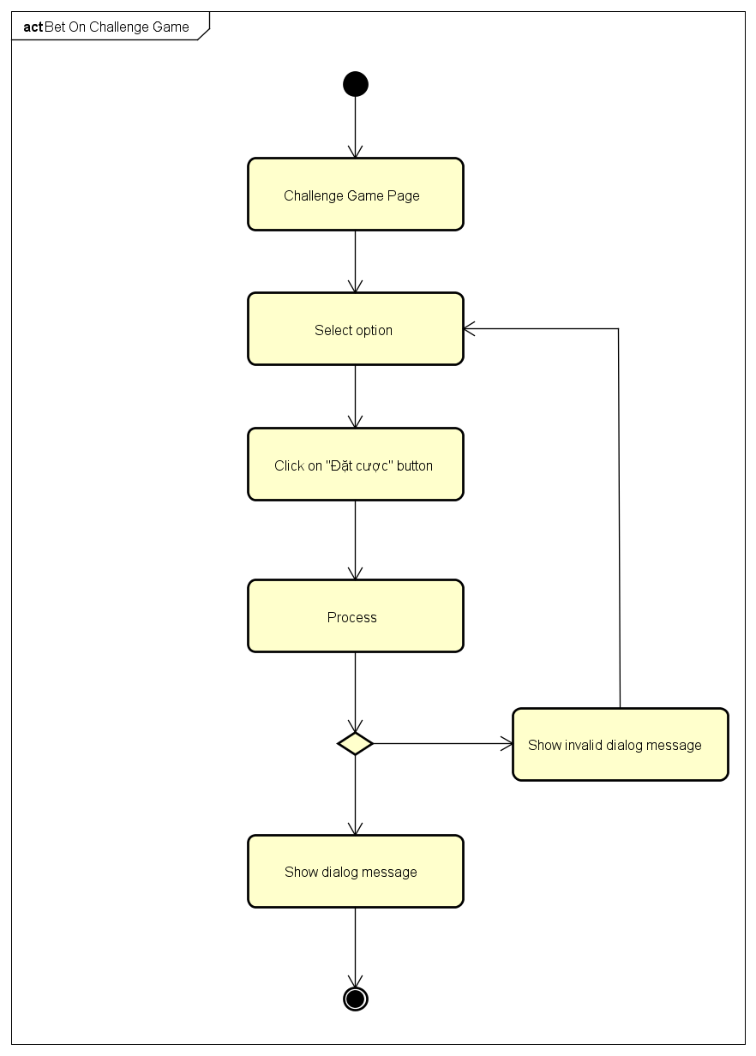

4.5.B. Admin Activities Diagram

4.5.B.1. Login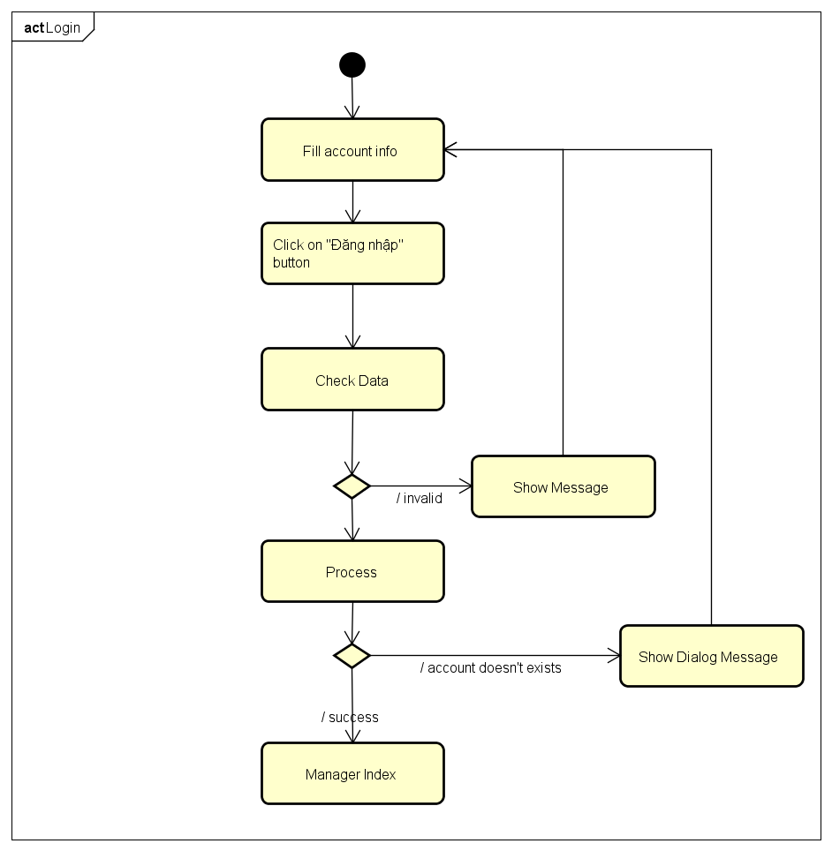

4.5.B.2.Send Notification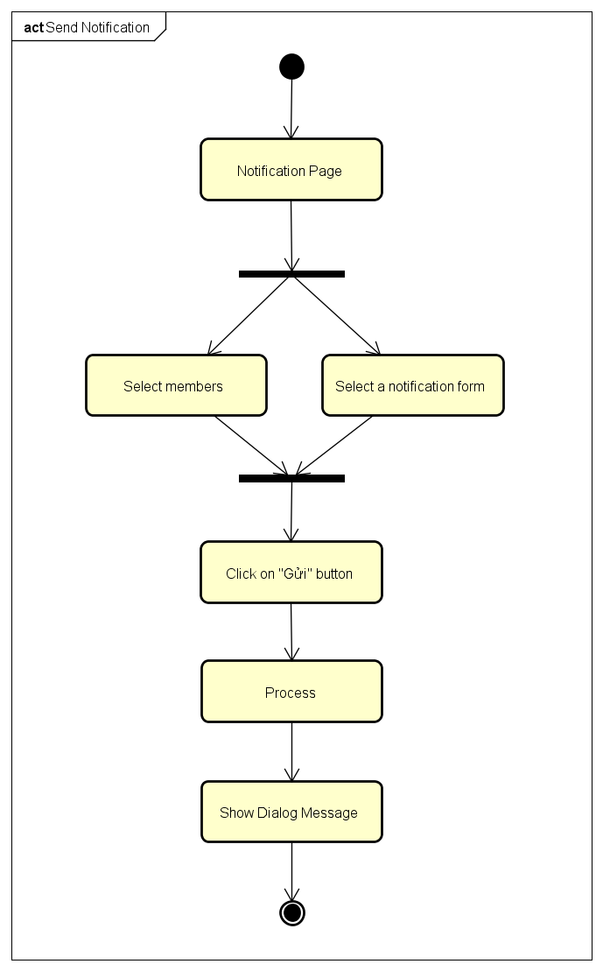

4.5.B.3.Add Notification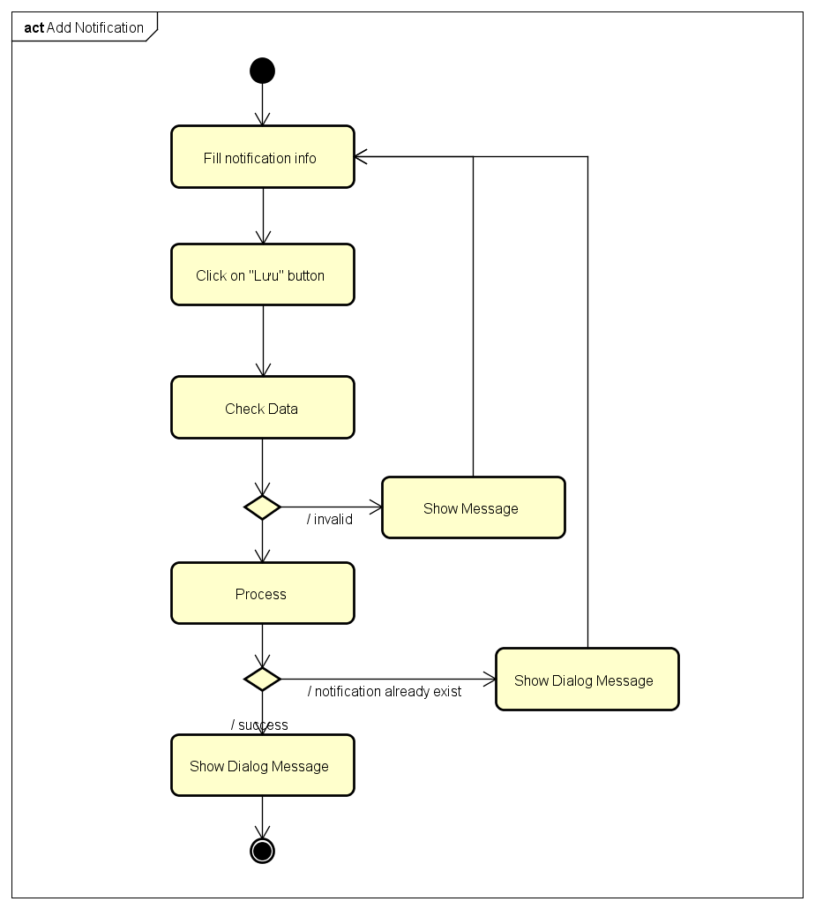

4.5.B.4.Delete Notification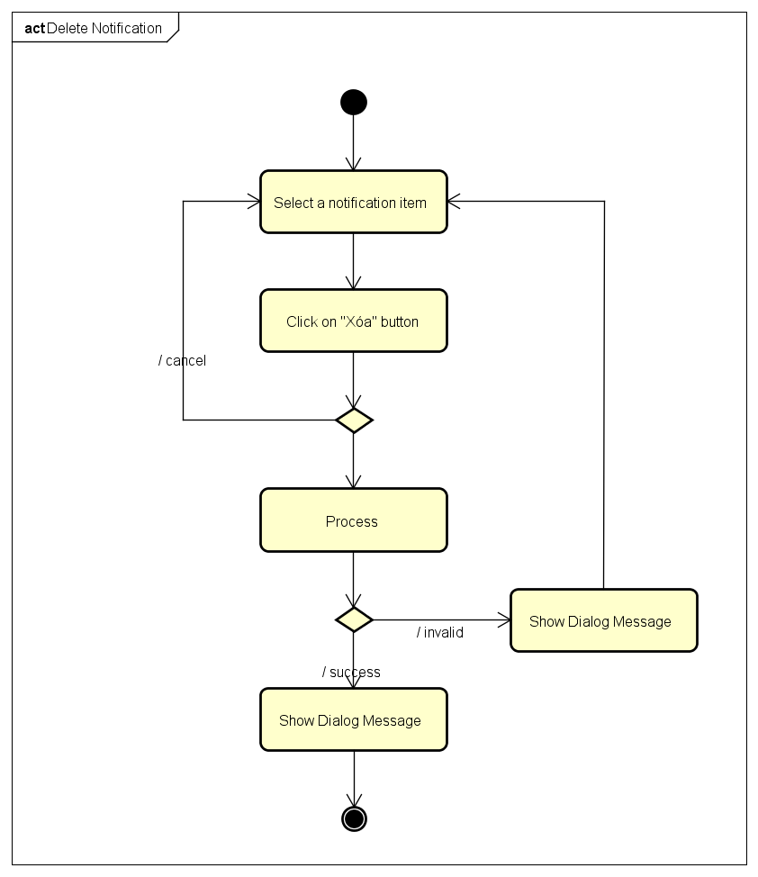

4.5.B.5.Edit Notification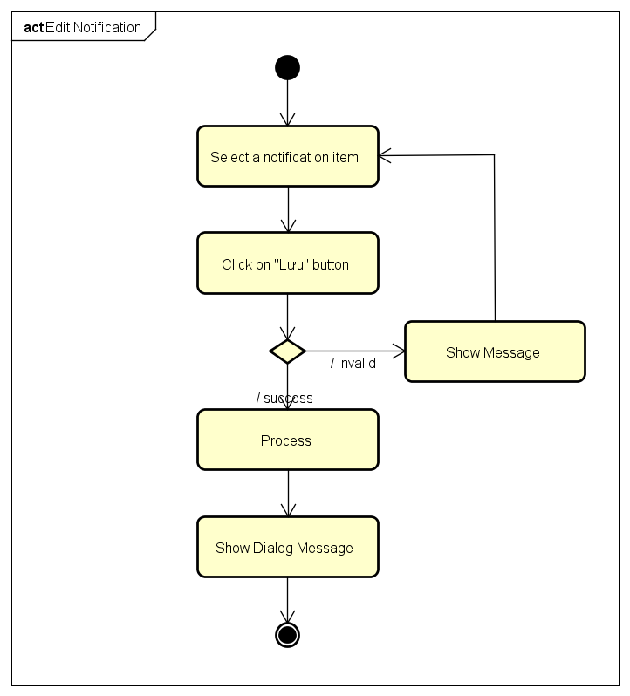

4.5.B.6.Search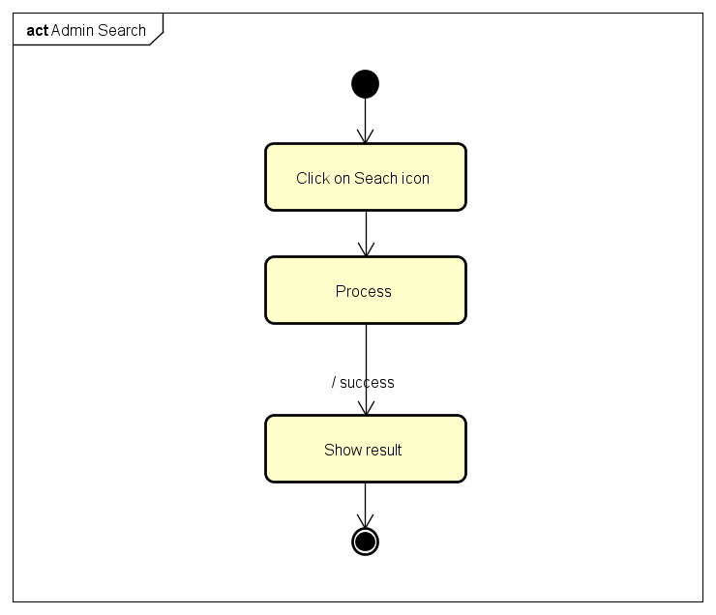

4.5.B.7.Block Manager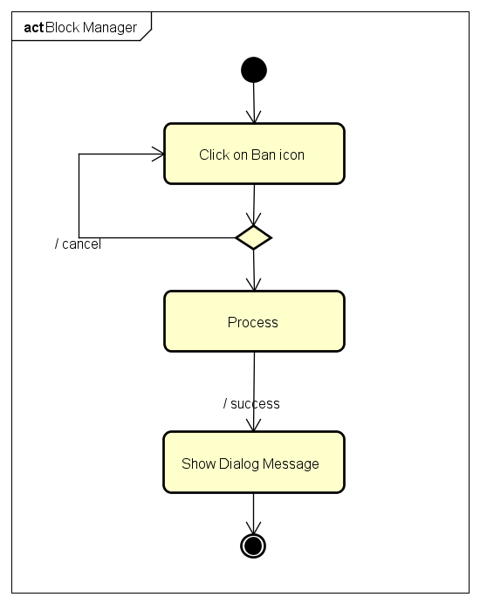

4.5.B.8.Unblock Manager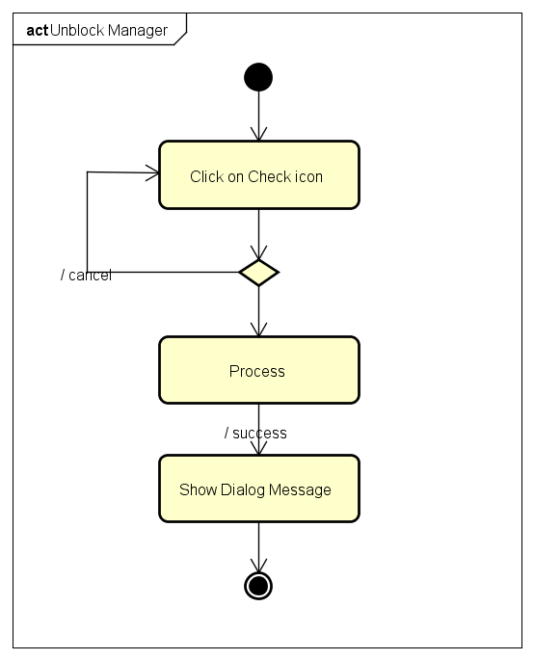

4.5.B.9.Change Gift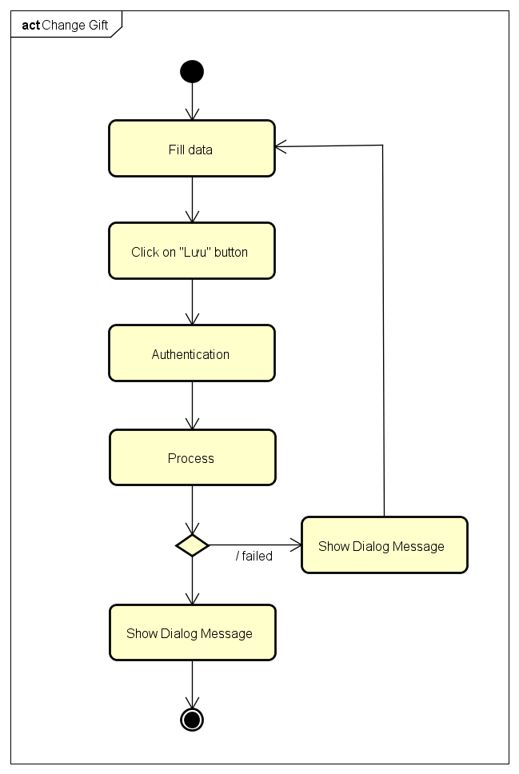

4.5.B.10.History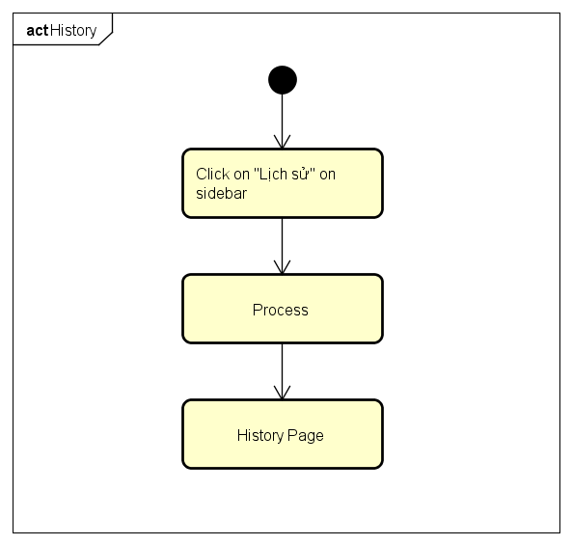

4.5.B.11.Create Game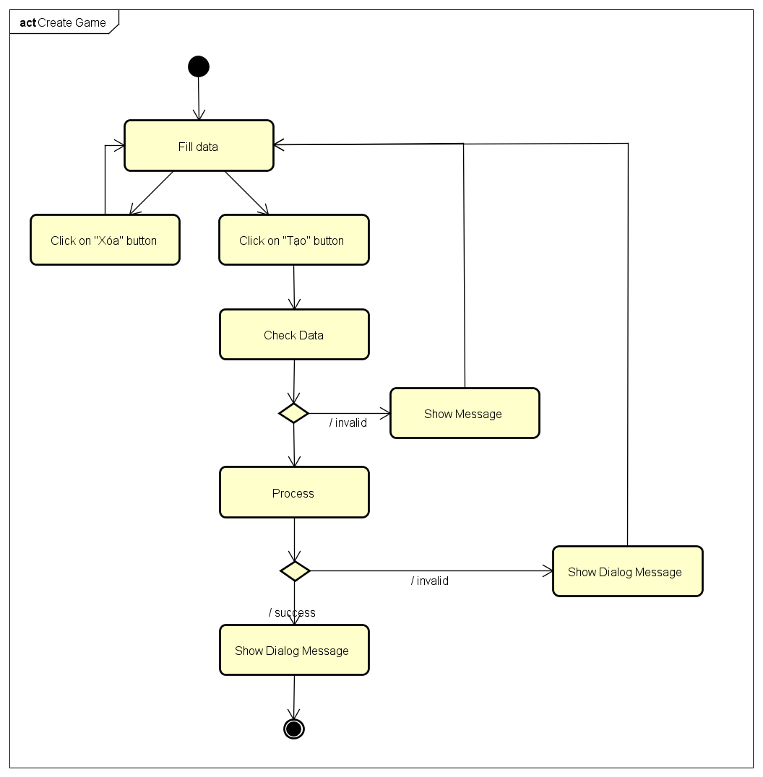

4.5.B.12.Edit Manager Information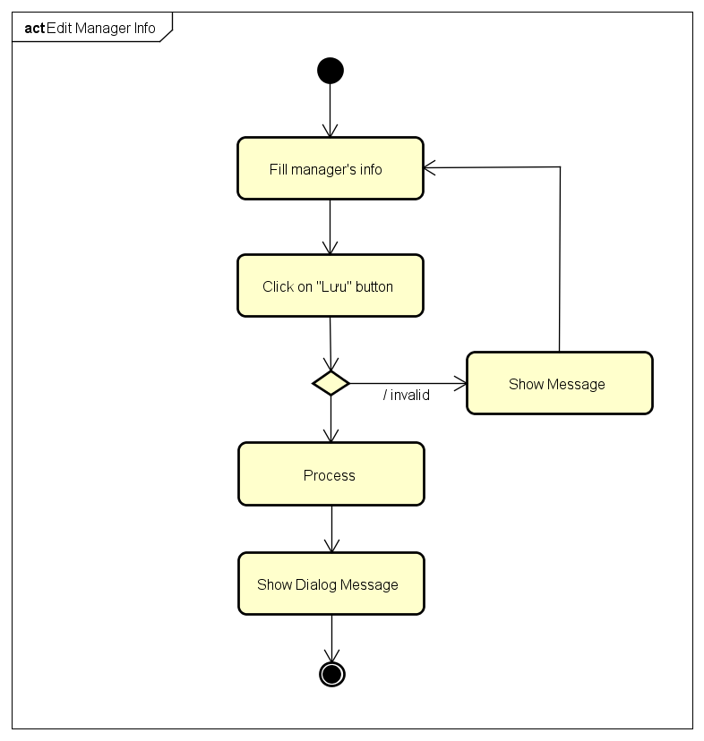

4.5.B.13.View Manager Information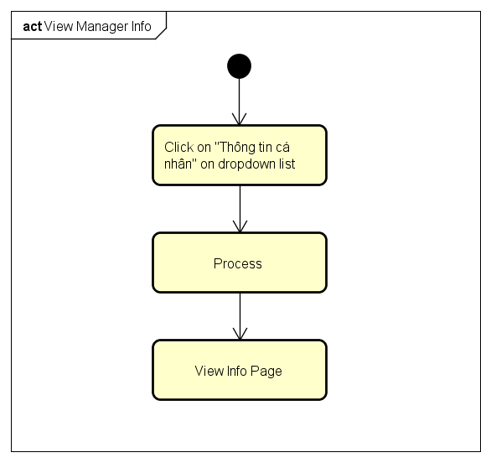

4.5.B.14.Change Password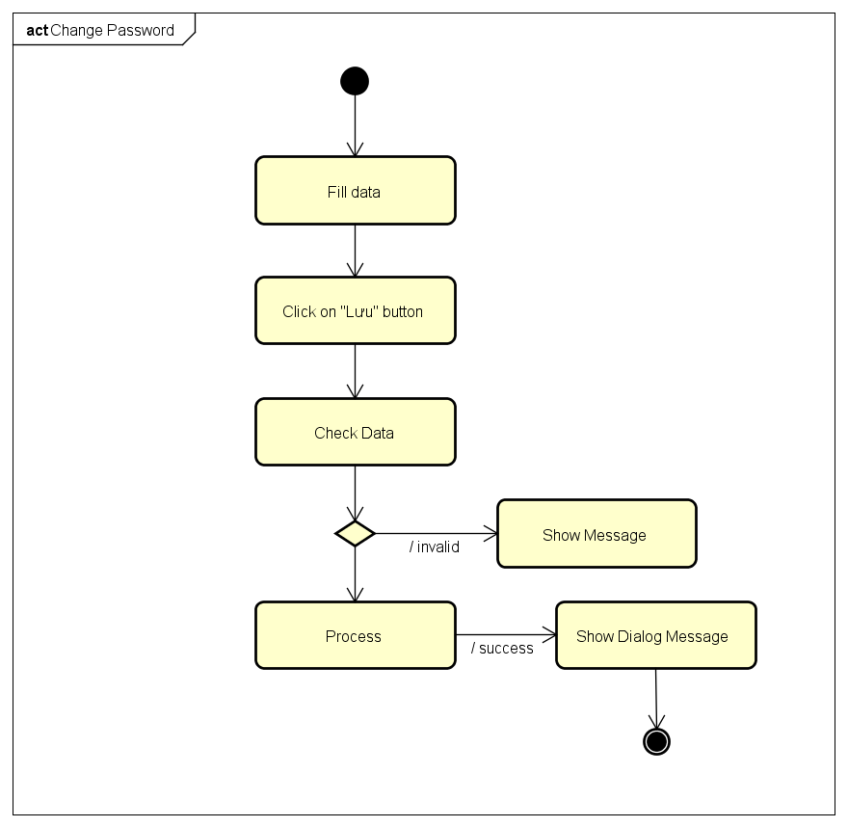

4.5.B.15.Forgot Password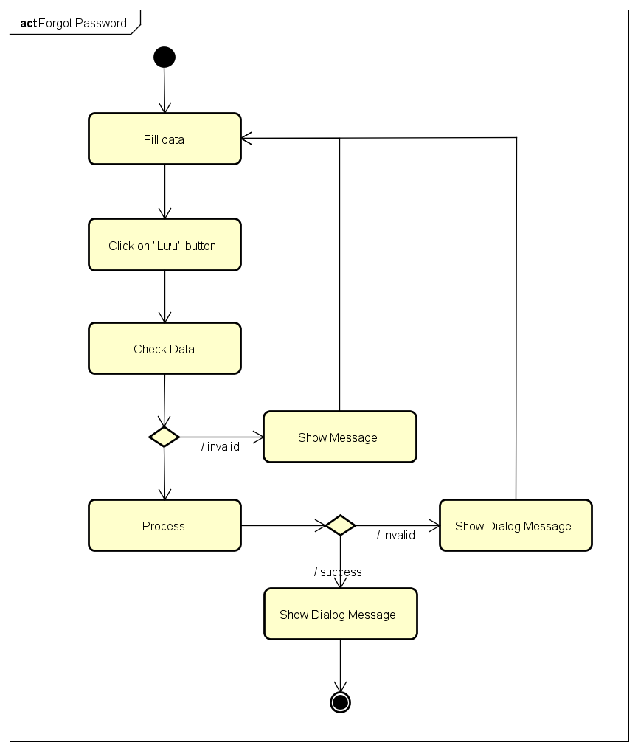

4.6. CRC Cards and Class Diagram

4.6.1. CRC Cards

4.6.2. Class Diagram

4.7.A. User Interface Design

4.7.A.1. Register and Login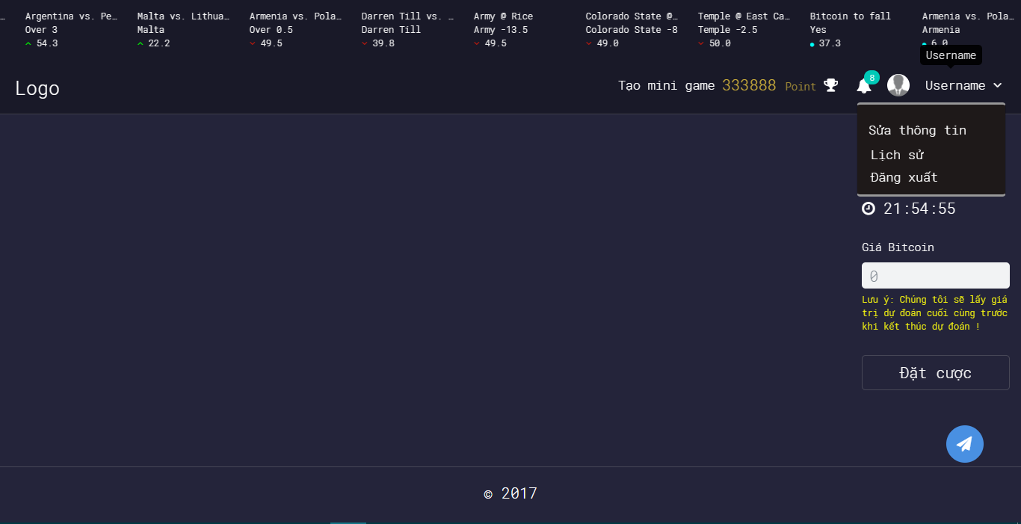

4.7.A.2. Login Using Facebook

4.7.A.3. Login Using Google Plus

4.7.A.4. Logout

4.7.A.5. Change Password

4.7.A.6. Forgot Password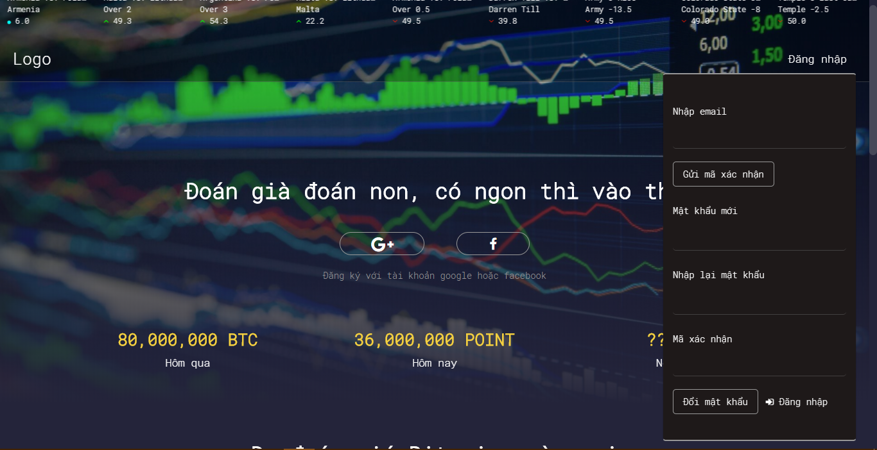

4.7.A.7. Edit Profile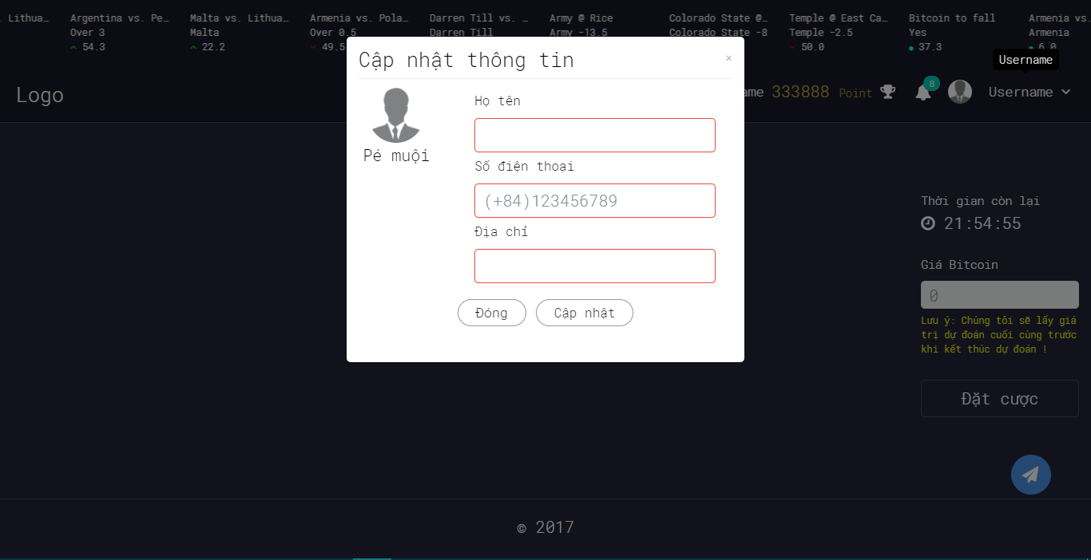

4.7.A.8. History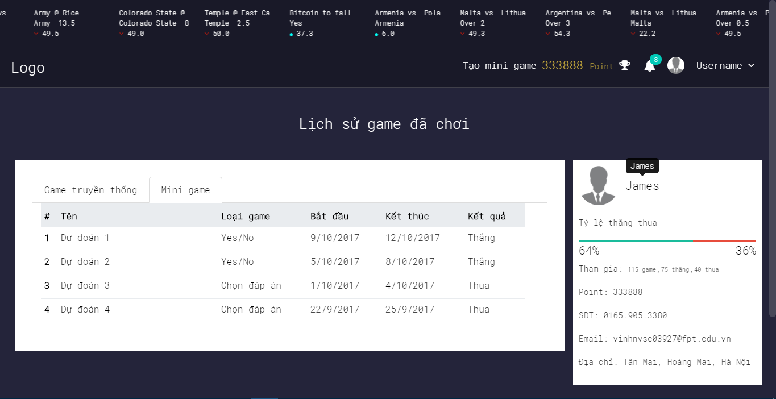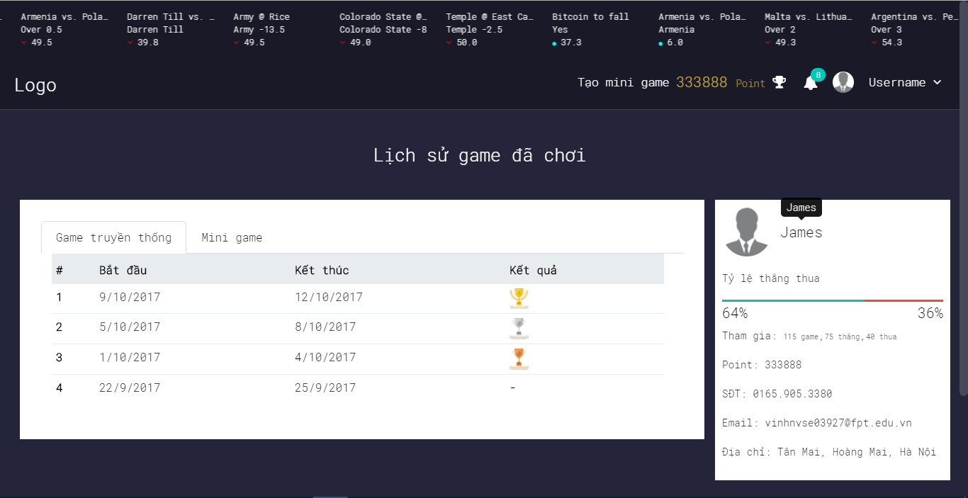

4.7.A.9. Notification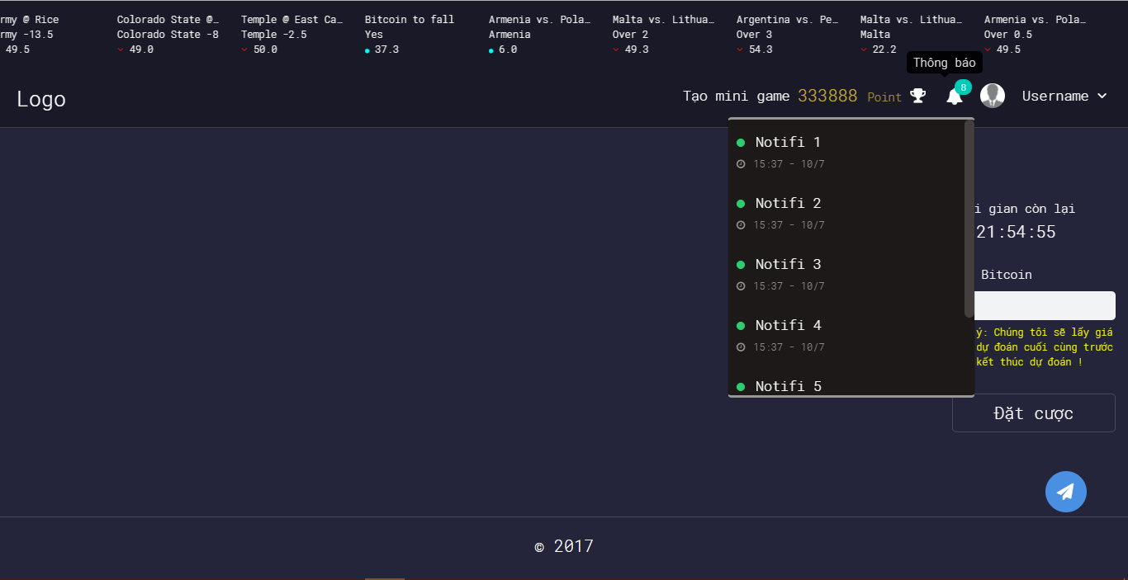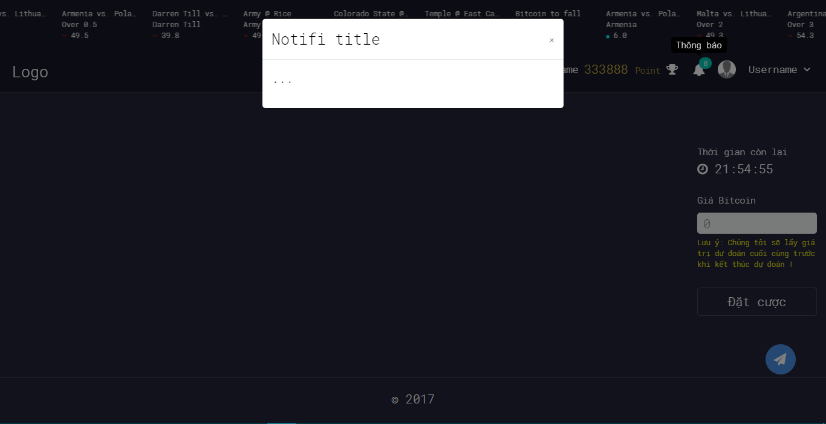

4.7.A.10. Ranking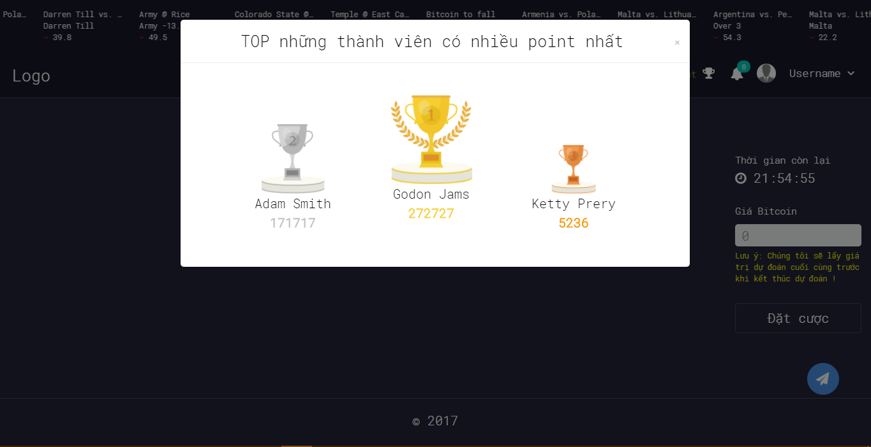

4.7.A.11. Create Yes/No Game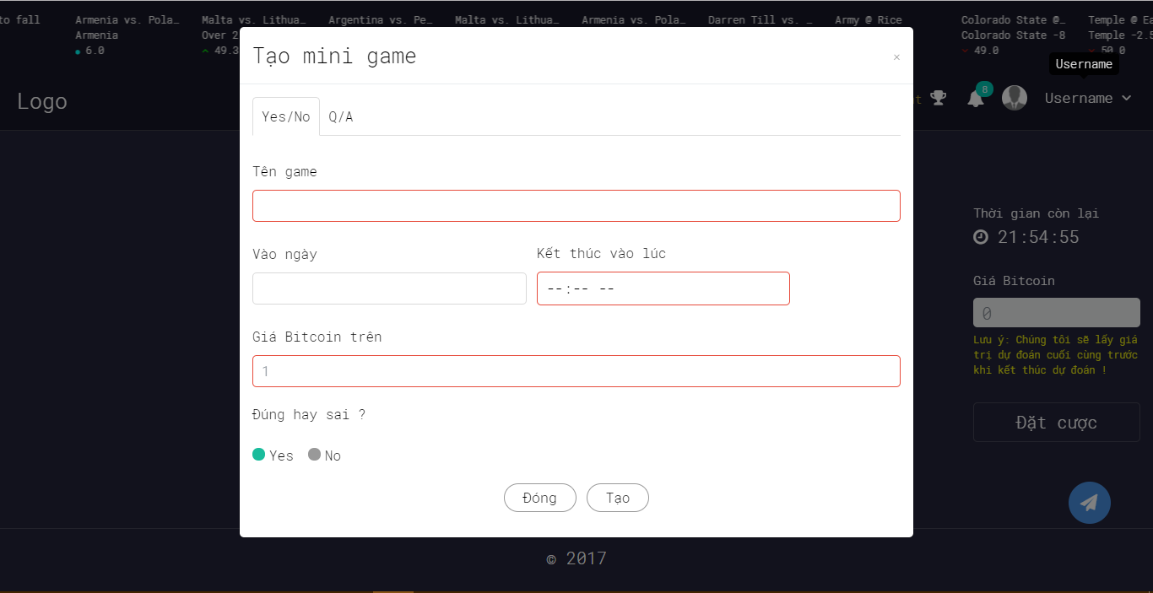

4.7.A.12. Create Multiple Choice Game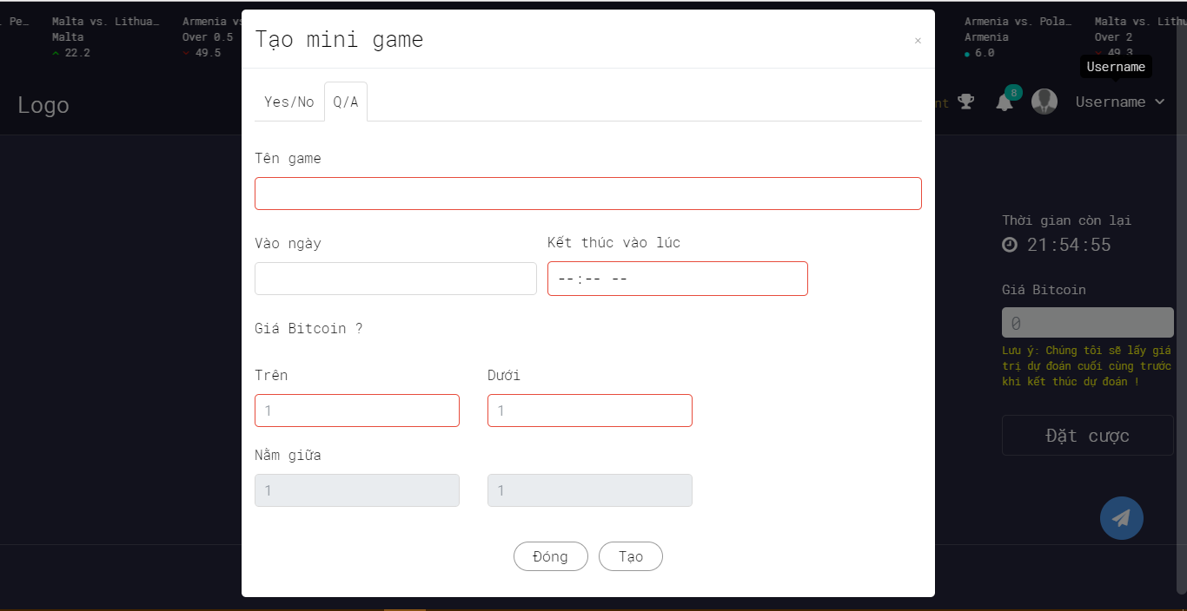

4.7.A.13. Bet On Traditional Game

4.7.A.14. Bet On Yes/No Game

4.7.A.15. Bet On Multiple Choice Game

4.7.A.16. YES/No Game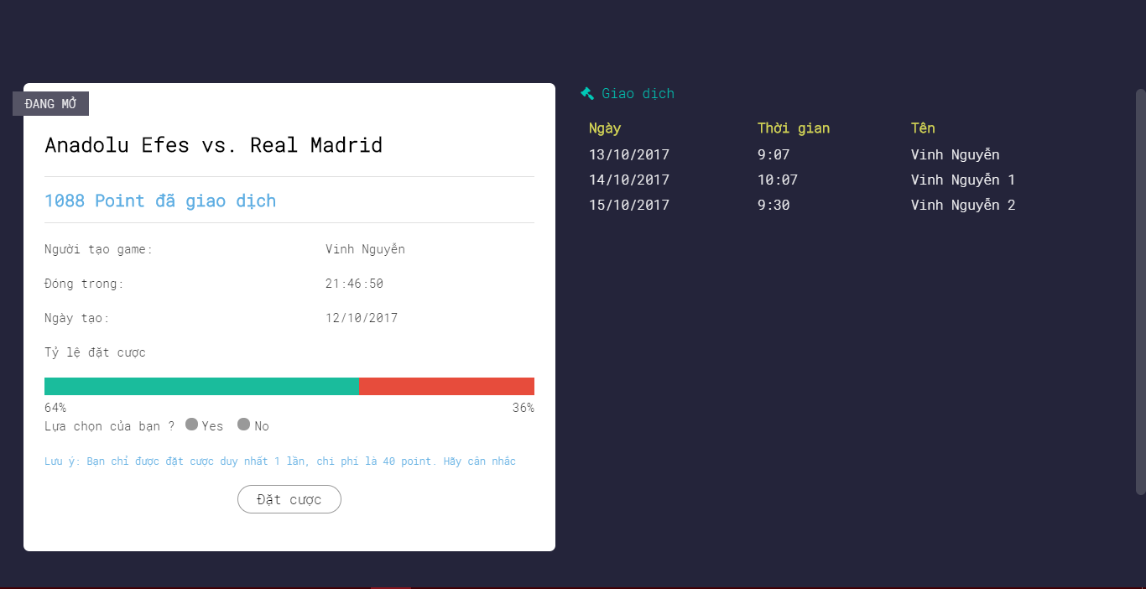

4.7.A.17. Multiple Choice Game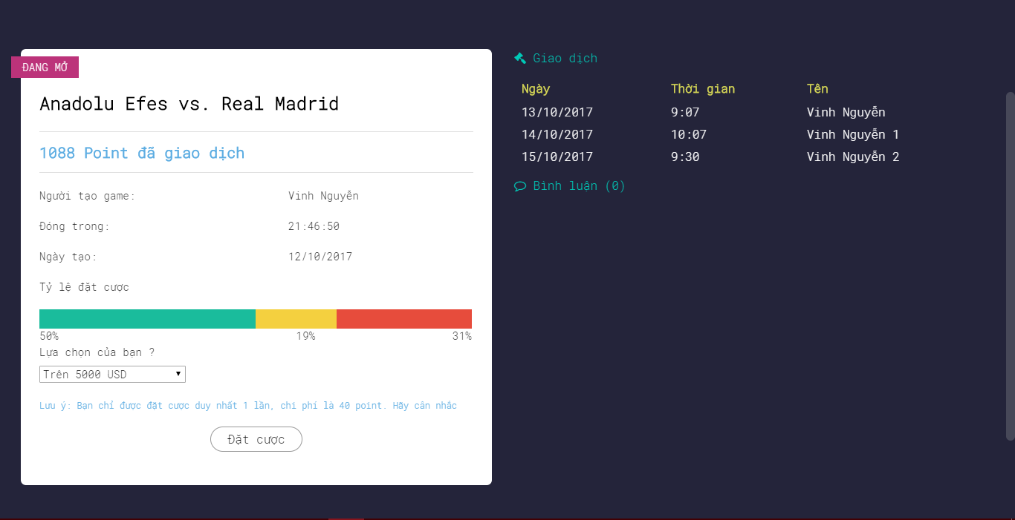

4.8. Database Design

4.8.1. Overview

Figure Database Design Screen

4.8.2. ROLE table

ROLE table store users’ role information

|  |  |  |  |  |  |
| --- | --- | --- | --- | --- | --- |
| **No.** | **Field Name** | **Type** | **Size** | **Description** | **Not Null** |
| 1 | ROLE_ID (Primary key) | int | 11 | The unique identity field for role | X |
| 2 | ROLE_NAME | varchar | 30 | Name of the role | X |

4.8.3. USERS table

|  |  |  |  |  |  |
| --- | --- | --- | --- | --- | --- |
| **No.** | **Field Name** | **Type** | **Size** | **Description** | **Not Null** |
| 1 | USER_ID  (Primary key) | int | 11 | The unique identity field for user | X |
| 2 | ROLE_ID | int | 11 | The unique identity field for role  REFERENCES ROLE(ROLE_ID) | X |
| 3 | USER_CIF | varchar | 50 | The user’s id is returned from facebook or google while login with these providers |  |
| 4 | USER_NAME | nvarchar | 100 | Name of user | X |
| 5 | PASSWORD | varchar | 100 | Password to login |  |
| 6 | USER_POINT | int | 11 | The point to join the created by system or users | X |
| 7 | EMAIL | varchar | 100 | Email of user | X |
| 8 | PHONE_NUMBER | varchar | 30 | Phone number of user |  |
| 9 | ADDRESS | nvarchar | 255 | Address of user |  |
| 10 | CREATE_DATE | date |  | The day that user join us | X |
| 11 | ATTENDANCE | bool |  | This field to check if user use service daily | X |
| 12 | ACTIVE | bool |  | To block or active user | X |

4.8.4. NOTIFICATION table

NOTIFICATION table store the message sent to user when necessary

|  |  |  |  |  |  |
| --- | --- | --- | --- | --- | --- |
| **No.** | **Field Name** | **Type** | **Size** | **Description** | **Not Null** |
| 1 | NOTICE_ID  (PRIMARY KEY) | int | 11 | The unique identity field for message | X |
| 2 | TITLE | nvarchar | 255 | Title of message | X |
| 3 | CONTENT | text |  | Content of message | X |
| 4 | CREATE_DATE | datetime |  | Date when message is created | X |

4.8.5. NOTIFICATION_TYPE table

NOTIFICATION_TYPE table store type of notice

|  |  |  |  |  |  |
| --- | --- | --- | --- | --- | --- |
| **No.** | **Field Name** | **Type** | **Size** | **Description** | **Not Null** |
| 1 | TYPE_ID  (PRIMARY KEY) | int | 11 | The unique identity field for message type | X |
| 2 | TYPE_NAME | varchar | 20 | Name of type | X |

4.8.6. NOTIFICATION_DETAILS table

NOTIFICATION_DETAILS table store logs when messages sent to users

|  |  |  |  |  |  |
| --- | --- | --- | --- | --- | --- |
| **No.** | **Field Name** | **Type** | **Size** | **Description** | **Not Null** |
| 1 | NOTICE_ID  references NOTIFICATION(NOTICE_ID) | int | 11 | The unique identity field for message | X |
| 2 | USER_ID  references USERS(USER_ID) | int | 11 | The unique identity field for user | X |
| 3 | TYPE_ID  references NOTIFICATION_TYPE(TYPE_ID) | int | 2 | The unique identity field for type | X |
| 4 | GAME_ID | int | 11 | To determine what game message responsible for | X |
| 5 | SEND_DATE | datetime |  | Date that message was sent to user | X |
| 6 | SEEN | bool |  | Status of message when received by user | X |

4.8.7. CHAT_ROOMS table

CHAT_ROOMS table store the channel that message’s sent to

|  |  |  |  |  |  |
| --- | --- | --- | --- | --- | --- |
| **No.** | **Field Name** | **Type** | **Size** | **Description** | **Not Null** |
| 1 | ROOM_ID  (Primary key) | int | 11 | The unique identity field for channel | X |
| 2 | GAME_ID  references SYSTEM_GAMES (GAME_ID) | int | 11 | Game that chat channel is created for | X |
| 3 | ROOM_NAME | varchar | 100 | The name of channel | X |
| 4 | CREATE_DATE | datetime |  | The day that room is created | X |

4.8.9. CHAT_MESSAGES table

CHAT_MESSAGES table store message that is commented by user to system game

|  |  |  |  |  |  |
| --- | --- | --- | --- | --- | --- |
| **No.** | **Field Name** | **Type** | **Size** | **Description** | **Not Null** |
| 1 | MESSAGE_ID  (Primary key) | int | 11 | The unique identity field for comment | X |
| 2 | USER_ID  references USERS(USER_ID) | int | 11 | The owner of comment | X |
| 3 | ROOM_ID  references CHAT_ROOMS(ROOM_ID) | int | 11 | The channel that comment in | X |
| 4 | CONTENT | nvarchar | 255 | Content of comment | X |
| 5 | SEND_DATE | dateitme |  | Date that user leave their comment | X |

4.8.10. CATEGORIES table

CATEGORIES table store currency category information

|  |  |  |  |  |  |
| --- | --- | --- | --- | --- | --- |
| **No.** | **Field Name** | **Type** | **Size** | **Description** | **Not Null** |
| 1 | CATEGORY_ID  (Primary key) | int | 11 | The unique identity field for category | X |
| 2 | CATEGORY_NAME | varchar | 30 | Category name | X |

4.8.11. CURRENCY_TYPE table

CURRENCY_TYPE table store currency type

|  |  |  |  |  |  |
| --- | --- | --- | --- | --- | --- |
| **No.** | **Field Name** | **Type** | **Size** | **Description** | **Not Null** |
| 1 | TYPE_ID  (Primary key) | int | 11 | The unique identity field for type | X |
| 2 | TYPE_NAME | varchar | 20 | Type name | X |
| 3 | CATEGORY_ID  references CATEGORIES(CATEGORY_ID) | int | 11 | Category of type | X |

4.8.12. CURRENCY_DETAILS table

CURRENCY_DETAILS table store information about a specificed currency unit at a time

|  |  |  |  |  |  |
| --- | --- | --- | --- | --- | --- |
| **No.** | **Field Name** | **Type** | **Size** | **Description** | **Not Null** |
| 1 | CURRENCY_ID  (Primary key) | int | 11 | The unique identity field for currency | X |
| 2 | PRICE | double |  | Price of currency unit at a time | X |
| 3 | UPDATE_AT | datetime |  | The time that currency is to be value at | X |
| 4 | TYPE_ID  references CURRENCY_TYPE(TYPE_ID) | int |  | Type of currency | X |

4.8.13. SYSTEM_GAMES table

SYSTEM_GAMES table store the game automatically created by system

|  |  |  |  |  |  |
| --- | --- | --- | --- | --- | --- |
| **No.** | **Field Name** | **Type** | **Size** | **Description** | **Not Null** |
| 1 | GAME_ID  (Primary key) | int | 11 | The unique identity field for game | X |
| 2 | TITLE | nvarchar | 255 | Game title | X |
| 3 | CONTENT | nvarchar | 255 | Game content | X |
| 4 | START_DATE | datetime |  | Time that game starts | X |
| 5 | END_DATE | datetime |  | Time that game ends | X |
| 6 | ACTIVE | bool |  | Status of game | X |
| 7 | POINT_TO_BET | double |  | Point spent to join game | X |
| 8 | RESULT | double |  | Result of game |  |
| 9 | CUR_TYPE_ID  references CURRENCY_TYPE(TYPE_ID) | int | 11 | Type of game corresponding to type of currency | X |

4.8.14. SYSTEM_GAME_LOGS table

SYSTEM_GAME_LOGS store history of system game

|  |  |  |  |  |  |
| --- | --- | --- | --- | --- | --- |
| **No.** | **Field Name** | **Type** | **Size** | **Description** | **Not Null** |
| 1 | USER_ID  references USERS(USER_ID) | int | 11 | Game’s player | X |
| 2 | GAME_ID  references SYSTEM_GAMES(GAME_ID) | int | 11 | Game that logs belong to | X |
| 3 | PRICE_GUESS | double |  | Value of currency unit user guess | X |
| 4 | DATE_GUESS | datetime |  | Time user leave their prediction | X |

4.8.15. AWARD table

AWARD table store gift for the 3 first prizes of system game

|  |  |  |  |  |  |
| --- | --- | --- | --- | --- | --- |
| **No.** | **Field Name** | **Type** | **Size** | **Description** | **Not Null** |
| 1 | AWARD_ID  (Primary key) | int | 11 | The unique identity field for award | X |
| 2 | PRIZE | int | 1 | The prize that the gift belongs to | X |
| 3 | AWARD_NAME | nvarchar | 100 | Name | X |
| 4 | PRICE | double |  | Value of gift | X |
| 5 | IMAGE_URL | varchar | 255 | Image of gift | X |
| 6 | ACTIVE | bool |  | Status of gift | X |

4.8.16. ACHIEVEMENT table

ACHIEVEMENT table store winners of system game

|  |  |  |  |  |  |
| --- | --- | --- | --- | --- | --- |
| **No.** | **Field Name** | **Type** | **Size** | **Description** | **Not Null** |
| 1 | A_ID | int | 11 | The unique identity field for achievement | X |
| 2 | USER_ID  references USERS(USER_ID) | int | 11 | User get achievement | X |
| 3 | AWARD_ID  references AWARD(AWARD_ID) | int | 11 | The ward for winner | X |
| 4 | GAME_ID  references SYSTEM_GAMES(GAME_ID) | int | 11 | Game that user get achievement | X |
| 5 | GET_AT | datetime |  | Time that user get achievement | X |

4.8.17. YN_GAMES table

YN_GAMES table store binary option game (true/faslse) created by users

|  |  |  |  |  |  |
| --- | --- | --- | --- | --- | --- |
| **No.** | **Field Name** | **Type** | **Size** | **Description** | **Not Null** |
| 1 | GAME_ID  (Primary key) | int | 11 | The unique identify field for game | X |
| 2 | OWNER_ID  references USERS(USER_ID) | int | 11 | The owner of game | X |
| 3 | CUR_TYPE_ID  references CURRENCY_TYPE(TYPE_ID) | int | 11 | The currency unit that game use to bet | X |
| 4 | TITLE | nvarchar | 255 | Game title | X |
| 5 | CONTENT | nvarchar | 255 | Game content | X |
| 6 | START_DATE | datetime |  | Time to start game | X |
| 7 | END_DATE | datetime |  | Time to end game | X |
| 8 | POINT_TO_BET | int | 5 | Point to join game | X |
| 9 | PRICE_BET | double |  | Value of currency unit that user raise to bet | X |
| 10 | RESULT | double |  | Result of game |  |
| 11 | PLAYER_COUNT | int | 2 | Number of players join game.  (<= 40) | X |
| 12 | ACTIVE | bool |  | Status of game. It’s set to false if game end | X |
| 13 | TOTAL_AMOUNT | int | 11 | Total point get from players  (PLAYER_COUNT*POINT_TO_BET) | X |

4.8.18. YN_GAME_LOGS table

YN_GAME_LOGS table store history of yn_game

|  |  |  |  |  |  |
| --- | --- | --- | --- | --- | --- |
| **No.** | **Field Name** | **Type** | **Size** | **Description** | **Not Null** |
| 1 | USER_ID  references USERS(USER_ID) | int | 11 | Players in game | X |
| 2 | GAME_ID  references YN_GAMES(GAME_ID) | int | 11 | The unique identify field for game that log is saved | X |
| 3 | ANSWER | bool |  | The answer players choose | X |
| 4 | ANS_TIME | datetime |  | Date that user join game | X |
| 5 | IS_WINNER | bool |  | Result of game that point out who is winner or looser |  |

4.8.19. MULTI_CHOICE_GAMES table

MULTI_CHOICE_GAMES table store multichoice game created by user

|  |  |  |  |  |  |
| --- | --- | --- | --- | --- | --- |
| **No.** | **Field Name** | **Type** | **Size** | **Description** | **Not Null** |
| 1 | GAME_ID  (Primary key) | int | 11 | The unique identify field for game | X |
| 2 | OWNER_ID | int | 11 | The owner of game | X |
| 3 | CUR_TYPE_ID | int | 11 | The currency unit that game use to bet | X |
| 4 | TITLE | nvarchar | 255 | Game title | X |
| 5 | CONTENT | nvarchar | 255 | Game content | X |
| 6 | START_DATE | datetime |  | Time to start game | X |
| 7 | END_DATE | datetime |  | Time to end game | X |
| 8 | POINT_TO_BET | int | 5 | Point to join game | X |
| 9 | PRICE_BELOW | double |  | Minimum value of currency unit that user raise to bet | X |
| 10 | PRICE_ABOVE | double |  | Maximum value of currency unit that user raise to bet | X |
| 11 | RESULT | double |  | Value of currency unit when game ends |  |
| 12 | PLAYER_COUNT | int | 2 | Number of players join game.  (<= 40) | X |
| 13 | ACTIVE | bool |  | Status of game. It’s set to false if game end | X |
| 14 | TOTAL_AMOUNT | int | 11 | Total point get from players  (PLAYER_COUNT*POINT_TO_BET) |  |

4.8.20. MULTI_CHOICE_GAME_LOGS table

MULTI_CHOICE_GAME_LOGS table store history of multi choice game

|  |  |  |  |  |  |
| --- | --- | --- | --- | --- | --- |
| **No.** | **Field Name** | **Type** | **Size** | **Description** | **Not Null** |
| 1 | USER_ID  references USERS(USER_ID) | int | 11 | Players in game | X |
| 2 | GAME_ID  references YN_GAMES(GAME_ID) | int | 11 | The unique identify field for game that log is saved | X |
| 3 | PRICE_BELOW | bool |  | Option that player choose. True if the real price < MULTI_CHOICE_GAMES (PRICE_BELOW) | X |
| 4 | PRICE_BETWEEN | bool |  | Option that player choose. True if the MULTI_CHOICE_GAMES (PRICE_BELOW) <= real price <= MULTI_CHOICE_GAMES (PRICE_ABOVE) | X |
| 5 | PRICE_ABOVE | bool |  | Option that player choose. True if the real price > MULTI_CHOICE_GAMES (PRICE_ABOVE) | X |
| 6 | ANS_TIME | datetime |  | Date that user join game | X |
| 7 | IS_WINNER | bool |  | Result of game that point out who is winner or looser |  |

# CHAPTER 5: SOFTWARE TESTING DOCUMENT

## **5.1. Introduction.**

This document describes the plan for testing the developed software system against the software requirements as defined in the Software Requirements Specification and Detailed Document. The purpose of these tests is to make sure that the software system developed during the LowHope project complies with the requirements. The planning of these test will be done in the Planning phase, they will be designed in the Design phase and finally must be executed in the Coding phase and Testing phase of each cycle in the project.

## **5.2. Test Plan.**

### **5.2.1. Test Process**



### **5.2.2. Requirement for Test**

#### **5.2.2.1. Test Items**

Developer will be performed unit test to ensure that all functions are working as expected. Tester will be under taking the responsibility of testing and validating the operation of the part that developed. The functions developed require completing design and execution of function to ensure proper coverage. The listing below identifies those items that have been identified as targets for testing. This list represents what will be tested.

##### **5.2.2.1.1 Functional Items**

The testing is done for all functionalities:

|  |  |  |  |
| --- | --- | --- | --- |
| **No** | **Use case ID** | **Name** | **Primary Actor** |
|  | UC1.01 | Register | Guest |
|  | UC2.01 | Login | Player, Manager, Admin |
|  | UC2.02 | Forget password | Player |
|  | UC2.03 | Logout | Player, Manager, Admin |
|  | UC2.04 | View profile | Player, Manager, Admin |
|  | UC2.05 | Edit profile | Player, Manager, Admin |
|  | UC2.06 | View chart of bitcoin price | Player |
|  | UC2.07 | Play Traditional betting Game | Player |
|  | UC2.08 | Play Yes_No betting Game | Player |
|  | UC2.09 | Play Multichoice betting game | Player |
|  | UC2.10 | Create Yes_No betting game | Player |
|  | UC2.11 | Create Multichoice betting game | Player |
|  | UC2.12 | View list of participant in a game | Player |
|  | UC2.13 | View history of player | Player |
|  | UC2.14 | View notifications | Player |
|  | UC2.15 | View top point | Player |
|  |  |  |  |
|  |  |  |  |
|  |  |  |  |
|  |  |  |  |
|  |  |  |  |
|  |  |  |  |
|  |  |  |  |
|  |  |  |  |

##### **5.2.2.1.2 Non Functional Items**

* User interface is clear and easy to understand. User need no more than 10 minutes to learn how to the application.

#### **5.2.2.2. Acceptance test criteria**

(Reference to FSoft norm 2013 for development project)

* The criteria for Test team to accept source code after Unit test of Development team:

- Number of UTC/KLOC: 80 - 90 Case/1KLOC

- Weight defects/KLOC: 8 - 9 bug/1KOLC

- Part coverage: 100%

* The criteria for accept the result of System test:

- Number of UTC/KLOC: 34 - 36 Case/1KLOC

- Weight defects/KLOC: 2 - 4 bug/1KOLC

- Part coverage: 100%

* The criteria accept the result of Acceptance test:

- Number of UTC/KLOC: 1 - 2 Case/1KLOC

- Weight defects/KLOC: 0 - 1 bug/1KOLC

- Part coverage: 100%

### **5.2.3. Test Approach**

* LowHope Website following V-Model process model:

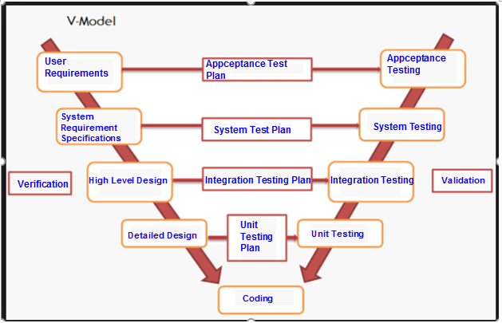

#### **5.2.3.1. Test stage**

|  |  |  |
| --- | --- | --- |
| **No** | **Test stages** | **Description** |
| 1 | **Unit Test** | * Unit Test is an important technique to improve software quality. * Unit testing is done by developers |
| 2 | **Integration Test** | * Integration Testing is a test that integrates a group of individual modules together with individual unit tests in each module. * A typical software project consists of several software modules, coded by different people. Integration testing focuses on testing the data transfer between modules and specific areas of use cases when all requirements are completed. * Integration test should be performed to ensure all components incorporate well. |
| 3 | **System Test** | * System test will be execute by LowHope tester * Testers will perform complete, end-to-end product testing staged in pre-production environment to validate that functions and system interfaces perform properly in production environment. After Integration test and Unit test. * Usually a software product is only tested on a demo environment, but the system test ensures that the system operates in a variety of environments and integrates with a variety of software and systems. * System test is a type of black box testing. System involves the operation of the outside of the software from the user's point of view. |
| 4 | **Acceptance Test** | * Acceptance testing is functional testing, which is done to check that the software meets the requirements of the customer. * Acceptable testing is performed by the customer, the user and the parties involved. * In acceptance testing will test the system to meet the business needs of the organization, the usability of the product. * Software runs with realistic data. * Acceptable testing is performed after system testing. |

### **5.2.4. Constraints**

- Working processing must be report Personal weekly report to PM and Supervisor.

- Deadline for testing only can be met if development progress is on time.

- At least one round of testing must be performed for requirements.

### **5.2.5. Rick List**

|  |  |  |  |  |  |
| --- | --- | --- | --- | --- | --- |
| **No** | **Description** | **Source** | **Probability** | **Exposure** | **Trigger** |
| 1 | Test phases is not completed due to testers’ lack of experience | Human | Medium |  |  |
|  |  |  |  |  |  |

### **5.2.6. Training Needs**

|  |  |  |
| --- | --- | --- |
| **No** | **Description** | **Description** |
| 1 | Testing process | - Learn & study by TungNT, CongLD, PhongNH, VinhNV.  - Understanding: Unit test, System test, Acceptance Test, Integration Test. Leaning from website: testing.vn |
| 2 | Test model | Learn & study by developer:  Understanding V-model |

### **5.2.7. Test Strategy**

#### **5.2.7.1. Test type**

##### **5.2.7.1.1. Function Testing**

Unit testing searches for defects in each function, and verifies the function of LowHope website. Website and tests whether its functions are implemented properly as required or not.

|  |  |
| --- | --- |
| **Test Objective** | Functional testing is a way of checking software to ensure that it has all the required functionality that's specified within its functional requirements. |
| **Technique** | Execute each use case, use-case flow, or function, using valid and invalid data, to verify the following:  - The expected results occur when valid data is used.  - The appropriate error or warning messages are displayed when invalid data is used. |
| **Completion criteria** | All planned tests have been executed. |
| **Special considerations** | Identify or describe those items or issues (internal or external) that impact the implementation and execution of function test |

##### **5.2.7.1.2. User Interface Testing**

Integration testing tests interfaces between components (website screen), interactions with different parts of a system, and interfaces between systems.

|  |  |
| --- | --- |
| **Test Objective** | Verify the following:  Navigation through the target-of-test properly reflects business functions and requirements, including window-to-window, field-to-field, and use of access methods (tab keys, mouse movements, accelerator keys). |
| **Technique** | Create or modify tests for each screen (website) to verify proper navigation and object states for each application window and objects |
| **Completion criteria** | Each screen(website) successfully verified to remain consistent with benchmark version or within acceptable standard |
| **Special considerations** | N/A |

##### **5.2.7.1.3. Data and Database Integrity Testing**

Data and Database Integrity Testing test integrity of data, accuracy of data and save data to the database.

|  |  |
| --- | --- |
| **Test Objective** | Ensure database access methods and processes function properly and without data corruption. |
| **Technique** | - Invoke each database access method and process, seeding each with valid and invalid data or requests for data.  - Inspect the database to ensure the data has been populated as intended, all database events occurred properly, or review the returned data to ensure that the correct data was retrieved for the correct reasons |
| **Completion criteria** | - All database access methods and processes function as designed and without any data corruption. |
| **Special considerations** | - Testing may require a DBMS development environment or drivers to enter or modify data directly in the databases. |

##### **5.2.7.1.4. Regression Testing**

Regression testing is to validate modified parts of the software, to make sure that the modification does not cause errors in other parts.

|  |  |
| --- | --- |
| **Test Objective** | - Regression testing is to validate modified parts of the software, to make sure that the modification does not cause errors in other parts. |
| **Technique** | - Reuse the set of test cases from an existing test suite to test a modified module.  - Construct a program-analysis infrastructure. We are building an extensible infrastructure to implement and evaluate a program-analysis. Basing on the analysis result, we identify scope of regression test. |
| **Completion criteria** | - All selected test cases (cases can cause bugs when changed requirement) are performed and passed. |
| **Special considerations** | N/A |

### **5.2.8. Test Stages**

|  |  |  |  |  |
| --- | --- | --- | --- | --- |
| **Types of Test** | **Stages of Test** | | | |
| **Unit Test** | **Integration Test** | **System Test** | **Acceptance Test** |
| **Function Test** |  |  |  |  |
| **User Interface Test** |  |  |  |  |
| **Data and Database Integrity Testing** |  |  |  |  |
| **Regression Test** |  |  |  |  |

### **5.2.9. Resource**

#### **5.2.9.1 Human Resource**

|  |  |  |
| --- | --- | --- |
| **Human** | **Roles** | **Specific Responsibility/ Comments** |
| **TungNT** | Test Leader | - Manage test resource and assign test tasks create Test Plan, System Test, Integration Test, Review Test Case, Execute test.  - Create integration test cases.  - Execute test case  - Report test result |
| **QuanTH** | PM + Developer | - Review test plan  - Review Test Result  - Create Unit Test & Execute test  - Report test result |
| **PhongNH** | Developer | - Create Unit test & Execute test  - Report test result |
| **CongLD** | Developer | - Create Unit test & Execute test  - Report test result |
| **VinhNV** | Designer + Dev Front-end + Tester | - Create integration test cases.  - Execute test case  - Report test result |

#### **5.2.9.2 Environment**

|  |  |
| --- | --- |
| Test tool | Hardware |
| Manual Testing | Laptop Asus X541UA-GO1384 - i5-7200U - 156 inch |

|  |  |
| --- | --- |
| **Hardware** | **Version** |
| Laptop | Laptop Asus X541UA-GO1384 - i5-7200U - 156 inch |

|  |  |
| --- | --- |
| **Software** | **Version** |
| Google chrome | 1.3.33.5 |
| Mozilla Firefox | 57 |
| Microsoft Word | 2017 |
| Microsoft Excel | 2017 |

### **5.2.10. Test Milestones**

|  |  |  |  |
| --- | --- | --- | --- |
| **Milestone Task** | **Effort** | **Start Date** | **End date** |
| * **Increment 1** | | | |
| Create test plan |  | 15/10/2017 | 17/10/2017 |
| Summit test plan version 1.0 |  | 17/10/2017 | 17/10/2017 |
| * **Increment 2** | | | |
| Create System test, test cases for chart |  | 25/10/2017 | 27/10/2017 |
| Create & execute Unit test, test case for Automatic processing |  | 30/10/2017 | 31/10/2017 |
| Create & execute Unit test, test case for functions of manager and functions of admin |  | 01/11/2017 | 07/11/2017 |
| Report Unit Test and System test result |  | 7/11/2017 | 07/11/2017 |
| * **Increment 3** | | | |
| Review and update and submit test plan ver 2.0 |  | 09/11/2017 | 09/11/2017 |
| Create System test, test case for Manager and admin website. |  | 09/11/2017 | 10/11/2017 |
| Execute and report System test for manager’s function and admin’s function in website |  | 11/11/2017 | 16/11/2017 |
| Create System test, test case for Player’s functions |  | 17/11/2017 | 18/11/2017 |
| Create and execute Unit test, test case for Player functions |  | 19/11/2017 | 21/11/2017 |
| Create and execute Integration Test, test case for admin and manager |  | 21/11/2017 | 22/11/2017 |
| Create and execute Integration Test, test case for player |  | 22/11/2017 | 24/11/2017 |
| Report Unit test and Integration Test |  | 25/11/2017 | 25/11/2017 |
| * **Increment 4** | | | |
| Execute and report system test, test cases for website |  | 26/11/2017 | 29/11/2017 |
| Submit final report of testing |  | 30/11/2017 | 30/11/2017 |

### **5.2.11. Deliverables**

|  |  |  |  |  |
| --- | --- | --- | --- | --- |
| **No** | **Deliverables** | **Delivered Date** | **Delivered by** | **Delivered to** |
| * **Increment 1** | | | | |
| 1 | Test Plan ver 1.0 | 17/10/2017 | TungNT | QuanTH |
| * **Increment 2** | | | | |
| 2 | Unit test, test cases result of Automatic processing | 29/10/2017 | PhongNH | QuanTH |
| 3 | Unit test, test case for functions of manager and functions of admin | 07/11/2017 | QuanTH | QuanTH |
| 4 | System test, test cases for chart | 28/10/2017 | TungNT | QuanTH |
| * **Increment 3** | | | | |
| 5 | System test, test case for Manager and admin website. | 10/11/2017 | TungNT | QuanTH |
| 6 | System test, test case for Player’s functions | 18/11/2017 | CongLD | QuanTH |
| 7 | Unit test, test case for Player functions | 21/11/2017 | CongLD | QuanTH |
| 8 | Integration Test, test case for admin and manager | 22/11/2017 | TungNT | QuanTH |
| 9 | Integration Test, test case for player | 24/11/2017 | TungNT | QuanTH |
| 10 | Report Unit test and Integration Test | 25/11/2017 | TungNT | QuanTH |
| * **Increment 4** | | | | |
| 11 | report system test, test cases for website | 29/11/2017 | TungNT | QuanTH |
| 12 | Submit final report of testing | 30/11/2017 | TungNT | QuanTH |
|  | | |